Drone Highway Inspection And Emergency Command Solution
<V1.1>

2017/7

Overview

1. Industry Background

From the perspective of the "Thirteenth Five-Year Plan" development plan for transportation information, during the 13th Five-Year Plan period, the global information technology revolution continues to develop rapidly, Internet+ and big data have become national strategies, and the Internet has become an important infrastructure for transportation. Intelligence has become a prominent feature of the transportation system and has had a broad and profound impact on the industry's governance system and service model. The development of industry information is facing unprecedented opportunities. Building a comprehensive transportation system with connected domestic and international channels, extensive regional urban and rural coverage, complete hub node functions, and integrated and efficient transportation services has put forward new requirements for transportation information.
Judging from the "Plan", the formal requirements point out that comprehensively deepening reform and promoting the construction of the rule of law require information to promote the modernization of industry governance capabilities. From the overall idea, We must persist in fully implementing the spirit of the 18th National Congress of the Communist Party of China and the Third, Fourth and Fifth Plenary Sessions of the 18th Central Committee, and focus on accelerating the " four transportation " Building and " Thirteenth Five-Year Plan" " The main tasks of transportation development in this period are to adhere to the guiding ideology of demand and problem orientation, focus on overall planning and opening up, integrated innovation, vigorously promote the construction of smart transportation, continuously improve the level of transportation information development, and abide by the basic principles of independent innovation, safety and controllability. Principles to achieve the goal of coordinated and efficient development environment. From the perspective of main tasks, it is necessary to implement "Internet + " to facilitate transportation, improve industry operation monitoring capabilities, improve industry collaborative law enforcement capabilities, improve transportation decision-making support capabilities, strengthen government management service efficiency, and strengthen Innovative applications of high and new technologies.

2. Current Status Of The Industry

The current road monitoring system architecture is constantly being improved, with video resolutions ranging from SD to HD, more and more monitoring points, and fewer and fewer monitoring blind spots, which greatly improves high-speed operation and maintenance capabilities. However, there are also problems in the development process. Many difficulties and challenges. Mainly reflected in the following aspects:
1) Consumption: Time-consuming and labor-intensive . In daily work, when road administration personnel collect information from places that cannot be reached directly, it is not only difficult, but also extremely time-consuming and labor-intensive;
2) Many: It is more difficult to deal with accidents
After the accident, there was a large traffic jam. It is difficult for accident handling vehicles to enter the accident scene at the first time; when people are injured, often after rescuers arrive at the scene, some rescue medicines and materials do not arrive at the scene in time due to emergency attendance, making it difficult to deliver rescue materials to the rescue scene; due to high speed
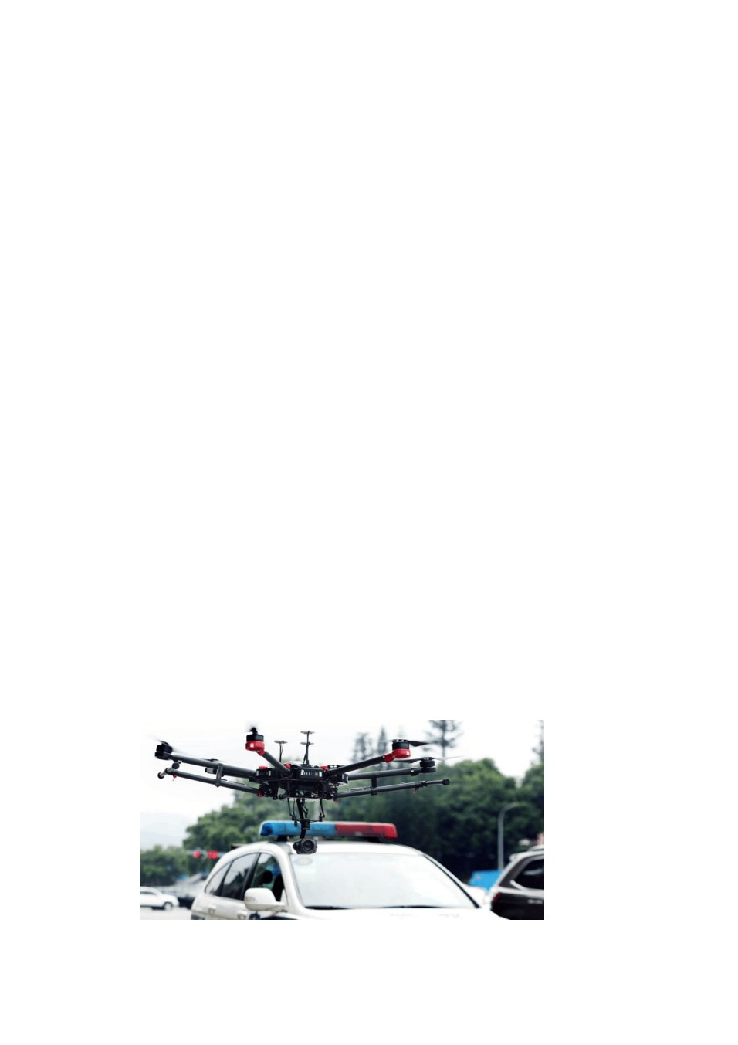The video surveillance points on the vehicle are all at fixed locations, making it difficult to track the vehicle involved in the accident at close range;
3) Low: heavy inspection workload and low efficiency
Currently, highways use manual road inspections, which not only requires a heavy workload, but also It is time-consuming and labor-intensive, and the efficiency is relatively low.
4) Risk: Harsh conditions endanger personal safety
When encountering natural disasters such as earthquakes, floods, tsunamis, and blizzards, ground transportation is completely paralyzed. The entry of manned aircraft and helicopters will endanger the personal safety of personnel. In their daily work, road administration personnel conduct inspections under bridges, in tunnels, on slopes, and in dangerous areas. It is not only difficult to collect personal information, but also endangers personal safety at all times.
With the development of modern communications and the continuous improvement of technology in our country, especially during the rapid development of 4G networks , the development of mobile communication networks has continued to achieve new progress and development. The network speed can meet the requirements for UAV operation. With its unique advantages such as strong mobility, wide monitoring range, high efficiency, economical, practical and efficient, "UAV" has its own unique solutions to the above problems. The method helps highway personnel quickly and accurately understand the accident situation at the scene, cooperate with the support vehicle to enter the scene to handle the accident, improve the efficiency of accident handling, and reduce the loss of life and property caused by the accident.

Overview of UAV Systems

By carrying high-definition cameras and audio modules as well as 4G on drones The transmission module puts the drone on the highway, transmits real-time video and audio data to the control end, and then transmits it through 4G Smart collaborative routing transmits video and audio data back to the existing video surveillance center to achieve a flexible video surveillance method. For daily traffic monitoring, emergency incident handling, and information collection on highways, the operation mode is more convenient and faster than traditional methods, which improves work efficiency and enhances the personal safety of law enforcement personnel.

4. UAV application advantages

Compared with traditional highway maintenance and emergency response methods , What are the following advantages of UAV systems?
1) Low cost , quick and convenient image acquisition
Small drones and ultra-light drones are cheap , most cost tens of thousands of yuan . A SLR camera plus an optical lens costs tens of thousands of dollars ; and routine maintenance is relatively simple , greatly reducing the cost of acquiring image data.
2) Strong mobility , Good work continuity.
It can be deployed in various environments anytime and anywhere to quickly carry out data collection operations . And can mount a variety of loads according to actual needs . For example, you can mount a high-definition camera , Conduct continuous observations of important areas , Real-time image data can even be transmitted back to the headquarters through the data link or monitored in real time on site . At the same time, schedule aircraft to adjust data collection locations according to demand ?
3) Strong timeliness
After the data collection is completed, the data can be roughly inspected on site . Repeated observations can be made on key parts , It can quickly and effectively monitor the actual road status .
4) Not affected by meteorological and geographical conditions
Generally, drone inspections are adapted to intense maneuvers and harsh environments . More suitable for performing high-risk tasks in special periods . Compared with manned aircraft and helicopters , Suffer from rain Weather restrictions such as fog and fog are much smaller . And it makes up for the shortcomings of satellite remote sensing that cannot obtain images due to cloud cover .
5) Strong anti-interference ability
Using an industrial-grade digital radio with more than 60,000 frequency hopping sequences as a controller ensures that the ground station has absolute control over UAV flight in a complex wireless environment.
6) Industrial grade reliability
It can work normally under strong wind conditions. Speed reaches 120KM time, 8M Video transmission is stable. The waterproof design of the fuselage ensures normal use in light rainy weather.
7) Strong video transmission capability
UAVs use microwave technology as a video image transmission channel and can reach a control coverage radius of 7-10KM, which is very suitable for tasks with complex environments and wide monitoring ranges.
8) Seamless connection with video surveillance system
The drone video surveillance protocol is in accordance with the national standard for video surveillance (GB/T 28181-2011) to ensure seamless integration of drone video with standard video surveillance systems.

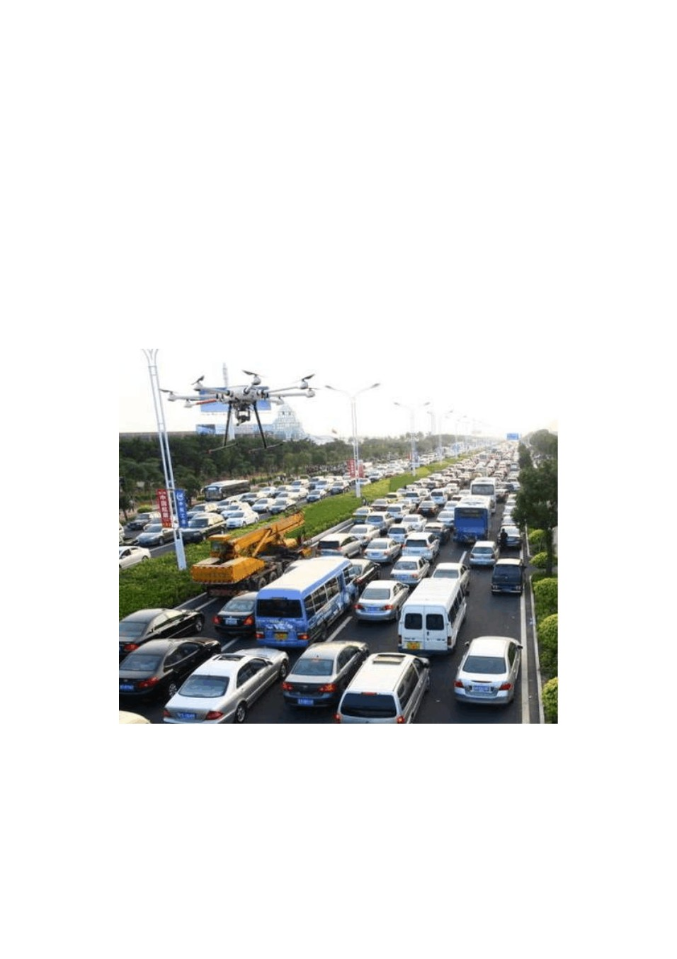

Application Scenarios

In the process of technological advancement and development in modern society, drones are no longer limited to the military field. In the process of development, due to the continuous improvement of technology and the compactness and convenience of drones, they are also gradually being used It is used in transportation and various other fields. Especially in the transportation industry, the use of drones has its irreplaceable advantages. Among them, some of the more typical applications are as follows.

2.1 Traffic Congestion Relief

By equipping drones with high-definition cameras and wireless broadcasting systems, remote traffic diversion can be carried out in areas with traffic jams on highways to quickly and efficiently solve traffic congestion problems.

2.2 Precise Location Of Traffic Accidents

Utilizing the high flexibility of drones, when a traffic accident occurs on the highway, the drone can quickly fly to the accident site and accurately locate the cause of the accident.

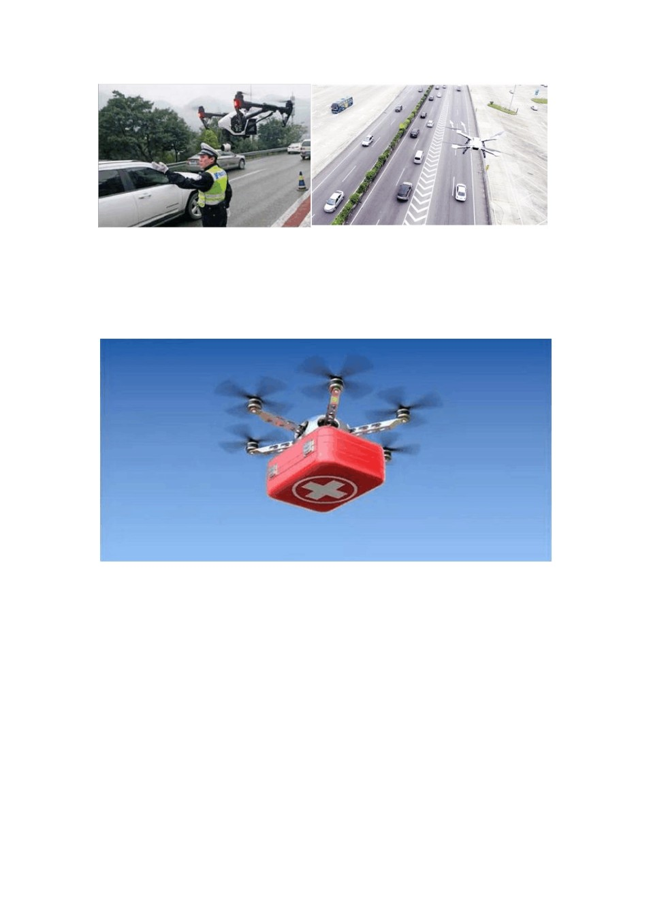

2.3 Emergency Rescue

With its strong maneuverability and flexibility, drones can transport rescue supplies to the accident site in a timely manner, providing strong support for rescuers to rescue the people on hand at the first time.

2.4 Assisting On Duty In High-Risk Or Harsh Environments

Highway officers can use drones to conduct surveillance under bridges, in tunnels, and Collect information on slopes and dangerous areas to prevent personnel on duty from being involved in danger, and can also conduct road inspections under extreme weather conditions.

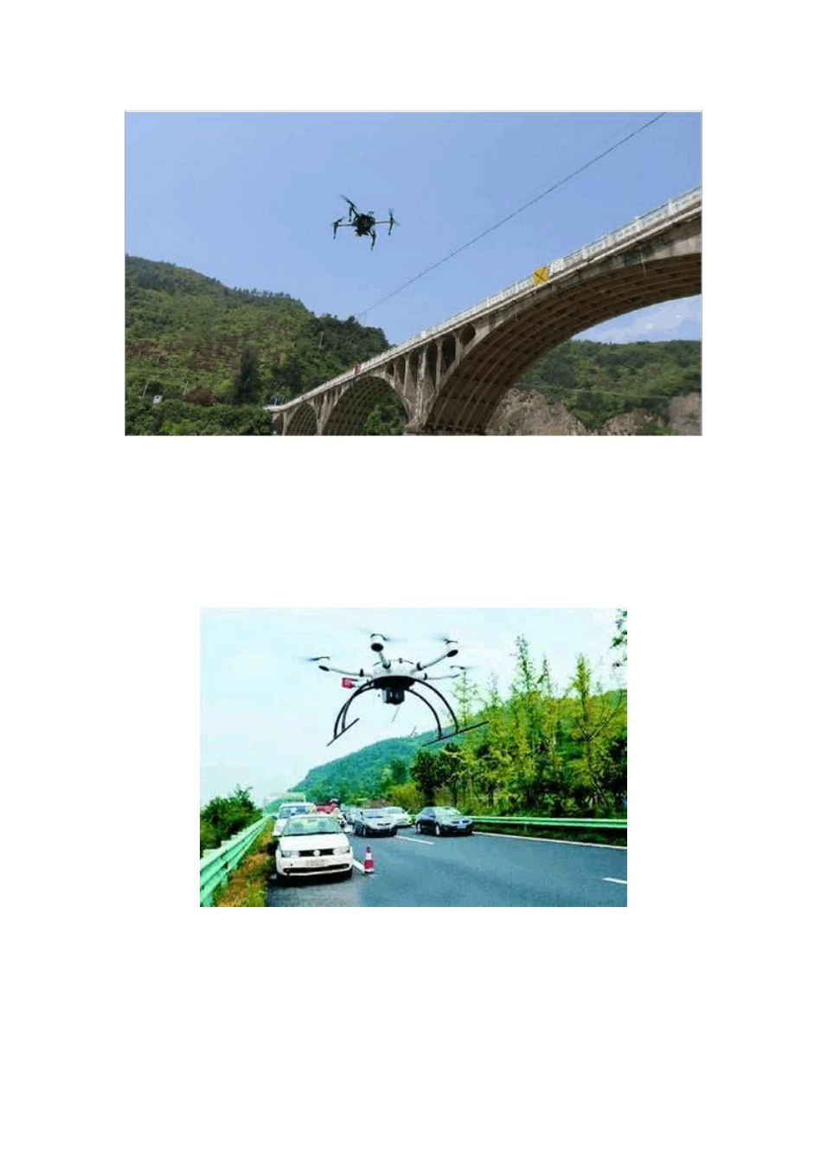

2.5 Capture Illegal Activities

Surveillance cameras on highways are fixed and cannot effectively capture illegal activities. The video and speed measuring equipment mounted on the "drone" can fix vehicle violations in all aspects and effectively maintain the normal order of the highway.

Introduction to UAV Systems

3.1 Design Principles

+ 4G image transmission monitoring solution was formulated. This solution will meet the monitoring needs of the highway management department.
This solution follows the principles of advanced technology, complete functions, stable performance, and cost saving:
1) Advancement and applicability
This system uses advanced drone equipment and purely digital signal transmission methods, using H.264 Coding technology combined with 3G/4G Wireless modulation technology reflects the latest development level of current computer control technology and computer network technology, and adapts to the requirements of the development of the times.
2) Economy and convenience
Fully consider the actual needs of users and the development trend of information technology, and based on environmental needs. The design and selection of functions are suitable for on-site conditions, and a 3G/4G/ wireless private network transmission solution is used, without the need for large-scale wiring. Project cost. The wireless transmission of front-end equipment is easy and fast to install and debug, and the back-end platform is easy to build, providing users with a convenient and fast plug-and-play function.
3) Openness
It is designed based on existing mature products, and also takes into account the current situation of the surrounding information and communication environment and the development trend of technology. It has an RJ-45 network communication port /RS232/RS485 communication interface, which can realize remote PTZ control.
4) Scalability
The system design takes into account the needs of future technology development and use, and has updated, Expansion and upgrade possibilities. And expand the system functions according to actual future requirements. At the same time, this solution leaves redundancy in the design to meet future development requirements.

3.2 Overall Application Diagram

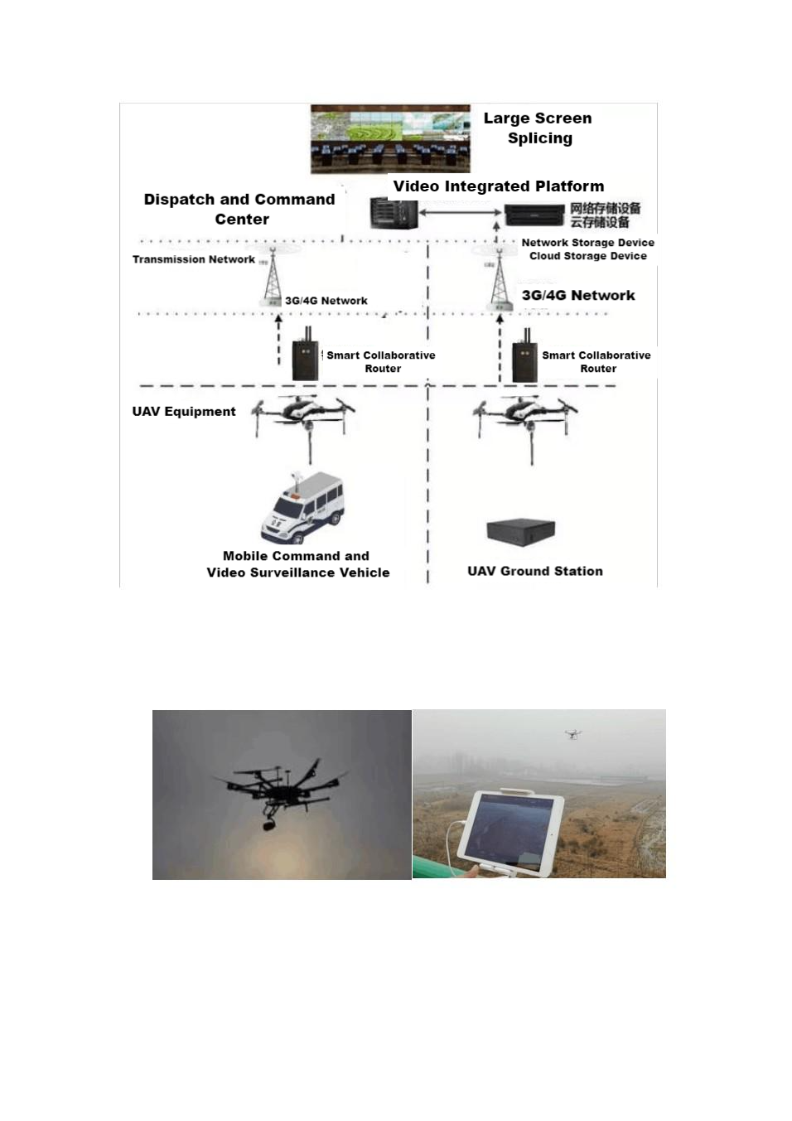

3.3 System Composition

3.3.1 UAV System

The UAV system uses preset take-off locations and ground vehicle maneuvers to provide UAV flight support. It provides uninterrupted high-altitude video guarantee for important transportation hubs. The video is transmitted back to the flight control terminal in real time, and the signal is uploaded to the dispatch command center through 4G image transmission equipment. Target locations beyond the drone’s flight range.

Use ground maneuvers to provide video support in the shortest possible time.
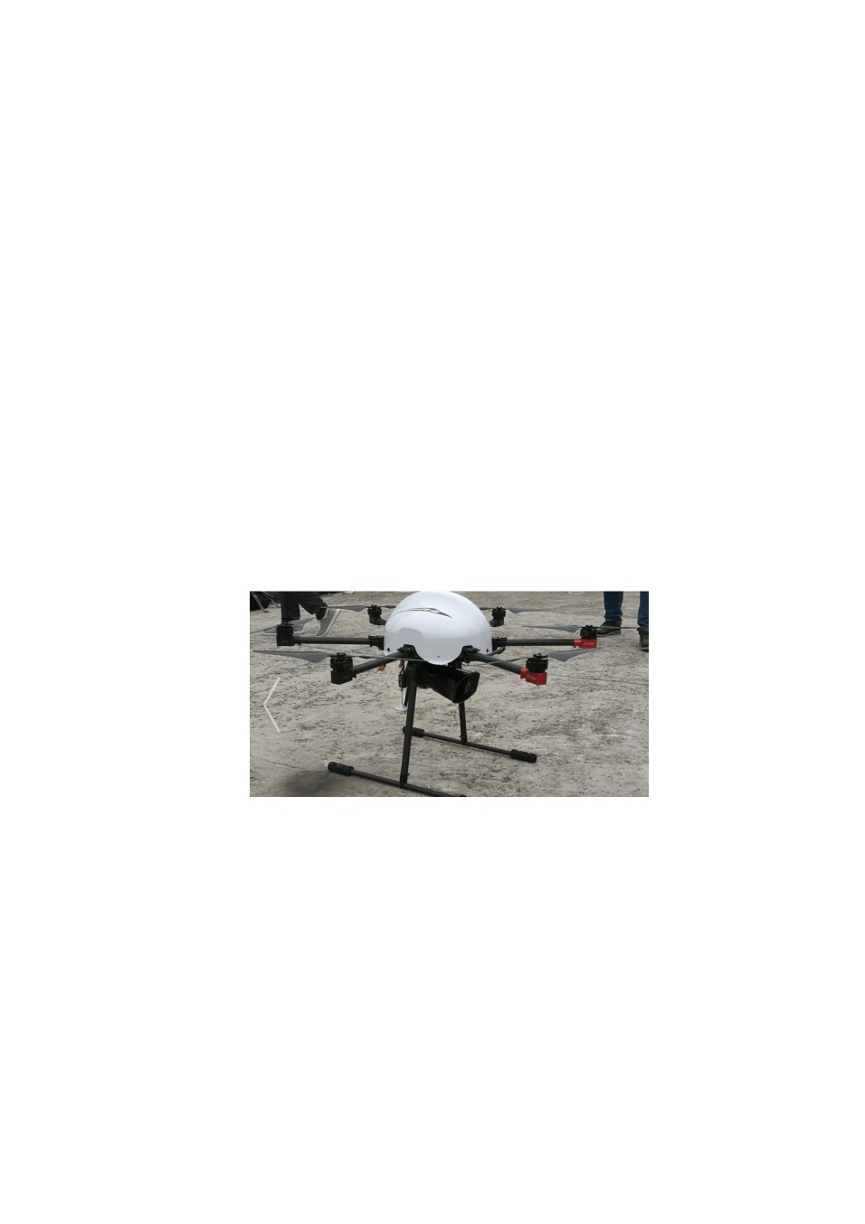According to different application scenarios, drones have different solutions, covering various application scenarios: small and convenient drones are easy to carry, and can take off in sequence behind the mission area for fixed-point surround surveillance. Each monitoring road section can be configured with 2 aircraft for alternate monitoring, and the cycle will ensure the continuity and real-time nature of monitoring work.
There are drones equipped with different types of lenses , It can be used as an emergency support model for the entire mission area. If there is a traffic accident or congestion in the surveillance area, you can carry a lens with 7x zoom performance and fly over the surveillance area. pass 7 The zoom function can capture the scene of a traffic accident or find a congestion point, which is convenient for traffic police to handle quickly and accurately. When visibility is low or at dusk, it can be equipped with a lens with infrared thermal imaging function to monitor road traffic conditions based on the heat emitted by the car.
UAVs with excellent endurance can be mounted with various types of professional shooting equipment, so they can be used as mission models for emergencies (such as haze weather, major traffic accidents, etc.). For example, when equipped with a camera with high magnification zoom capability, It can provide ultra-long-distance high-definition images, and at the same time, the lens with the haze removal function can clearly outline the details of roads and vehicles in low visibility conditions.

When using different aircraft to perform tasks, you can use the HDMI interface of the remote control to use the 4G network live broadcast method to transmit the video footage of the surveillance area back to the dispatch command center in real time, which is helpful for road administration, Traffic police can keep abreast of road conditions and provide real and effective reference for leadership decision-making when major accidents occur.
From the perspective of UAV characteristics, UAV systems applied to highways have the following characteristics:
1) Large range: UAVs can fly at low altitudes, have short paths, fast speeds, flexible viewing angle changes, and large range of activities.
2) High efficiency: UAVs require short ground and maintenance preparation times and can be deployed at any time. Compared with manned general aircraft, manned helicopters, or other means of transportation, UAVs have the characteristics of low investment and high efficiency.
3) Condescending: Drones can have a bird's-eye view of the real traffic flow on the ground, which is helpful for the highway management department to grasp the overall situation.

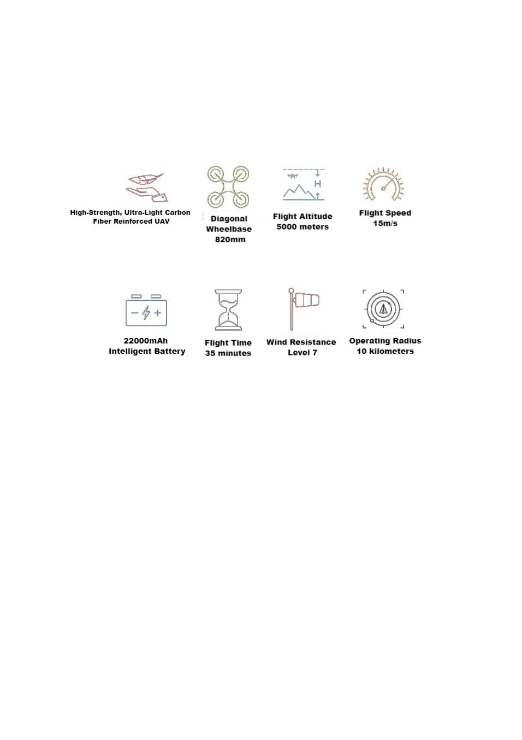Overall command and correct guidance.
4) Low risk: When participating in high-speed traffic management, drones can perform high-risk tasks in disaster weather or polluted environments.
Drone performance:

1) Satellite positioning module: GPS , Beidou, GLONASS three-mode

2) Mechanical characteristics of propeller blade: Folding propeller

3) Hovering accuracy (relative accuracy), horizontal: ± 0.2m , vertical: ± 0.5m

4) Flight control: Multi-attitude flight modes such as fixed altitude, fixed point, autonomous cruise, one-button voltage reduction protection, automatic return to home, preset no-fly zone, and electronic fence
5) Working environment: -20 ~ 60 ° C , 95% non-condensation

6) The mechanical characteristics of the machine arm: Foldable

7) The landing gear feature: Can be retracted and retracted remotely

8) Rack weight: 3.3kg

9) Maximum take-off weight: 10kg

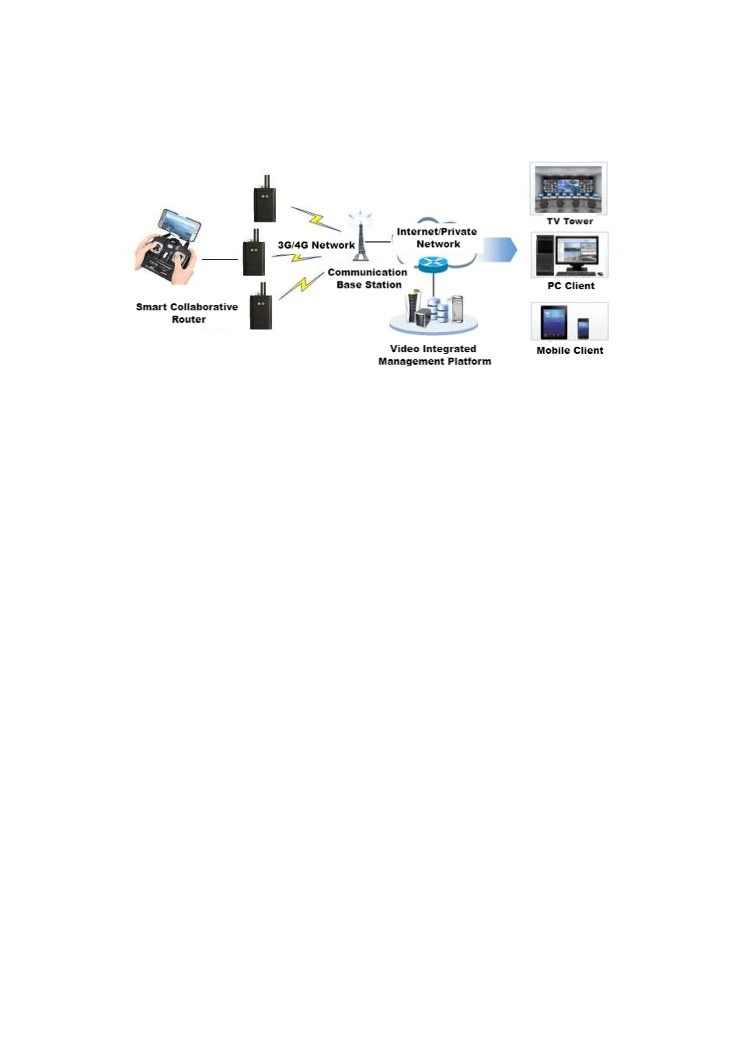3.3.2 4G Image Transmission System

The UAV return signal transmits on-site images and equipment operation data pictures in real time to the monitoring and supervision center of the water conservancy station through the HDMI interface emergency terminal. In the background, the real-time video can be viewed through the client, interact with the site, and issue instructions.
When law enforcement officers carry the individual soldier system to start patrol work, the individual soldier system is turned on. From startup to shutdown, the positioning function is always in working state; after the system camera is started, it records the video of the inspection process; when encountering a law enforcement emergency, it starts Alarm function, Send an assistance call to the monitoring room or system monitoring center; the individual soldier system transmits the live video of the law enforcement to the monitoring room or system monitoring center in real time, establishing a two-way voice to accept the guidance and dispatch of the superior department; During patrol work, law enforcement officers can use the individual soldier to The system records on-site footage. When needed, the monitoring room and monitoring center can start real-time transmission and view on-site video; in the event of emergencies or problems that cannot be solved by grassroots personnel, patrol law enforcement officers can send messages to the monitoring room or system through the individual soldier system. The monitoring center makes alarm calls, conducts two-way voice calls, accepts law enforcement opinions and dispatch instructions from superior departments, guides on-site law enforcement work, and ensures the smooth completion of emergencies and complex incident handling.
4G Compared with the wired image transmission method, the image transmission system has the following characteristics:
1) The equipment is compact, flexible to operate, and has a backpack-style design for easy on-site trial use.
2) The terminal adopts embedded system architecture, high-performance H265 Code processor design.
3) The device supports functions such as video collection, encoding compression, transmission, two-way intercom, and geolocation .
4) Support 4G full Netcom network standard; multi-card binding transmission strategy, supporting up to four cards for simultaneous transmission.
5) It can be used in application scenarios with high real-time requirements such as drone image transmission and live TV image transmission .
6) The monitoring points are flexible and no fixed point monitoring is required. Real-time monitoring can be carried out anywhere that can be reached.
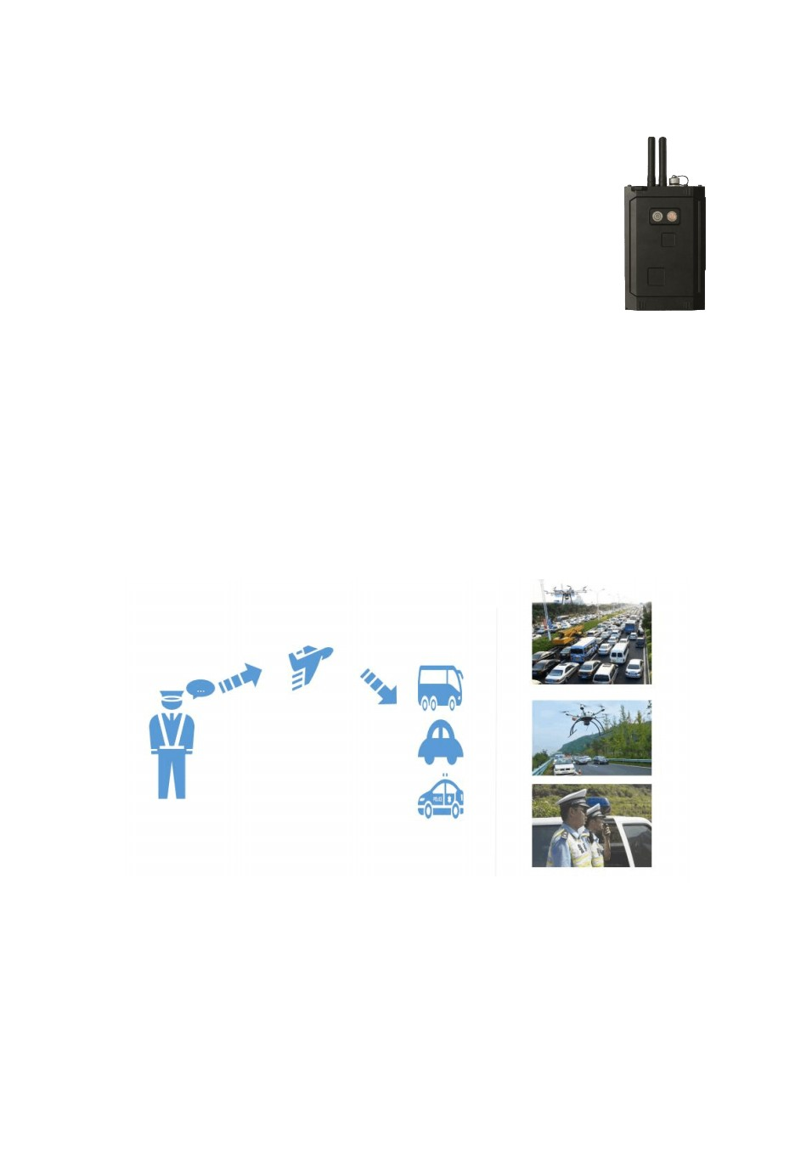Dispatch And Control .
4G Image Transmission Equipment Performance:
1) 1 way HDMI video input
twenty one road AHD video input ( compatible CVBS)
3) Video encoding H265/264 Main Profile , supports up to 1080P transmission and storage
4) Audio supports AAC encoding, up to 32K Sampling Rate
5) Local storage, supports 2 TF card storage , single card supports128GB
6) The front end and the center can have two-way voice intercom
7) 4G LTE four-card binding, dual-card binding, single-card transmission
8) Picture capture, JPEG format, supports up to 2 million pixel images
9) GNSS Beidou /GPS positioning
10) Large-capacity lithium battery supports long battery life of the device

3.3.3 Wireless Propaganda System

When there is a traffic jam on the highway and the on-duty personnel are unable to go to the scene to conduct traffic diversion and accident handling in person, the wireless broadcasting system on the drone can be used to conduct remote traffic diversion and accident handling work, improving traffic congestion and accident handling capabilities.
The personnel on duty perform voice input through a handheld wireless voice transmitter. The wireless voice receiver mounted on the drone can receive the voice information sent by the personnel on duty and combine it with the video information. duty officer

Officers can experience on-duty and handling traffic jams and accidents as if they were on site.
Wireless Shouting System Performance:

1) Supports single-send single-receive and single-send multiple-receive application modes.
2) The speaker weighs 500g , has an integrated design, simple structure and is easy to install.
3) Internal magnetic horn effectively avoids interfering with the aircraft’s geomagnetic field.
4) Using digital speech algorithm, the sound clarity is high and the noise of analog speech is eliminated.
5) Support real-time shouting and SD Memory card voice broadcast, flexible switching at any time.
6) The sound quality of the shouting is clear and loud, the police tone has a deep bass and strong penetration, 100 measured at 80 decibels from a distance of one meter.
7) Effective sound transmission distance is 1 km.
8) Anti-howling design, there is no whistle from the loudspeaker meters away.
9) The speaker is small in size and light in weight, and has low air resistance when flying on the aircraft.
10) The transmitting and receiving transmission distance can reach up to 10 Kilometers, distance changes do not affect sound intensity and quality.
11) Use in noisy environments does not affect the clarity of the voice and is more suitable for complex on-site command environments.

3.3.4 Dispatch Command Center Platform

The drone video surveillance protocol is in accordance with the national standard for video surveillance (GB/T 28181-2011) to ensure that drone videos are seamlessly connected to standard video surveillance platforms. It supplements the shortcomings of traditional video surveillance cameras, brings a new perspective to highway traffic management, and improves the response speed to emergencies.
The central video platform is connected to the UAV system, which has good functional expansion characteristics for the UAV system. The specific features are as follows:
It has good scalability, can easily add monitoring points and alarm functions, has strong traceability, and has strong centralized storage and monitoring capabilities for the information returned by the drone. Through the network, it can simultaneously monitor the comprehensive command of drone signals in different regions. High ability, Through the analysis and judgment of the overall situation at the center, the traffic situation can be controlled as a whole .

3.4 High-Speed Industry Functional Applications

3.4.1 Daily Traffic Monitoring

Large fixed-wing UAVs have the characteristics of high speed, long range, It has many advantages such as high flying height, and this kind of drone can usually be equipped with a high-definition digital camera, which can clearly shoot and video the real-time situation on the ground. It is very suitable for daily patrols and road condition collection tasks in the air. If the fixed-wing drone is operated in cruise mode, it will automatically travel to and from the planned road section without manual intervention every day. In this way, the drone is like a flying dry eye, Send a steady stream of video information to the road command center through the mobile Internet. The road command center can intuitively and quickly monitor the traffic conditions and weather conditions of the road. Have a clear understanding of the traffic conditions, and can publish the real-time traffic conditions to the information platform, so that drivers and passengers on the road and people about to travel can obtain the latest and most accurate road conditions information. Choose your travel route and time independently to lay a solid foundation for safe and convenient travel.

3.4.2 Traffic Control

When there is an accident on the highway, escape, When illegal behaviors such as card breaking and other bad behaviors occur, drones equipped with video transmission systems and global positioning systems can track and locate the vehicles involved in the accident over long distances and guide law enforcement officers to intercept and deal with them. While contributing to the fight against road crimes, it also avoids the danger caused by law enforcement vehicles directly intercepting and chasing vehicles on the highway, and improves the personal safety of road law enforcement personnel.

3.4.3 Emergency Response

1) On-site monitoring and command
When traffic jams, accidents or even fires occur on the highway, As well as other geographical and meteorological factors that seriously affect traffic operation safety, how to allow decision-makers to understand the on-site situation faster and more intuitively has always been a problem. Because fixed cameras have limited coverage and cannot meet the needs of full video coverage, Road administration and traffic police vehicles and personnel carrying vehicle-mounted or individual surveillance systems may also be isolated far away from the scene by the long traffic flow. A quick-response video transmission, especially an on-site command platform, is particularly important.
In developed countries in Europe and the United States, this kind of rapid response integration is generally carried out by helicopters. However, due to many factors such as the high price of helicopters and high operation and maintenance costs. As a result, it is not suitable for China's current national conditions. this situation
This is where drones that are cheap and relatively easy to maintain come in handy.
The speed of fixed-wing drones is much higher than that of ordinary vehicles. And its movement is not restricted or interfered by terrain. You can fly directly to the location of the incident, Rush to the scene as soon as possible and transmit the video of the scene from the air to the road command and dispatch center. Drones can provide a bird's-eye view of the live traffic flow on the ground, which will help the road management department grasp the overall situation, provide overall command and correct guidance, and contribute to solving problems such as road congestion.
After an emergency occurs, Rotor drones can be equipped with different mission modules such as megaphones, sirens, and traffic control lights. Road law enforcement personnel can arrive at the scene faster before the road law enforcement officers arrive. Traffic managers performing dispatching and command tasks can directly direct and clear on-site traffic through the traffic control equipment carried by the rotor drone.
2) Assist in rescue
When a traffic accident occurs on a highway, large-scale traffic jams may follow. In particular, many times when rescuers arrive at the scene, they find that some of the urgently needed equipment and medicine cannot arrive at the scene in time, and the injured cannot be transferred in time. and medical treatment. In this critical moment, every minute is extremely precious. The addition of drones solves these problems. Rotary-wing drones can avoid congested traffic and crowds, and can land directly to the scene to deliver urgently needed supplies and equipment.
In view of the above situation, Higher requirements have been placed on the current highway inspection and emergency command systems. In terms of long-distance monitoring, it must be able to flexibly supplement the previous wired video point monitoring to reduce monitoring blind spots and improve work efficiency; in terms of emergency incident handling, it must be able to provide front-end and back-end two-way communication services when roads are interrupted. , to realize the emergency command function.

3.3.4 Information Collection

In daily work, road administration personnel conduct inspections under bridges, in tunnels, It is very difficult to collect information on slopes and dangerous areas. It is not only time-consuming and labor-intensive, but also unsafe. Due to the lack of professional knowledge and equipment, the accuracy of the collected information is not high. Freezing in extremely severe weather, Heavy fog and heavy rain make road inspection work even more challenging. In all the above aspects, drones demonstrate strong security, accurate and convenient information collection, and high economical and cost-effectiveness.

3.3.5 Capturing Illegal Activities

Usually when investigating traffic violations, the traffic police often cannot be relatively concealed, but when drones come into play, the luck of many car owners is dashed. When investigating traffic violations, drones are usually released to 200~300
meters away, flying at an altitude of 20~30 meters, high-speed illegal activities can be comprehensively monitored.

3.5 Challenges Faced By Drones

The highway has a long driving distance and a large cruising range. The drone needs to be flexible and flexible to follow the vehicle or check the details of the accident congestion point. Only in this way can we effectively make up for the blind spots caused by poor ground camera positions. Therefore, we put forward higher requirements for the endurance and mission mounting of UAVs.

System Inventory

4.1 UAV Flight Control System

4.2 Wireless Propaganda System

4.3 4G Image Transmission System

4.4 Dispatch Command Center Platform

