Oil Pipeline Applications
Looking back at the period from 2010 to 2014, the "eight explosions in four years" that occurred at Dalian Petrochemical Company are still vivid in our minds. As many domestic oil and gas pipelines have been in operation for many years, the safety issues of oil and gas pipelines have become increasingly prominent. Therefore, regular inspections of potential safety hazards in oil and gas pipelines have been carried out. Investigations and inspections need to be carried out urgently.
With the rapid development of the national economy, the country's demand for energy is increasing. As the country's energy artery, the safety of oil and natural gas pipelines is particularly important. UAV systems use the power of modern science and technology to escort safety inspections, landform surveys, and enterprise equipment safety in the petroleum and petrochemical fields.
Traditional oil pipeline inspection work mainly involves two methods: regular inspections by security inspectors and irregular spot inspections by superior inspection departments. Both methods use manual contact, and have the following main disadvantages:

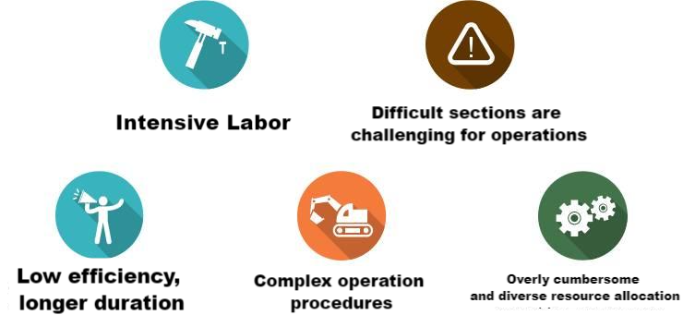

Drones can not only complete feasibility studies, initial designs, and construction drawings of long-distance pipelines and oil and gas fields, but can also carry out pipeline monitoring and maintenance work; they can save time-consuming and labor-intensive manual measurements and aerial surveys can be used to map maps. Fast speed, timely information feedback, improve work efficiency.

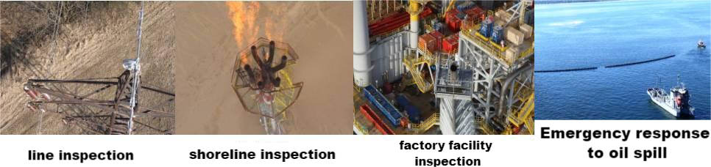
Drones used in pipeline operations have the characteristics of fast speed, high efficiency, and timely information feedback. The workflow during the test flight is as follows:

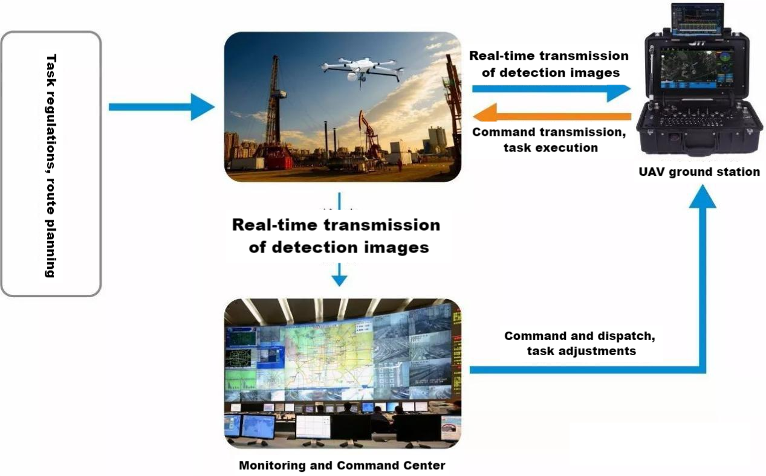

Line Selection
The use of drones during the line selection process can comprehensively and quickly understand the topography, vegetation, hydrology and other information of the area, thereby providing a basis for pipeline line selection. The drone can be equipped with a high-resolution aerial camera, and can also carry out surveying-level photography of the mission area by carrying an inclination mapper. After the aircraft lands, it can perform quick or detailed puzzles and provide regional ground and spatial data and basic geographical information in a timely manner. Provide guidance on route selection during the feasibility study stage of oil and gas pipelines.

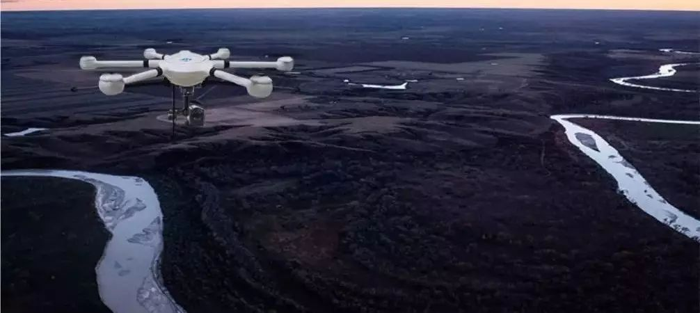
Keep Track Of Construction Progress
In the early stage of construction, drones can be used to understand the terrain, roads, surrounding environment, etc. of the construction site, so that construction personnel and equipment can enter the site and start construction as soon as possible; in the ongoing stage of construction, drones can be used to take pictures of the construction progress and material usage on site. , equipment layout, pipeline direction, etc., adjust personnel and equipment in a timely manner, and carry out construction according to design requirements.
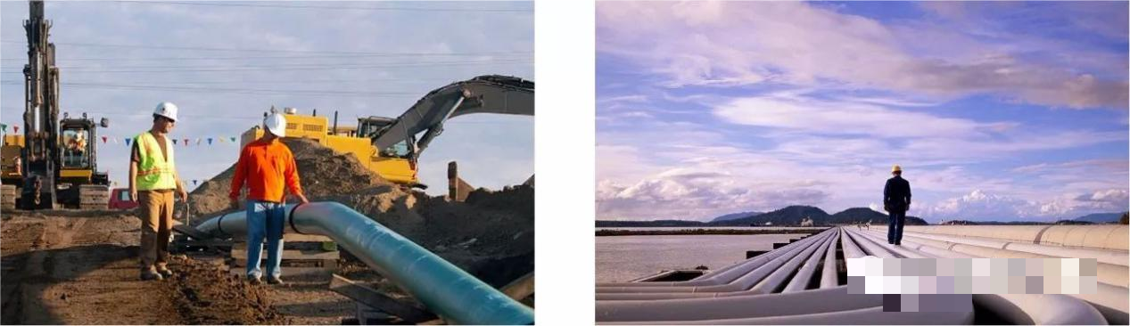

Emergency Repair
During pipeline emergency repair operations, remote sensing images captured by drones are used to assess the location and extent of damage to the damaged pipe section, monitor the site in real time, understand the specific circumstances of the accident, and formulate maintenance and repair plans to reduce the impact of the disaster. to the lowest.

Real Time Monitoring
The UAV can be equipped with visible light and infrared dual-light pods, has day and night monitoring capabilities, can conduct long-range real-time monitoring of target areas, and can perform fixed-point hovering monitoring over designated targets. After being equipped with a video tracking module, it can lock on designated targets on the ground for steady gaze and explore details, thereby discovering obvious signs that pipelines within the jurisdiction have been damaged and stolen.
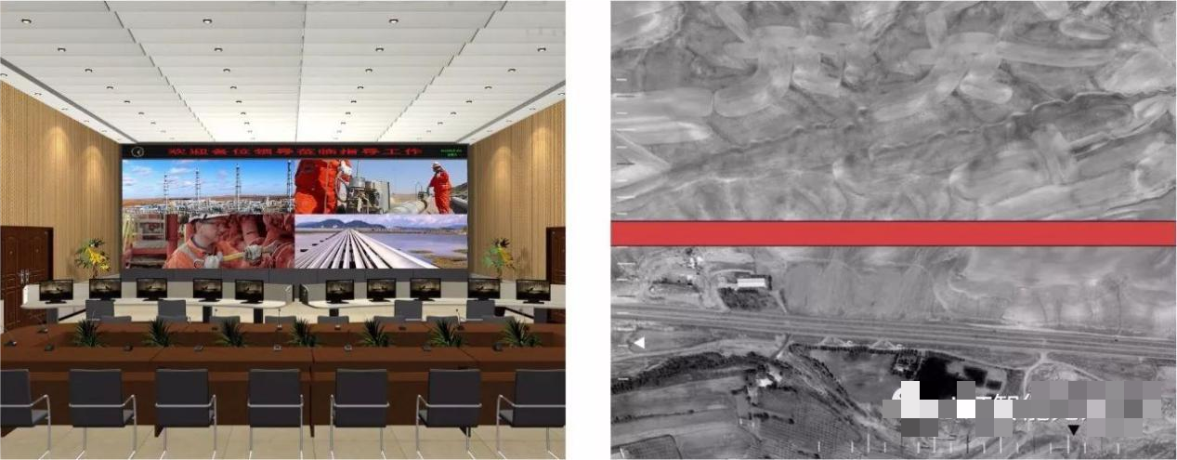

Offshore Oil Spill Monitoring

UAVs are equipped with high-definition zoom cameras or infrared thermal imaging cameras to conduct sea surface oil monitoring, regular and fixed-point air patrols, and comprehensively and intuitively monitor oil leaks, oil construction site working conditions, etc.

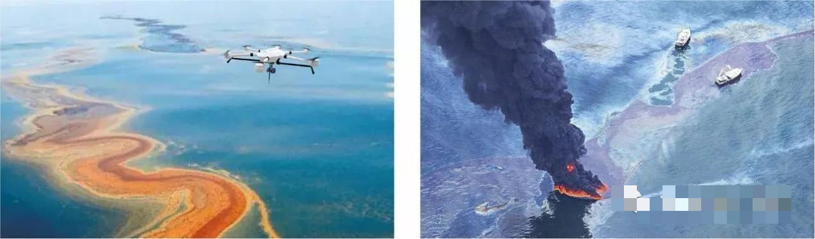

Oil And Gas Rig Inspection
The drone is equipped with a high-definition zoom camera or an infrared thermal imager, which can intuitively obtain the detailed status of each working rig. Infrared can not only detect oil leakage, but also work without obstacles at night. The drone can save more time and cost, and can greatly improve the safety of engineers.
