Foshan Yufei Technology Co., Ltd.

UAV Tilt Photogrammetry System

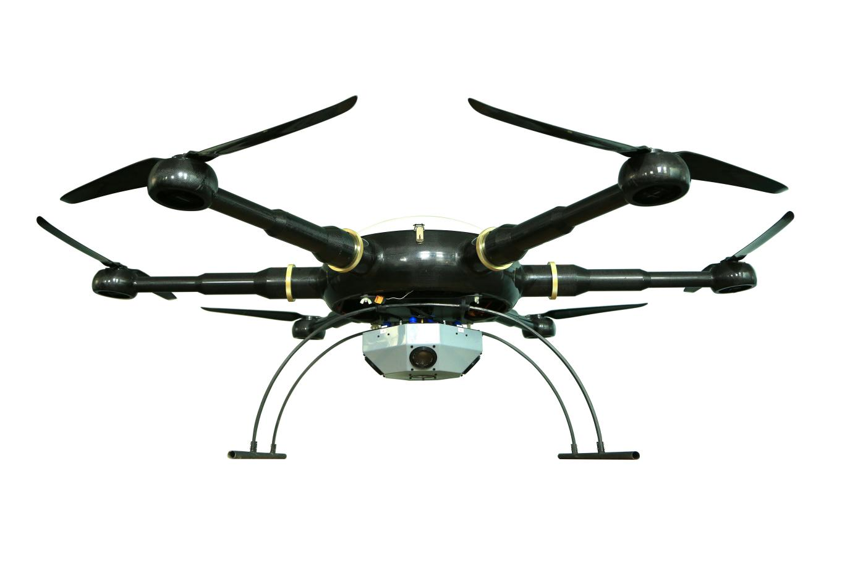

Table of Contents
1. UAV Platform 3
1.1 Introduction to UAV Platform 3
1.2 UAV Physical Indicators: 3
1.3 UAV Performance Indicators: 4
1.4 Product Delivery List 4
2. Tilt Photography Sensor Platform 7
2.1 Introduction to Tilt Photography Lens 7
2.2 Oblique photography lens parameters 8
3. Application Platform Function 8
3.1 Intelligent Ground Station 8
3.2 Intelligent Cloud Monitoring and Management System 9
- Applications and Cases 9
4.1 Case 1: Three-dimensional Display of Oil Storage Survey 9
4.2 Case 2: “Country Garden” Community Promotion Three-dimensional Display 9
4.3 Case 3: Three-dimensional Display of Playground Construction Planning 10
4.4 Case 4 Three-dimensional Display of Municipal Building Image Promotion 10
5. After-sales Service 11
4.1 Drone Training ( Foshan ) 11
4.2 Transportation 13
4.3 Product After-sales Service 13
1. Drone Platform

1.1 Introduction to UAV Platform
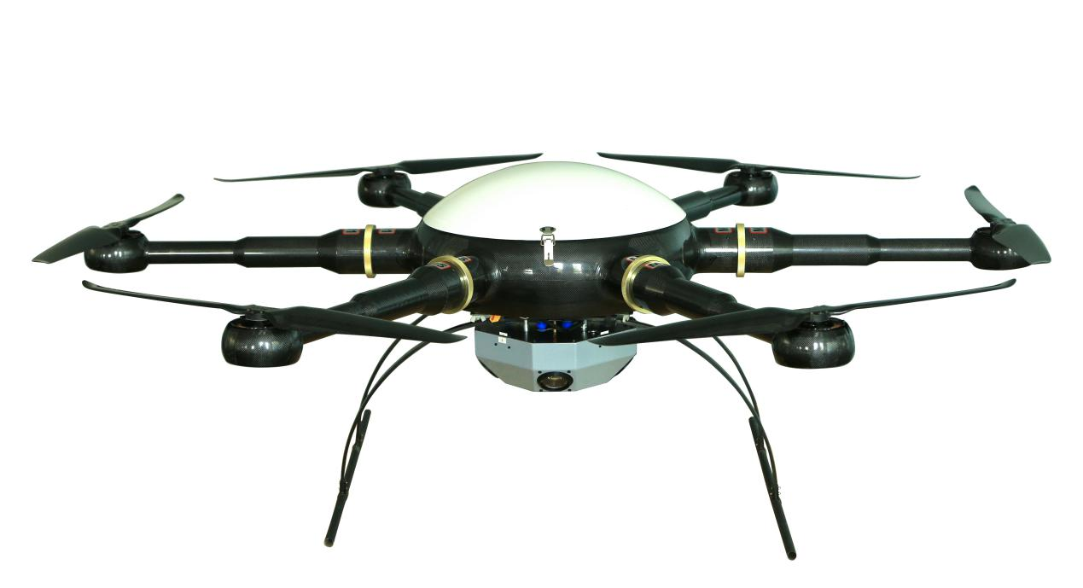The Yufei tilt photography drone is independently developed and produced by Foshan Yufei Technology Co., Ltd. It is equipped with a tilt photography sensor on the electric multi-rotor drone flight platform to perform small-range, high-resolution, and large-scale tilt aerial photography. The collected images can be used to automatically produce high-resolution, high-precision true three-dimensional models through modeling software.

1.2 Physical Indicators of UAV:
1. Body material: one-piece carbon fiber;
2. Motor: waterproof brushless motor;
3. Blade: 28.5-inch high-strength carbon fiber propeller;
4. Axis distance: 1600 mm;
5. Height: 600 mm;
6. Empty weight: <12kg (including standard power battery);
7. Maximum diameter: 2250 mm;
8. Battery pack: 6S1Px2x22000mAh
9. Storage box size: 750mmx650mmx420mm
10. Motor parameters: stator outer diameter 83mm, KV value KV135

1.3 UAV Performance Indicators:
1. Flight ceiling: 5000 m above sea level;
2. Control radius: 3-5 kilometers blocked by trees (up to 10 kilometers in open space);
3. Recommended operating height: ≤ 1000 m (relative to take-off point);
4. Maximum take-off weight: 18kg;
5. Battery life: >50min;
6. Power supply: military battery, total capacity 44000 mAh, voltage 22.2 V, equipped with 1 set of balancing charger;
7. Maximum horizontal flight speed: 15m/s
8. Climbing speed: 5 m/s;
9. Cruising speed: 8 m/s;
10. Hovering accuracy: ±30cm in vertical direction, ±20cm in horizontal direction;
11. Flight mode: autonomous flight, manual flight;
12. Minimum take-off and landing space: 16 m²;
13. Operating temperature: -20 ℃ ~ +60 ℃ ;
14. Environmental humidity: ≤95%;
15. Modular design: fully interchangeable;
16. Airborne POS: Airborne POS records fixed-point exposure attitude information;
17. Double star positioning: Beidou and GPS dual system positioning;
18. Waterproof level: The entire aircraft can prevent ≧ IP54 rainfall;

1.4 Product List
Serial number | Type | Name | Quantity |  |  |  | Unit |  |  |  | Remark
1 | Body | Six-axis multi-rotor | 1 |  |  |  | Set |  |  |  | YF-866
1.1 | Body list | Body X1; full carbon fiber + carbon plate inner frame
 |  | Upper cover X1; fiberglass,
 |  | Arm X6; full carbon fiber + quick lock ring aluminum parts
 |  | Load plate X1; with connectors for quick load change
 |  | Landing gear X1; full carbon fiber, high toughness and anti-collision
 |  | Motor rain cover X6; full carbon fiber
2 | Power system | ESC | 6 |  | Individual |  |  | Hobbywing high pressure version
 |  | Motor | 6 |  | Individual |  |  | Customization (logo can be customized)
 |  | Propeller | 6 |  | Branch |  |  | 28.5-inch full carbon fiber hollow propeller
3 | Power Battery | 6s1p22000 battery X2 | 2 |  | Group |  |  | Military battery
4 | Battery transport box | Battery transportation explosion-proof box | 1 |  | Set |  |  | Military green military industry
5 | Charger | All-in-one charger | 1 |  | Set |  |  | Customized anti-collision
5.1 | Charger list | Charger body X1
 |  | AC220 power cord X1
 |  | 6P balanced charging cable X2
 |  | Direct charging cable X2
 |  | Shock-absorbing packaging box X1
 |  | Charger manual X1
6 | Body control | Dual redundant safety flight control | 1 |  |  |  | Set
 |  | Digital radio (installed on the machine body) | 1 |  |  |  | Set |  |  | Bidirectional data transfer
7 | Ground station control | Ground station | 1 |  |  |  | Set |  |  | Customized military three-proof type
7.1 | Ground station list | Wandefu customized ground station X1
 |  | Digital radio station (two-way data reception) X1
 |  | COME cable X1
 |  | Ground station charging cable X1
 |  | RTK fixed column X1
 |  | RTK link cable X1
 |  | RTK modulex1
8 | Tripod | High-end tripod | 1 |  |  |  | Set |  |  | Place RTK module
9 | Remote control | Remote control 14SG | 1 |  |  |  | Set |  |  | American hand or Japanese hand
9.1 | Remote control list | 14SG transmitter X1 (installed on the body),
 |  | Receiver X1,
 |  | Charger X1,
 |  | Remote control supporting battery X1,
10 | Transportation | Aluminum alloy transport box for fuselage and other modules |  | 1 |  | Set |  |  | Custom made
 |  | Machine arm aluminum alloy transport box |  | 1 |  | Set |  |  | Custom made
11 | After-sales service | Warranty card |  | 1 |  | Open
 |  | Certificate |  | 1 |  | Open
12 | Tool | Screwdriver set tool |  | 1 |  | Set

2. Tilt Photography Sensor Platform

2.1 Introduction to Tilt Photography Lenses
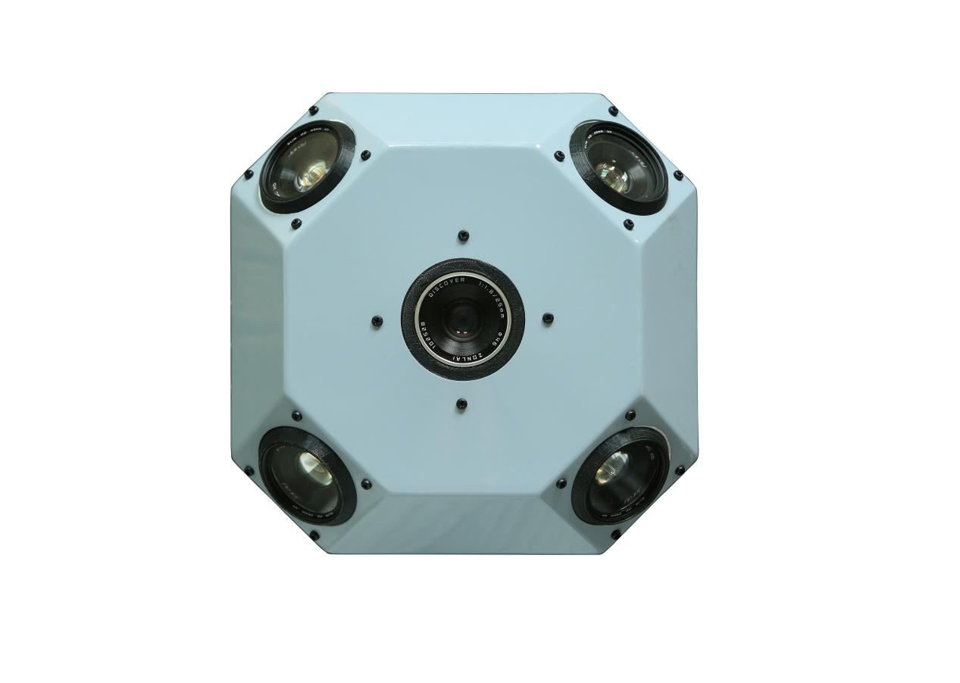
The Yufei oblique photography sensor integrates one vertical and four oblique cameras, and simultaneously collects images from different angles such as vertical and side view, realizing unified control, unified storage and unified power supply of multiple measurement-grade cameras, and one-click copying. All camera images are produced, the spatial relationship between cameras is strict and accurate, multiple waterproof and anti-fall protections, anti-strong electromagnetic interference, streamlined sealed fairing design can work normally in harsh operating environments.

2.2 Oblique Photography Lens Parameters
Sensor parameters | Quantity | CCD quantity 5
 | Power on and off status | 5 CCDs switch on and off at the same time
Electrical parameters | Power supply | Flight controller power supply/built-in battery
 | How to take pictures | Flight control shutter
Camera parameters | Effective Pixels | 120 million
 | Sensor size | 23.5mmx15.6mm
 | Pixel size | 4.525um
 | Image Resolution | 4000x6000
 | Slope | 45 Degree
 | Storage | 320G
 | Exposure method | Flight control trigger exposure
 | Lens focal length | 4x35mm; 1x24mm
Working environment | Operating temperature | -20 ℃ ~60 ℃
 | Working humidity | 95%
 | Protection level | IP45
Physical dimension | Size | 260mm*260mm*120mm
 | Gross weight | 2500g

3. Application Platform Functions

3.1 Intelligent Ground Station
One-click takeoff and landing function, intelligent route planning, camera control and automatic operation, mission configuration and instruction reference, flight status tracking, and flight log output

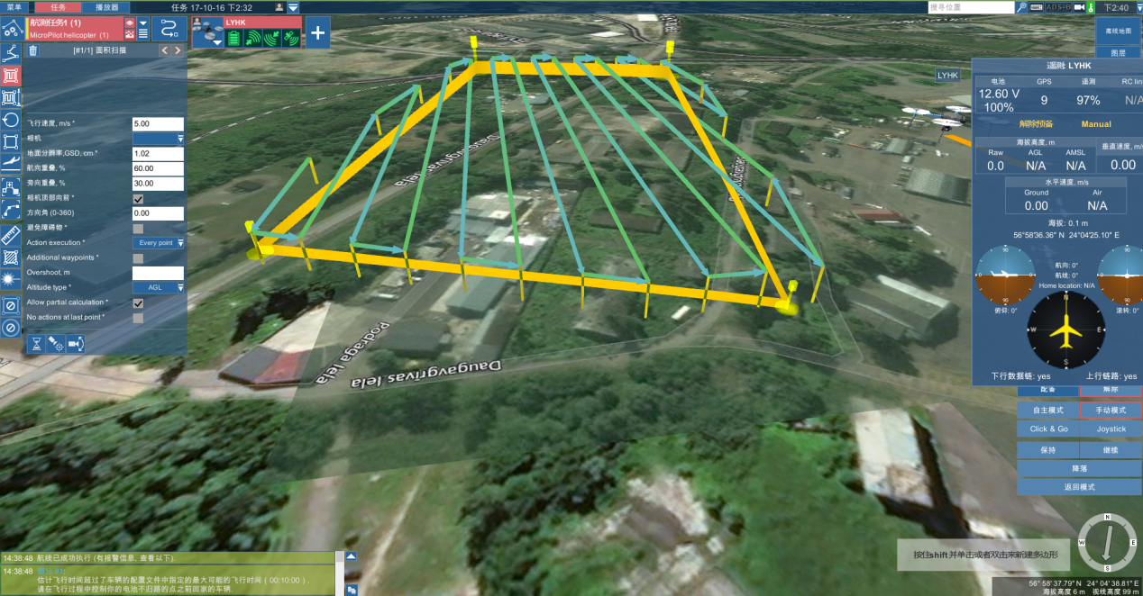

3.2 Intelligent Cloud Monitoring and Management System
Monitor the aircraft's flight status and location information without distance restrictions, and use powerful cloud computing capabilities to calculate aircraft abnormality warnings.

4. Cases and Applications
The oblique photography system of Yufei UAV has been tested in practical applications under various environmental requirements such as urban construction, fire protection and plant protection, and high-risk facilities, and has received unanimous praise from customers.

4.1 Case 1: Three-dimensional display of oil storage survey
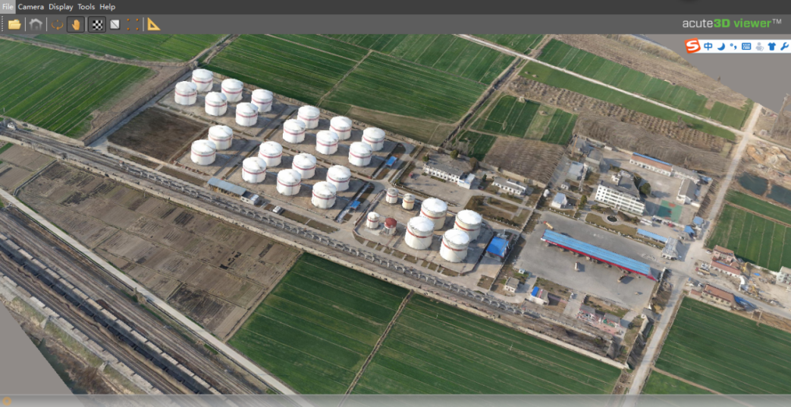
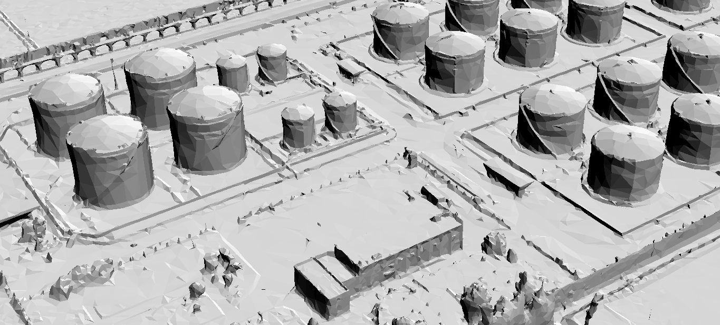
4.2 Case 2: “Country Garden” community promotion three-dimensional display
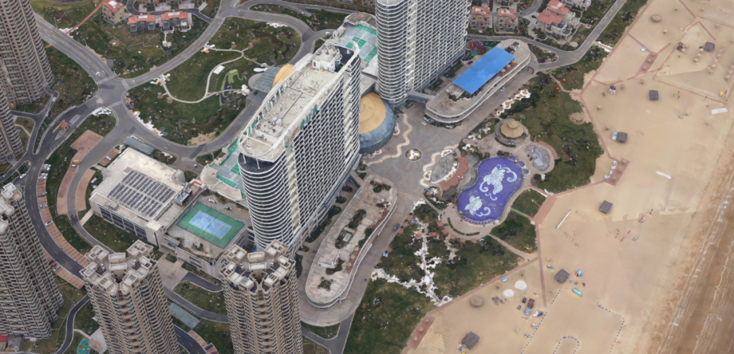
4.3 Case 3: Three-dimensional display of playground construction planning
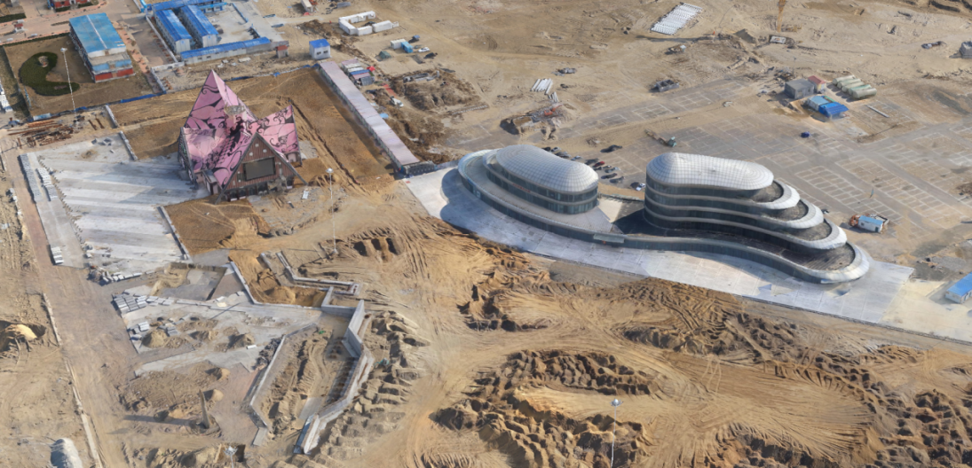
4.4 Case 4 Three-dimensional display of municipal building image promotion
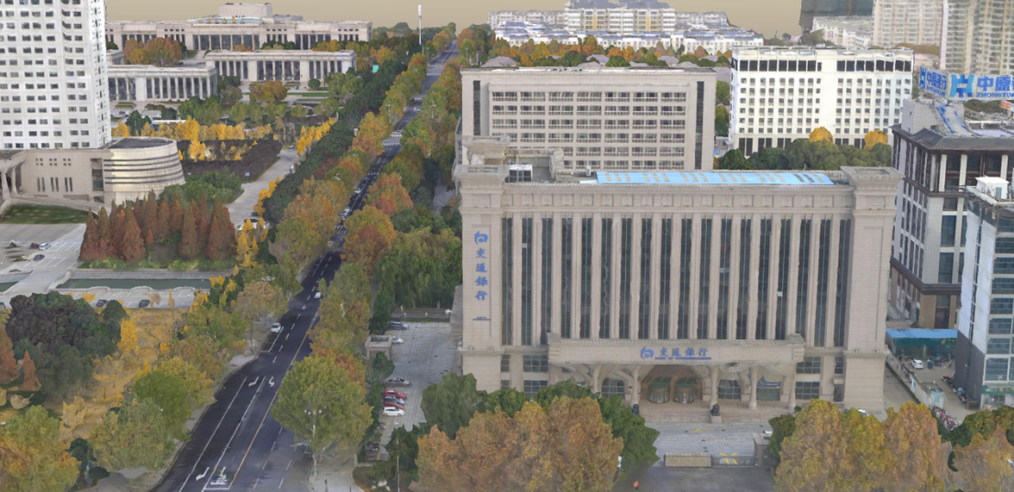

5. After-sales Service

5.1 Drone Training (Foshan)
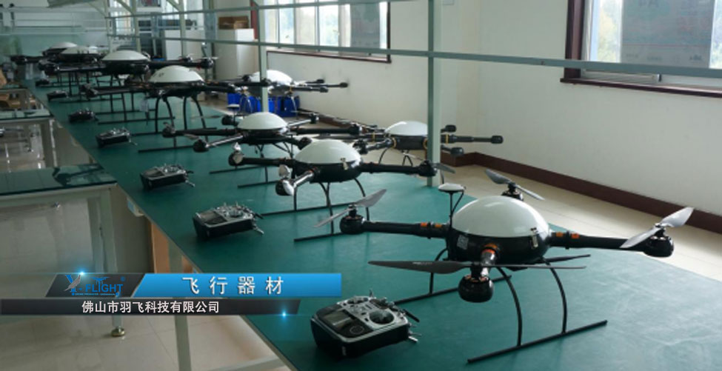
1. Basic theoretical training on UAV - including introduction to UAV systems, UAV flight control systems, avionics systems, mission and trajectory planning, navigation systems, system operation management, etc.;
2. UAV simulation training - based on the type and model of the aircraft purchased by the user, targeted computer simulation flight training of the aircraft, etc.;
3. UAV daily maintenance knowledge training - including UAV assembly, repair, maintenance and upkeep, UAV ground operation station use, UAV take-off, landing and flight operations, etc.;
4. UAV practical training - based on the type and model of the aircraft purchased by the user, targeted practical operation training of the aircraft, which also includes practical operation training of the ground station, daily maintenance and inspection training before and after take-off, and take-off Landing operation training, etc.
Special UAV training enables students to master UAV control, installation and maintenance skills. (2-3 people, 1-2 weeks of special drone training)
5. In-house training on automatic three-dimensional modeling of data - computer automatic modeling system training.

5.2 Transportation
All equipment delivered should be packed according to standard protective measures for packaging and transportation. Such packaging should adapt to the long-distance transportation, moisture-proof, shock-proof, rust-proof and other requirements required by the specific nature of the equipment to ensure that the equipment is transported safely. Arrive at the delivery location. Party A is fully responsible for the property and quality risks during delivery and transportation.

5.3 Product After-sales Service
The free warranty period is one year, and the warranty period starts from the date of delivery of all goods.
1. During the warranty period, regular remote network and telephone technical support and usage training will be provided free of charge, and related expenses such as repairs and replacements caused by product quality problems will be borne for free. During the warranty period, we are only responsible for the delivery, maintenance and quality assurance of the goods within the territory of the People's Republic of China.
2. If there is a quality problem with the equipment during the warranty period, an emergency response will be made within 2 hours after receiving the repair failure notification. If the fault cannot be eliminated, the customer will send the faulty product back to the manufacturer for free repair. After the equipment repair is completed, the customer will Spare parts are returned to the manufacturer, and all costs incurred will be borne by the manufacturer. The spare parts provided by the manufacturer shall still comply with the quality standards agreed in this contract.
3. For product failures caused by non-quality problems (such as improper operation or human damage, etc.), the supplier provides paid maintenance testing and technical support services.

