New Technology Solutions For Ultra-Long-Distance Control And Wireless Charging

In recent years, the drone industry has developed rapidly and played an important role in transportation, agricultural plant protection, emergency rescue and disaster relief, industrial production, media and entertainment and other fields. With the widespread use of drones, the original point-to-point communication method between drones and remote controllers can no longer meet the demand. Networked drones through mobile networks will definitely become a development trend.
The newly developed drone has two innovative functions: 4.5G beyond visual range drone control and variable-magnification monitoring image transmission. It can perform beyond visual range control through 4.5G signals, and can also transmit thermal imaging video in real time through image transmission. When the battery is low, the drone can also complete wireless charging tasks through ground charging stations, which solves the problems of drone operation relying on remote controls, limited image transmission, and inconvenient battery carrying, which greatly expands the application scope of drones. .

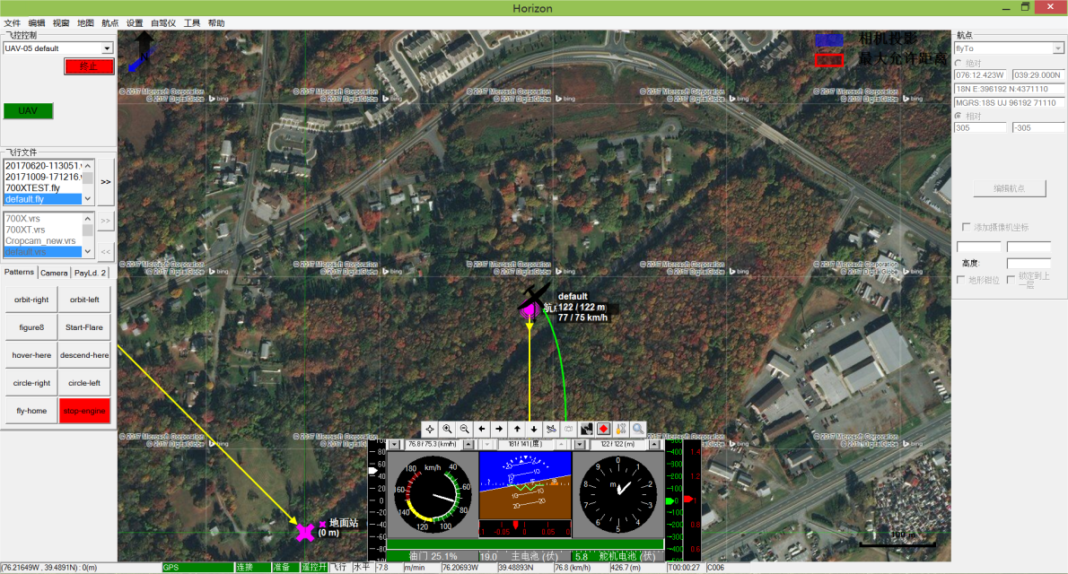

Drone Remote Unlocking
At the scene, a tablet computer is used to issue mission instructions to the drone far away in Nanjing. The signal is transmitted through the 4.5G network and transmitted to the drone flight management module in real time. The drone will complete unlocking, flight route and scheduled operation execution according to the instructions. The entire task does not require remote control.

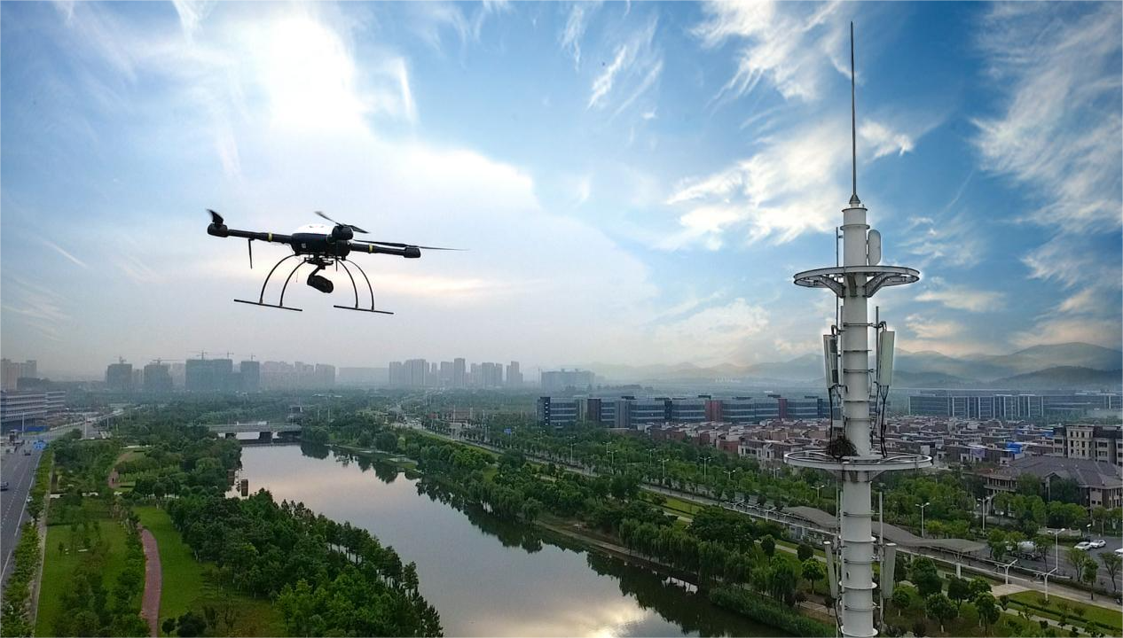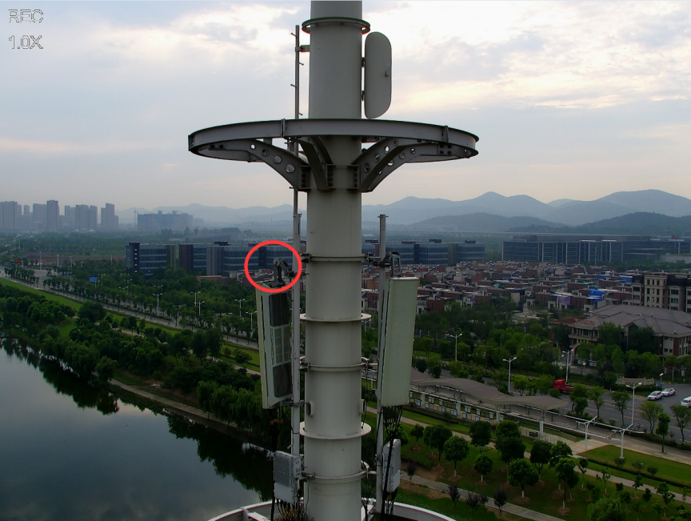
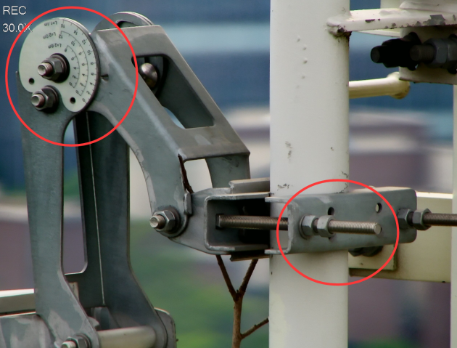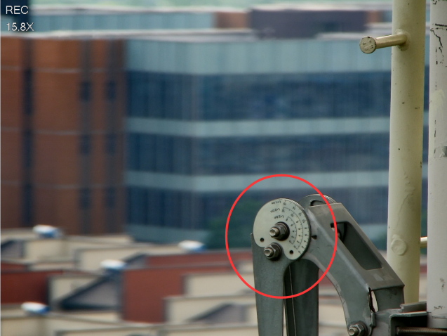

High-Altitude Working Site Video Is Transmitted To The Shandong Site In Real Time
The video captured by the high-zoom camera carried by the drone as well as the drone's power, flight distance, flight speed, flight altitude and other data can also be transmitted back to the Shandong site in real time via 4.5G , allowing the operator to supervise Line-of-sight and real-time understanding of drone operations. When the drone's power is low, an alarm will be sent to the operator through the APP. The operator can choose to land the aircraft or go to recharge.
After receiving the instruction to charge, the drone first records the location of the operation interruption point, then searches for the nearest charging vehicle through the cloud system , completes its independent route setting, and finally reaches the charging vehicle .
With the accurate landing of the drone, the charging contact of the drone's tripod comes into contact with the charging metal surface of the ground charging vehicle to close the circuit.

Then the charging car automatically returns to the nearby charging room according to the track . After arriving at the parking position of the charging room , it is charged by the positive and negative contacts on the charging car and the charging contacts on the wall. At this time, the remote operator can understand the drone's charging rate and actual power level in real time through the APP. After completing charging, a task can be sent to the aircraft. The charging vehicle will go out to a fixed location along the guide rail, and the drone will take off again and continue operations from the original interrupted operation location.
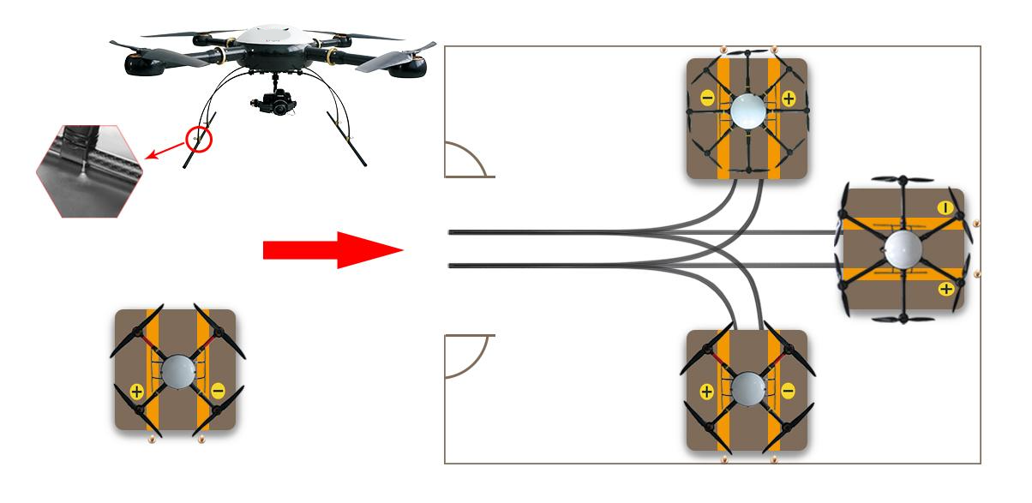

Drone Wireless Charging
At present, combined with 4.5G ultra-long-distance control technology and automatic charging technology , new drones can achieve ultra-long-distance control and precise control. In the future, in the fields of transportation, logistics, security, plant protection and other fields, the application of drones will gradually expand, and eventually build a true "connected sky".

