Foshan Yufei Technology Co., Ltd. Security Drone Application Solution

1 Industry Overview
1.1 Industry background
With the advantages of low cost, easy maneuverability, high flexibility and stability, drones can complete tasks such as aerial surveillance, daily patrols, search and tracking, etc., and have been favored by police departments. Public security officers and armed police use drones to respond to unexpected social incidents, traffic police departments use drones to manage traffic, and special police departments use drones to conduct aerial reconnaissance and arrest criminals. In short, police drones will assist various police departments to play a more important role in the field of public safety in the future.
1.2 Industry Applications
The application of drones in the police industry is mainly divided into community police fields, public security criminal police fields, anti-terrorism emergency response fields , etc. For the field of community police, drones can carry out routine inspections in public areas, monitor large gatherings, monitor crowd disturbances, and respond to emergencies such as media failures. The drones fly over the target area to carry out all-round and uninterrupted surveillance of the target area. Monitoring provides prerequisites for public security officers to fully control the situation. The police can also make corresponding decisions based on the evidence collected by drones, which not only saves police force, but also helps the public security department to grasp the real-time situation of relevant areas in a timely manner. For the field of public security and criminal police, drones can play a major role in certain target areas or certain target areas where personnel cannot be dispatched for some reason. They can be used for aerial reconnaissance, fixed-point monitoring, and target tracking. The time is greatly shortened and the detection of criminal cases is helped in a more timely manner.
2 Application Solutions
2.1 Y-flight Drone
Y-flight UAV relies on the country's top UAV expert team and superb technical support to launch a multi-rotor police UAV. This series of UAVs are aerial platforms with excellent performance. They adopt intelligent systems and have functions such as automatic takeoff, mission planning, route flight, fixed-point reconnaissance, regional reconnaissance, and automatic landing. The mid- and low-altitude monitoring system has technical characteristics such as rapid maneuverability, low cost of use, and simple maintenance operations. It also has the ability to quickly and real-time patrol and monitor the ground. It is a new type of mid- and low-altitude real-time transmission and infrared imaging rapid acquisition system. It is widely used in various areas of our country. It has its unique advantages in terms of difficult detection caused by various urban environments and various complex geographical environments.
2.2 Scheme Design Specifications
Standards and laws and regulations for system implementation
serial number | standard | name
1 | GB 4208 | Enclosure protection level (IP code)
2 | GB/T 15498-2003 | Enterprise standard system, management standard and work standard system
3 | GJB 2347 | General specifications for drones
4 | GJB 3060-1997 | General specifications for UAV electrical systems
5 | GJB 3065-1997 | General specification for carbon fiber unidirectional and fabric prepregs
6 | GJB 3728-1999 | UAV ground test requirements
7 | GJB 5434-2005 | General requirements for flight testing of unmanned aerial vehicle systems
8 | GJB 5435-2005 | UAV Strength and Stiffness Specifications
9 | GJB 5433 | General requirements for unmanned aerial vehicle systems
10 | GJB/Z105 | Electronic Products Anti-Static Discharge Control Manual
11 | HB 5662 | Aircraft equipment electromagnetic compatibility requirements and test methods
12 | HB 6434 | Basic requirements for interface design of airborne electronic equipment
13 | QJ 2245 | Anti-static requirements for electronic instruments and equipment

2.3 Plan Design Basis
1) People-oriented, humanized design, with customer service as the purpose, improve the work efficiency of the security department and reduce the difficulty of operation.
2) The ground station uses a high-brightness screen, which is suitable for field operations, and has multiple functions for easy use by operators.
3) The police can be dispatched quickly, image data can be quickly obtained in a short time, transmitted back in real time, and decisions made in real time. The captured data can also be brought back for analysis, so that there are no blind spots during the inspection.
4) It can be equipped with a variety of payload modules. According to different operating environments, it can be equipped with different equipment. At the same time, it can be equipped with camera equipment and a publicity system. It can conduct publicity and communication while monitoring targets, and solve practical problems more effectively.
5) The overall solution has low usage and maintenance costs, high efficiency, convenient transportation and easy to master.
2.4 Scheme Implementation Principle
The system application plan is based on the YF-866S UAV and is equipped with a stable visible light detector and infrared thermal imager payload (photoelectric pod), megaphone system, high-power light projection system, 30x zoom pan/tilt and other equipment. Replace and match to complete inspection and video recording according to different tasks and needs.

System inspection process: Y-flight UAV is equipped with mission equipment such as cameras, infrared thermal imaging cameras or wire damage detectors; the ground control station with autonomous navigation and positioning function allows ground staff to set flight parameters and control the aircraft to take off autonomously along the route. Flying over the ups and downs of the road; the digital image transmission station transmits video footage during inspections in real time; ground inspectors judge the route conditions based on the real-time video, and determine and record the location based on GPS positioning. After completing a flight mission, the aircraft lands autonomously and is recovered.
The Y-flight security drone system meets the following requirements:
(1) Support the required monitoring frequency.
(2) Have a certain battery life and support the required monitoring range;
(3) Able to adapt to special meteorological and terrain environments in complex environmental operations;
(4) Real-time transmission capability of monitoring information;
(5) The equipment is modular and can be quickly switched to meet the inspection needs of different operations;
(6) Ease of training and operation, and adaptability to take-off and landing environments;

2.5 Solution Equipment Composition
Y-flight security drone is composed of Y-flight drone flight platform, automatic flight control system, measurement and control communication equipment, mission load equipment and ground station control system. The UAV flight platform is responsible for completing the flight mission; the automatic flight control system is responsible for the autonomous flight control of the aircraft; the measurement and control communication equipment is responsible for two-way data communication between the aircraft and the ground and the transmission of aerial photography and mapping data; the mission load is mainly photoelectric pod equipment, supporting Visible light and infrared camera functions; the ground station is responsible for aircraft route planning, real-time adjustment of flight attitude and other tasks, and control of the rotation angle of the photoelectric pod.

2.5.1 UAV Flight Platform
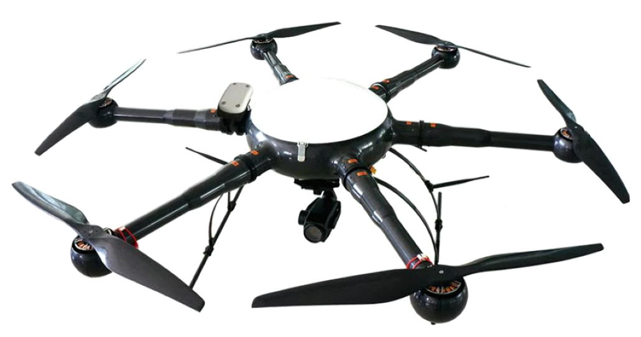
The Y-flight power inspection drone flying platform uses the YF-866S six-rotor industrial drone, which is made of carbon fiber composite materials. It has a modular structure and can be assembled in 5 minutes. Transportation and assembly are very convenient. YF -866S UAV is easy to operate and has strong industry applicability. It has the characteristics of longest flight time and stable flight at the same level, making the operation more convenient and reliable.
1) Structural Features
The new all-carbon fiber integrated machine technology has a stronger structure and lighter weight. The load capacity and flight time are guaranteed .
The entire machine adopts a modular design, and the arms, upper cover, fuselage, landing gear, load and other parts that need to be assembled can be quickly disassembled and assembled.
2) Working Environment
The working temperature ranges from minus 20 degrees to plus 60 degrees Celsius, ensuring normal operation in most places.
Wind resistance level: Level 6
It can work normally in places with high humidity and heat.
3) Technical parameters
Drone Physical Indicators:
1. Body material: one-piece carbon fiber;
2. Motor: waterproof brushless motor;
3. Blade: 24-inch high-strength carbon fiber propeller;
4. Axis distance: 1250 mm;
5. Height: 500 mm;
6. Empty weight: <5kg
7. Maximum diameter: 1820 mm;
8. Battery pack: 6S1Px2x16000mAh
9. Storage box size: 800mmx800mmx430mm
UAV Performance Indicators:
1. Flight ceiling: 5000 m above sea level;
2. Whether there is RTK: Yes
3. Working height: ≤ 5000 m;
4. Maximum take-off weight: 18kg;
5. Battery life: Battery life >50min;
6. Power supply: military battery, total capacity 32000 mAh , voltage 22.2 V, equipped with 1 set of balancing charger;
7. Waterproof level: ≧IP45
8. Maximum lifting speed: 5 m/s;
9. Cruising speed: 10 m/s;
10. Hovering accuracy: ±0.2m in vertical direction, ±1m in horizontal direction;
11. Flight mode: autonomous flight, manual flight;
12. Minimum take-off and landing space: 4m*4m
13. Operating temperature: -20 ℃ ~ +60 ℃;
14. Environmental humidity: ≤95%;
15. Modular design: fully interchangeable;
16. Airborne POS: Airborne POS records fixed-point exposure attitude information;
17. Double star positioning: Beidou and GPS dual system positioning;
2.5.2 Automatic Flight Control System
The automatic flight control system includes airborne flight control, ground station software, etc. It can stably control the Y-flight drone to fly unmanned in various environments. It is simple and convenient to use, has high control accuracy, and has strong GPS navigation automatic flight function. It can set the flight altitude, flight speed, etc., and has various task interfaces. , convenient for users to use various task equipment. It can complete autonomous takeoff and landing, route flight, etc. In addition, there are many safety protection solutions to ensure flight safety and failure protection to the greatest extent.
2.5.3 Ground Control Station System
The ground station system includes ground station notebook, ground digital transmission radio , serial port connection, and digital transmission antenna . The two-way data communication between the ground station software and the aircraft mainly has the following functions: setting flight control parameters , calibrating and setting sensor parameters, real-time adjustment of autonomous flight PID, monitoring and controlling flight status, graphically displaying flight data, controlling task loads, and playing back flight data. .
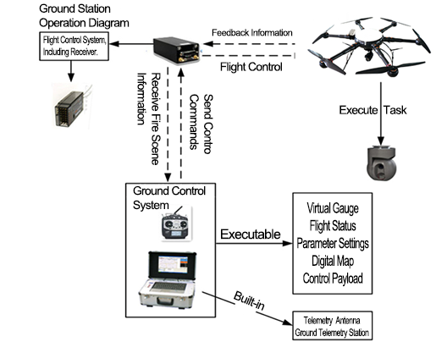
The ground station can mainly achieve the following functions:
1) Communicate with the autopilot. The ground station control software communicates with the autopilot and data link through the serial port using an agreed communication protocol.
2) Flight control, send flight navigation instructions to the autopilot, switch flight modes, change routes in real time, customize tasks, etc.
3) Moving map, map loading, coordinate calibration, display, dragging, zooming; real-time flight track display, waypoint display and editing.
4) Route planning: edit waypoints on the electronic map, upload them to the aircraft after editing, and then download the waypoints in the autopilot to the ground station, and compare them with the edited waypoints to avoid missing waypoints.
5) Virtual instruments. Virtual instruments intuitively display various important data such as the aircraft's attitude, altitude, heading, throttle, and voltage.
6) Aircraft status and sensor value display, displaying various flight status and sensor values numerically or graphically .
7) Parameter configuration to ensure flight safety and ensure the smooth progress of the mission.

2.5.4 Task Load Equipment
- YF_SG14X dual light pod
megapixel visible light movement with 14x zoom (3.5x optical*4x digital) , and a 640*480 resolution, 50Hz, 25mm lens uncooled thermal imaging movement. Dual-light three-axis gimbal camera with target tracking function .
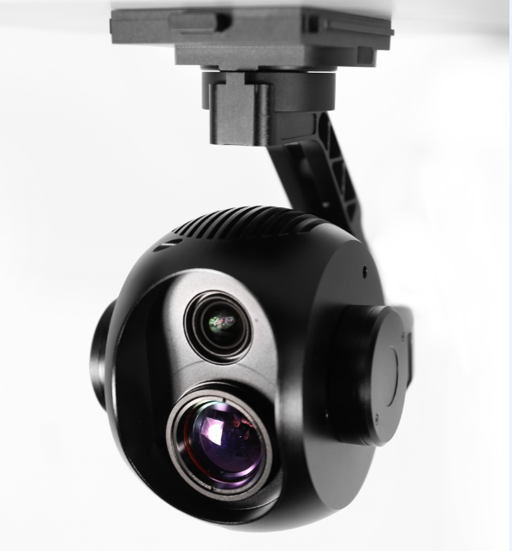
- Features
Easy to operate
Point to zoom, return to center with one click, and operate the pod with the mouse or touch screen, making it easier to get started and operate more accurately.
GPS information record: (needs to be paired with customized flight control or open protocol, user-developed)
Video: subtitle file record. Photos: Picture overlay, POS point information. Special functions, more practical.
Quick release
Patented design, convenient, reliable, tool-free quick disassembly, convenient for storage and replacement of other pod equipment.
High precision
± 0.008° control stabilization accuracy, industry-leading. The image is still stable even at the maximum focal length and during rapid flight movements.
High pixels
Visible light 12 million effective pixels, the picture is clearer.
zoom
Visible light: 14x zoom (3.5x optical*4x digital) makes it easier to see details.
Smart tracking
Intelligent target tracking makes tracking moving targets easier and more convenient.
Modular
The X30 series pods can be quickly switched without tools through the quick-release shock-absorbing structure . It is convenient to quickly replace other task equipment according to different usage scenarios. X30 pod (30x zoom, 5 million pixels ), X30T pod ( 35x zoom, intelligent tracking),
Highly expandable
, the pod series can be modularly replaced to adapt to different application scenarios. Standardized pod interface. There is also CAN bus expansion. Great room for expansion.
Open SDK
The ground station end is open, allowing users to integrate it into their own ground station software. Air unit: Data transmission and CAN bus interface are open for easy access to third-party flight control software . Share flight control data information, share data links, and remote control links.
- Technical Parameters
Overall parameters
product name | YF-SG14X dual-light zoom pod
Operating Voltage | 12V-25V
power | 8.4W
weight | 786g
Memory card type | Micro SD card (single card)
Dimensions (length, width and height) | 136*96*155mm
Interface Type | RJ45 (network port)
Control display mode | Windows system PC; Android phone , tablet (with flight control)
Real-time transmission resolution | Thermal imaging: 640*480 Visible light: 720P, 1080P
Environmental parameters
Operating temperature | -10°~45°
storage temperature | -20°~70°
PTZ parameters
Angle jitter | ±0.008°
Installation method | Removable
Controllable rotation range | Pitch: +70° to -90°; heading: ±160°
Structural design scope | Pitch: +75° to -100° Heading: ±175°; Roll: +90° to -50°
Maximum control speed | Pitch: 120º/s; heading 180º/s
Smart target tracking | support
Camera parameters
visible light
sensor | CMOS:1/2.3″; total pixels 13 million
lens | 3.5x optical zoom lens  F:3.85~13.4mm  Minimum shooting distance: 1m~3m (near focus~far focus)  Field of view (horizontal): 82~25°
Image storage format | JPEG
Video storage format | MP4
Operating mode | video; take pictures;
through fog | Electronic fogging + optical fogging (automatically turned on)
exposure mode | automatic exposure
resolution | 30fps;25fps(3840*2160)8 million  Maximum capture resolution: (4024*3036) 12.22 million
2D noise reduction | Support (automatically turned on)
3D noise reduction | Support (automatically turned on)
electronic shutter | 1/3~1/30000 seconds
exposure | automatic mode;
Information Video Overlay (OSD) | support
Point to zoom | support
Pointing zoom range | 1~3.5x optical 4x digital
Zoom to single image with one click | support
Thermal Imaging
Detector performance
Detector type | Uncooled infrared microbolometer
resolution | 640*480
Sensitivity | ≤60mk@300k
Frame rate | 50Hz
Optical properties
lens | 25mm fixed focus lens
F number | 1.0
- YF-30X zoom head
The YF-30X zoom product is a professional-grade optical zoom pod based on HDMI, which can be used in public security, fire protection, transportation, electricity and other fields. Full HD image quality lens, lossless optical zoom movement, high-altitude bird's-eye view without missing any details, flexible presentation of broad field of vision and vistas. It is equipped with a self-developed high-precision three-axis stabilizing gimbal to ensure high stability of the image during zooming and shooting, and to obtain the best shooting results. It outputs high-definition images in real time and supports on-board high-definition video and picture storage. Execute photography, video, zoom and other commands based on ground remote control.

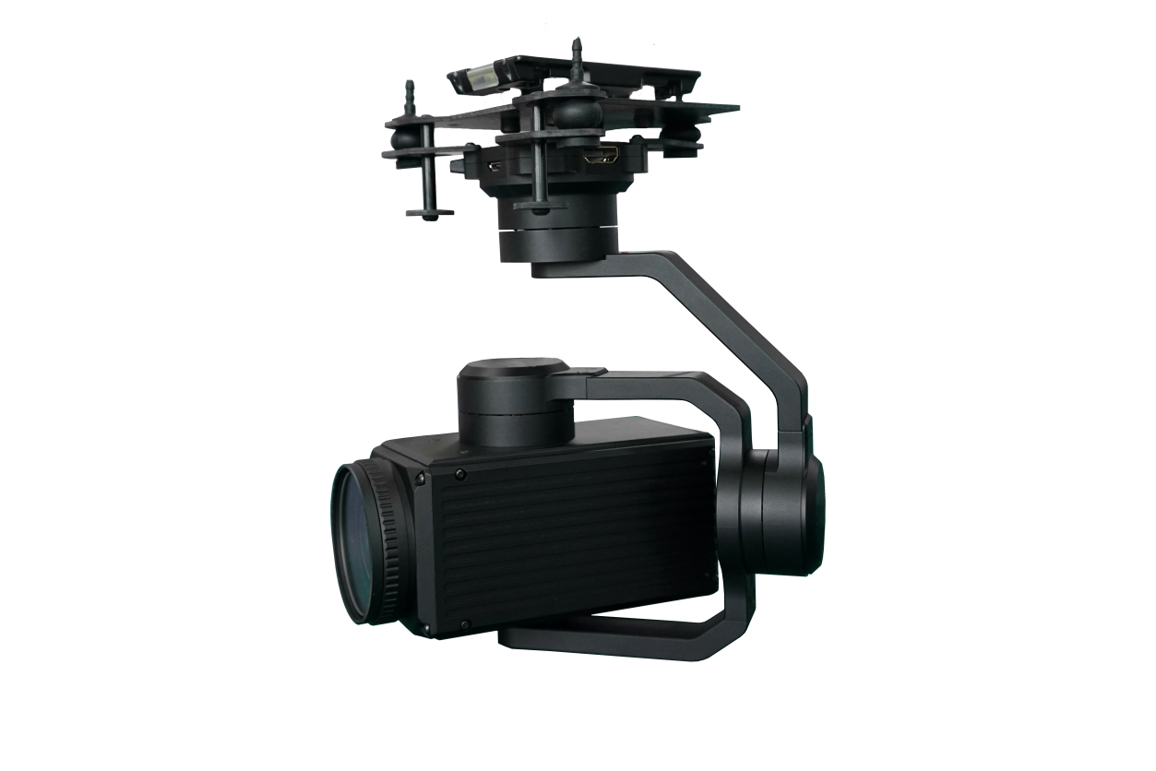
- Features
- 30x optical zoom movement, 5 million pixel high- definition resolution
- Support HDMI high-definition real-time output
- Three-axis stabilized gimbal , controllable accuracy ±0.01°, action range pitch ±90°, heading ±160°
- Multiple formats controllable (SBUS/PPM/open TTL serial port protocol)
- High-precision gimbal anti-shake technology, gimbal motor, structural center of gravity adjustment
- Shock absorbing technology
- Technical Parameters
Overall parameters
size | 115*166*174mm
weight | 780g
PTZ parameters
Angle jitter | 0.01〫
Installation method | Detachable
Controllable rotation range | Pitch: ±90〫, Pan: ±160〫
Structural design scope | Pitch: ±160〫, Pan: ±160〫, Roll: +70〫 to −250〫
Maximum control speed | Pitch: ±100〫/S, Pan: ±100〫/S
Camera parameters
sensor |  | 1/1.8"CMOS
 |  | Effective pixels: 5 million
 |  | Maximum resolution: 3096 (H) * 2080 (V)
lens |  | Equivalent focal length: 28.8~864mm
 |  | Aperture: F1.5~F4.3
 |  | Minimum shooting distance: 100mm~1500mm (near focus~far focus)
 |  | Field of view (horizontal): 61~2.3 (degrees)
resolution |  | HDMI output format supports 8 types, namely: 1080p/30fps, 1080p/25 fps, 1080i/60fps, 1080i/50fps, 720p/60fps, 720p/50fps, 1080p/60fps, 1080p/50fps
Signal-to-noise ratio (S/N) |  | ≥55dB(AGC Off, Weight ON)
Minimum illumination |  | Color: 0.05Lux/F1.5; black and white: 0.005Lux/F1.5
Anti-shake |  | Support electronic image stabilization
Environmental parameters
working environment |  | (−10℃~+60℃/20℅ to 80℅RH)
Storage environment |  | (−20℃~+70℃/20℅ to 95℅RH)
- YF-HHQ loudspeaker
Y-flight aviation megaphone is a wireless aerial loudspeaker and communication device specially developed for small drones. Especially suitable for micro-unmanned helicopters, multi-rotor and other flying platforms. Products can be widely used in public security, fire protection and other fields.
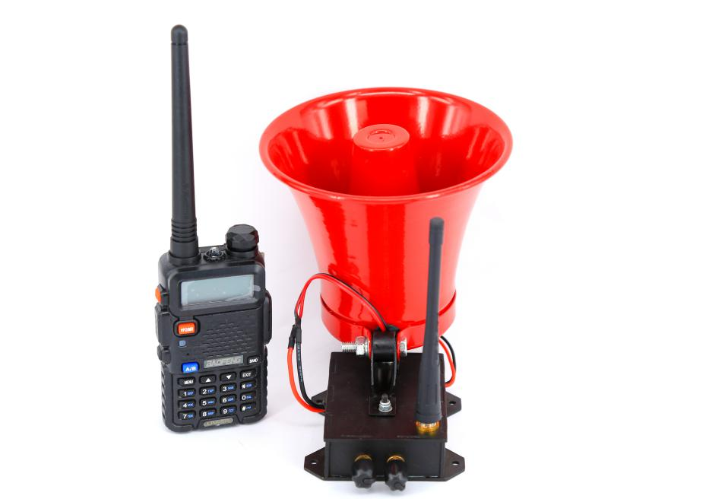

- Features
1. Small size and light weight, suitable for almost all industrial drones.
2. Far distance. The maximum transmission distance of 4km can meet the needs of most industrial applications.
3. Easy to use. The airborne terminal has its own mounting holes. It only needs to provide 12-24V power supply to work, without complicated configuration.
- Wide range of applications. In addition to being mounted on unmanned flying platforms, this product can be used on unmanned vehicles, unmanned ships, or other platforms and scenarios that require remote wireless amplification.
- Easy to upgrade. Users can replace the speakers with higher power according to actual usage (supports 8 ohm, 20-30w speakers) to adapt to different usage environments.
- Technical Parameters
name | index
Total weight of loudspeaker equipment | 595g
Amplifier size | 148*82*155mm
Operating Voltage | 12-25v
Speaker power/voltage | 20w/12v
Communication distance | 4km
Typical working height | 50-100m (relative to the ground)
working volume | When the flight altitude is 50m, the ground volume is about  60 decibels
maximum volume | 70 decibels
Operating temperature | -20~55°
environment humidity | 85%

2.6 Plan implementation process
2.6.1 Security inspection tasks
The system can perform at least three tasks: emergency inspection (quickly and accurately find target areas and targets), regular inspection (replace manual regular inspection, improve inspection efficiency, reduce inspection costs, and reduce the labor intensity of inspection personnel) ), annual line patrol (replacing manned aircraft to implement the annual planned aviation line patrol).
Three mission situations:
(1) UAVs for emergency and routine flights
Problem solving: Respond to emergencies and temporary tasks and other needs
First of all: UAVs can quickly respond to emergencies and are suitable for natural disaster warning patrol flights and accident emergency flights;
Secondly: through rapid inspection of large-scale flights, we can grasp the accident situation at the first time.
Finally: the degree of damage on the ground is understood through aerial photography and mapping, and the ground workstation immediately notifies the management office of dispatching police information based on real-time aerial photography monitoring data.
Advantages of emergency response: It improves the efficiency of the police team in handling emergency incidents, quickly and accurately assesses emergencies, and wins valuable and sufficient time to solve problems.
(2) UAV visible light inspection flight
Solve the problem: Carry out daily line inspection tasks regularly.
First: the drone conducts automatic flight inspections based on the GPS coordinate points programmed in advance for inspections.
Secondly: UAVs perform inspection and monitoring and synchronously transmit them to ground staff in real time.
Finally: After the drone completes the inspection mission, ground staff will judge the inspection results based on the inspection content information, and formulate corresponding solutions based on the specific situation.
Advantages of conventional visible light inspection: It is used for daily inspection tasks. Compared with traditional manual inspection on the ground, drone visible light inspection has the characteristics of high work efficiency, high accuracy and large working range.
(3) UAV equipped with infrared thermal imaging equipment for inspection flight
Solve the problem: night inspection lighting problem. The picture below shows the effect of infrared photography at night.
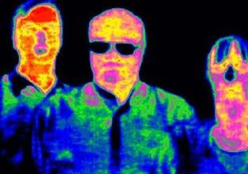
Illustration of infrared camera effects at night
UAVs are equipped with infrared thermal imaging equipment to inspect inspection lines. By comparing abnormal temperature changes, they can find highly concealed problem points. Combined with traditional visible light line patrols, thermal imaging line patrols will greatly improve the accuracy of problem point detection. accuracy. Advantages of emergency inspection: It improves the efficiency of the night inspection team in handling emergency incidents. The drone is equipped with infrared thermal imaging equipment to quickly and accurately conduct infrared inspections of suspicious points, gaining valuable and sufficient time to find suspicious persons and repair problems. .

