Foshan Yufei Technology Co., Ltd.
Environmental Monitoring Drone
Application Solution

1 Overview Of The Environmental Testing Industry
1.1 Industry Background
As China's air pollution situation has become more and more serious in recent years, especially haze (particulate matter PM2.5, PM10, etc.) accounts for an increasingly important proportion of pollutants, so the task of air pollution detection and control in China has also Getting heavier. In this regard, the state has also deployed or improved particulate matter and gas detection equipment in most cities, forming a densely distributed ground pollution source detection network with national control points combined with provincial air pollution points.
However, we can also clearly see that there is still a large gap between the predictions based on ground monitoring data at national control points and the actual development of environmental pollution conditions. In addition, the treatment methods implemented based on ground monitoring data, such as ground watering, construction Plans such as construction site covering, traffic restrictions, industrial production restrictions, boiler modifications, desulfurization and denitrification treatment, etc., have not been satisfactory.
As the third generation of remote sensing technology after aviation and aerospace remote sensing, UAV remote sensing technology has the advantages of three-dimensional monitoring, fast response speed, wide monitoring range, and small terrain interference. It is an ideal method for identification of pollution sources and concentration monitoring of atmospheric emergencies in the future. one of the important development directions.
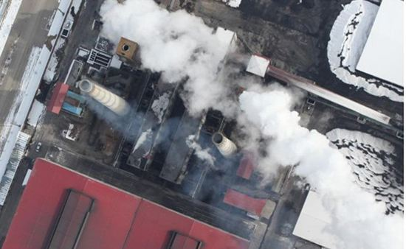

1.2 Industry Needs
The country has put forward the policy of paying equal attention to the prevention and control of environmental pollution and the protection of the ecological environment. To strengthen the protection of the ecological environment, we must monitor our country's ecological environment. This includes monitoring deserts, grasslands, forests, oceans, and agricultural ecological environments. It also requires remote sensing and telemetry of air pollution, water pollution (such as ocean redness, oil spill pollution) and pollution sources. It also requires the establishment of satellite ground receiving systems and satellite image analysis. Systematically analyze the current status and changing trends of environmental and ecological quality, and provide a scientific basis for decision-making for national environmental and ecological protection and construction.
In some remote areas, atmospheric environment testing often relies on people carrying testing equipment to obtain data in person, which will cause a lot of waste of human resources. However, using drones equipped with gas sensors can save a lot of manpower and resources. The drone can carry a wireless WiFi module to realize real-time data observation and recording of gas detection. In addition, the gas sensor system carried by drones can also be used as the best solution for pipeline gas leakage investigation, because drones carrying sensors are more convenient and efficient than people carrying sensors.
2 Application Solutions
2.1 Y-Flight Drone
Y-flight UAV relies on the country's top UAV expert team and superb technical support to launch a multi-rotor environmental monitoring UAV. This series of UAVs are aerial platforms with excellent performance. They adopt intelligent systems and have functions such as automatic takeoff, mission planning, route flight, fixed-point reconnaissance, regional reconnaissance, and automatic landing. The mid- and low-altitude monitoring system has technical features such as rapid maneuverability, low cost of use, and simple maintenance operations. It also has the ability to quickly and real-time patrol and monitor the ground. It is a new type of mid- and low-altitude real-time transmission and rapid acquisition system of atmospheric data. It is used in my country’s rapid Monitoring exhaust gas emissions has its unique advantages in difficult detection and other aspects.
2.2 Scheme Design Specifications
Standards And Laws And Regulations For System Implementation
Serial Number | Standard | Name
1 | GB 4208 | Enclosure Protection Level (IP Code)
2 | GB/T 15498-2003 | Enterprise Standard System, Management Standard And Work Standard System
3 | GJB 2347 | General Specifications For Drones
4 | GJB 3060-1997 | General Specifications For UAV Electrical Systems
5 | GJB 3065-1997 | General Specification For Carbon Fiber Unidirectional And Fabric Prepregs
6 | GJB 3728-1999 | UAV Ground Test Requirements
7 | GJB 5434-2005 | General Requirements For Flight Testing Of Unmanned Aerial Vehicle Systems
8 | GJB 5435-2005 | UAV Strength And Stiffness Specifications
9 | GJB 5433 | General Requirements For Unmanned Aerial Vehicle Systems
10 | GJB/Z105 | Electronic Products Anti-Static Discharge Control Manual
11 | HB 5662 | Aircraft Equipment Electromagnetic Compatibility Requirements And Test Methods
12 | HB 6434 | Basic Requirements For Interface Design Of Airborne Electronic Equipment
13 | QJ 2245 | Anti-Static Requirements For Electronic Instruments And Equipment

2.3 Plan Design Basis
1) People-oriented, humanized design, with customer service as the purpose, improve work efficiency and reduce operating difficulty.
2) Fully considering the working environment of the environmental industry, it adopts industrial-grade design. The whole machine is made of carbon fiber one-piece material. It can realize operation functions in medium light rain environment or level 5 wind environment.
3) The ground station uses a high-brightness screen, which is suitable for field operations, and has multiple functions for easy use by operators.
4) It can quickly perform tasks, quickly obtain image data in a short time, transmit it back in real time, and make real-time decisions. The captured data can also be brought back for analysis, so that there are no blind spots during the inspection.
5) A variety of gas parameters can be monitored. Such as PM2.5, PM10, NO2, SO2, CO, O3, VOC, etc.
6) The overall solution has low usage and maintenance costs, high efficiency, convenient transportation and easy to master. After one investment, the cost of each inspection is extremely low.
2.4 Scheme Implementation Principle
The system application plan is based on the YF -866S UAV and is equipped with an atmospheric monitor or a gyro-stabilized visible light detector, an infrared thermal imager, a water quality sampler and other loads to conduct real-time monitoring of the atmospheric environment, inspection and video recording. , photos, and evidence collection for subsequent analysis and processing.
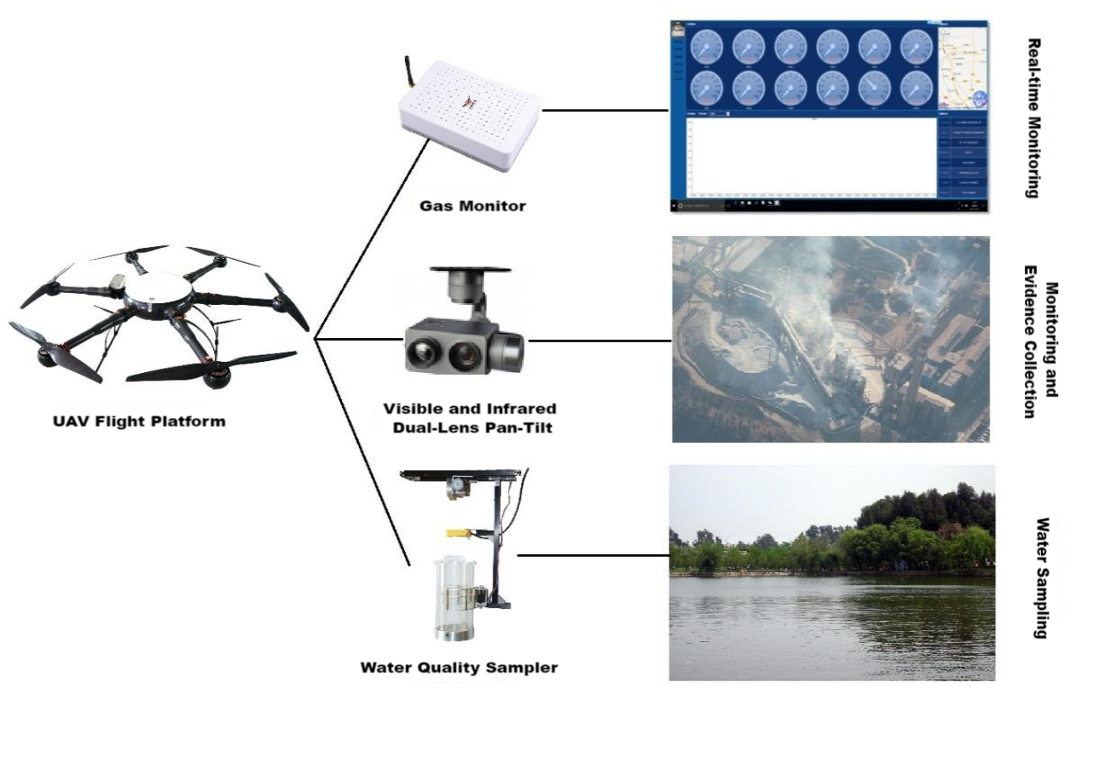
System working process: Y-flight UAV is equipped with mission equipment such as gas monitor, dual-light pod or water quality sampler; the ground control station with autonomous navigation and positioning function allows ground staff to set flight parameters and control the aircraft to take off autonomously along the route. The digital image transmission station transmits video recordings during inspections in real time; ground inspectors judge the route conditions based on the real-time video and determine the location based on GPS positioning and record it. After completing a flight mission, the aircraft lands autonomously and is recovered.
Y-flight environmental monitoring drone system meets the following requirements:
(1) Support the required monitoring frequency.
(2) Have a certain battery life and support the required monitoring range;
(3) Ability to adapt to special weather and terrain environments in complex operations;
(4) Real-time transmission capability of monitoring information;
(5) The equipment is modular and can be quickly switched to meet the inspection needs of different operations;
(6) Ease of training and operation, and adaptability to take-off and landing environments;
(7) It can meet the characteristics of wild distribution and being far away from population centers.

2.5 Solution Equipment Composition
Y-flight environmental monitoring drone is composed of Y-flight drone flight platform, automatic flight control system, measurement and control communication equipment, mission load equipment and ground station control system. The UAV flying platform is responsible for completing the flight mission; the automatic flight control system is responsible for the autonomous flight control of the aircraft; the measurement and control communication equipment is responsible for two-way data communication between the aircraft and the ground and the transmission of aerial photography and mapping data; the mission load is mainly an airborne atmospheric detector, Dual-light pods, water quality samplers, etc. can produce real-time air pollution conditions and conduct video evidence collection; the ground station is responsible for the aircraft's route planning and real-time adjustment of flight attitude and other tasks.

2.5.1 UAV Flight Platform
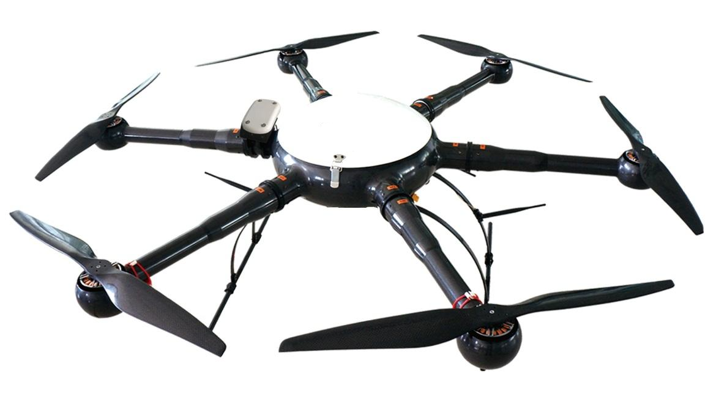
The Y-flight environmental monitoring UAV flight platform uses the YF-866S six-rotor industrial UAV, which is made of carbon fiber composite materials. It has a modular structure and can be assembled in 5 minutes. Transportation and assembly are very convenient. The YF-866S UAV is easy to operate and has strong industry applicability. It has the characteristics of longest flight time and stable flight at the same level, making the operation more convenient and reliable.
1) Structural features
The new all-carbon fiber integrated machine technology has a stronger structure and lighter weight. The load capacity and flight time are guaranteed.
The entire machine adopts a modular design, and the arms, upper cover, fuselage, landing gear, load and other parts that need to be assembled can be quickly disassembled and assembled.
2) Working environment
The working temperature ranges from minus 20 degrees to plus 60 degrees Celsius, ensuring normal operation in most places.
Wind resistance level: Level 6
It can work normally in places with high humidity and heat.
3) Technical parameters
Drone Physical Indicators:
1. Body material: one-piece carbon fiber;
2. Motor: waterproof brushless motor;
3. Blade: 24-inch high-strength carbon fiber propeller;
4. Axis distance: 1250 mm;
5. Height: 500 mm;
6. Empty weight: <5kg
7. Maximum diameter: 1820 mm;
8. Battery pack: 6S1Px2x16000mAh
9. Storage box size: 800mmx800mmx430mm
UAV Performance Indicators:
1. Flight ceiling: 5000 m above sea level;
2. Whether there is RTK: Yes
3. Working height: ≤ 5000 m;
4. Maximum take-off weight: 18kg;
5. Battery life: Battery life >50min;
6. Power supply: military battery, total capacity 32000 mAh, voltage 22.2 V, equipped with 1 set of balancing charger;
7. Waterproof level: ≧IP45
8. Maximum lifting speed: 5 m/s;
9. Cruising speed: 10 m/s;
10. Hovering accuracy: ±0.2m in vertical direction, ±1m in horizontal direction;
11. Flight mode: autonomous flight, manual flight;
12. Minimum take-off and landing space: 4m*4m
13. Operating temperature: -20 ℃ ~ +60 ℃;
14. Environmental humidity: ≤95%;
15. Modular design: fully interchangeable;
16. Airborne POS: Airborne POS records fixed-point exposure posture information;
17. Double star positioning: Beidou and GPS dual system positioning;
2.5.2 Automatic Flight Control System
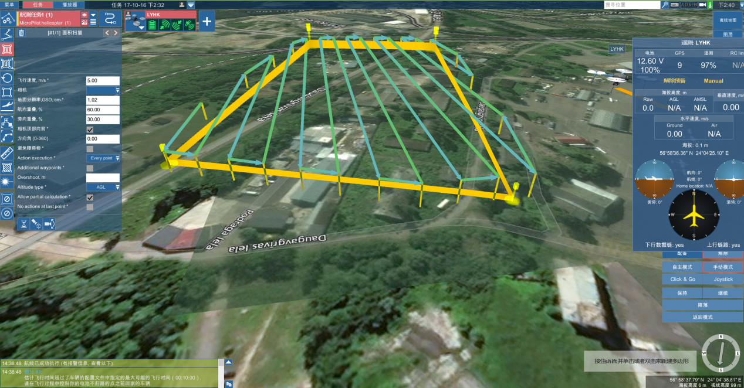
The automatic flight control system includes airborne flight control, ground station software, etc. It can stably control the Y-flight drone to fly unmanned in various environments. It is simple and convenient to use, has high control accuracy, and has strong GPS navigation automatic flight function. It can set the flight altitude, flight speed, etc., and has various task interfaces. , convenient for users to use various task equipment. It can complete autonomous takeoff and landing, route flight, etc. In addition, there are many safety protection solutions to ensure flight safety and failure protection to the greatest extent.
2.5.3 Ground Control Station System
The ground station system includes ground station notebook, ground digital transmission radio, serial port connection, and digital transmission antenna. The two-way data communication between the ground station software and the aircraft mainly has the following functions: setting flight control parameters, calibrating and setting sensor parameters, real-time adjustment of autonomous flight PID, monitoring and controlling flight status, graphically displaying flight data, controlling task loads, and playing back flight data. .
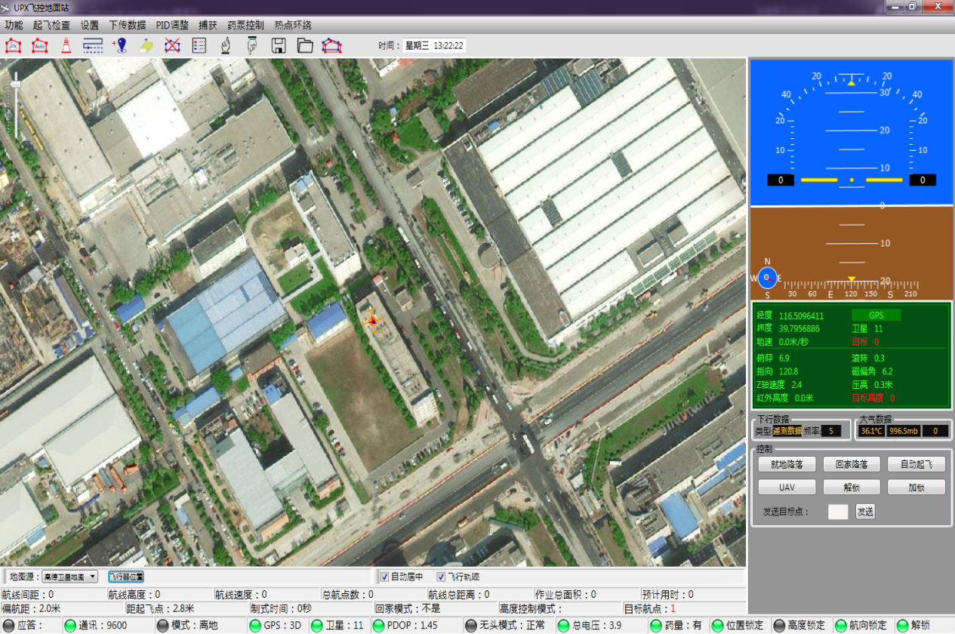

The ground station can mainly achieve the following functions:
1) Communicate with the autopilot. The ground station control software communicates with the autopilot and data link through the serial port using the agreed communication protocol.
2) Flight control, send flight navigation instructions to the autopilot, switch flight modes, change routes in real time, customize tasks, etc.
3) Mobile map, map loading, coordinate calibration, display, dragging, zooming; real-time flight track display, waypoint display and editing.
4) Route planning: edit waypoints on the electronic map, upload them to the aircraft after editing, and then download the waypoints in the autopilot to the ground station to compare with the edited waypoints to avoid missing waypoints.
5) Virtual instruments. Virtual instruments intuitively display various important data such as the aircraft's attitude, altitude, heading, throttle, and voltage.
6) Aircraft status and sensor value display, displaying various flight status and sensor values numerically or graphically.
7) Parameter configuration to ensure flight safety and ensure the smooth progress of the mission.
2.5.4 Mission Load Equipment
- YF-SKA Gas Monitor
YF-SKA Gas Detection Ceremony is a product specially designed for UAV atmospheric environment monitoring. By configuring a variety of intelligent gas sensors, it can simultaneously monitor atmospheric temperature, humidity, PM10, PM2.5, SO2, NO2, CO, O ₃ and VOCs, CL2 , H 2 S, NH ₃ , EX and other characteristic pollution parameters, and can flexibly select and freely combine monitoring indicators according to customer needs , and cooperate with the ground-side "Atmospheric Real-time Monitoring Software" to view unmanned air pollution in real time Gas data of the environment where the machine is located.
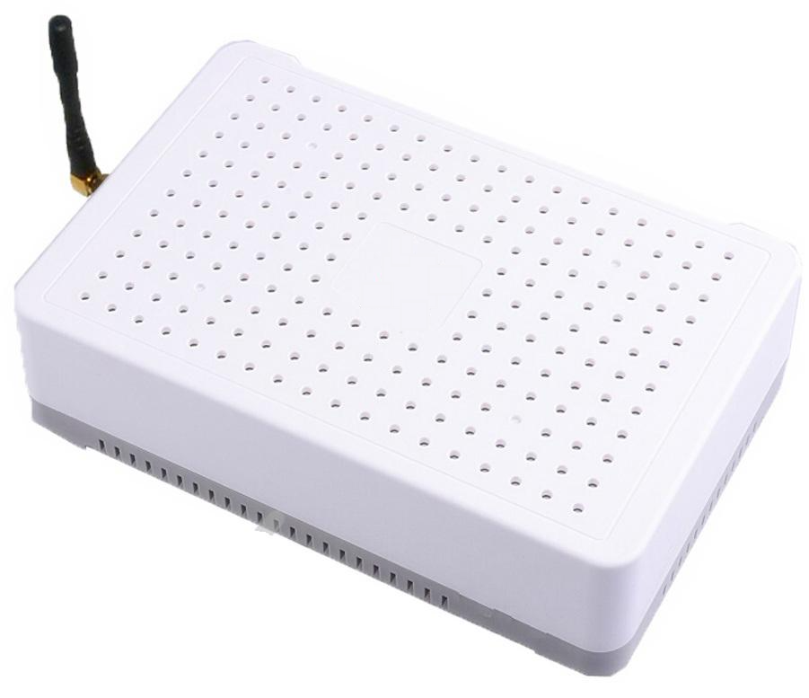
- Gas detector features
●Thousands of gas sensors can be replaced at any time, and the system has automatic identification function.
●The shell is waterproof, windproof, dustproof and impact-proof design
●Display monitoring data in real time and generate corresponding trend curves.
●You can view historical real-time data, and generate curve analysis graphs at the same time. Historical data can be displayed in list and chart styles for easy comparison and viewing.
●Display longitude and latitude, altitude, aircraft status, temperature, humidity, PM1, PM2.5, PM10, and thousands of gas real-time concentration values at the same time.
●Detection accuracy can reach ppb level.
●Real-time wireless transmission of data to the ground terminal, or real-time transmission to the server via GPRS.
- UAV gas detection load parameters
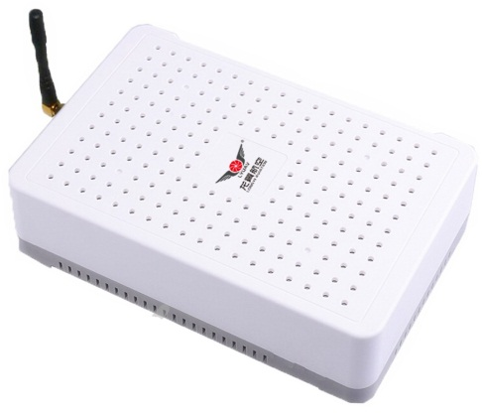
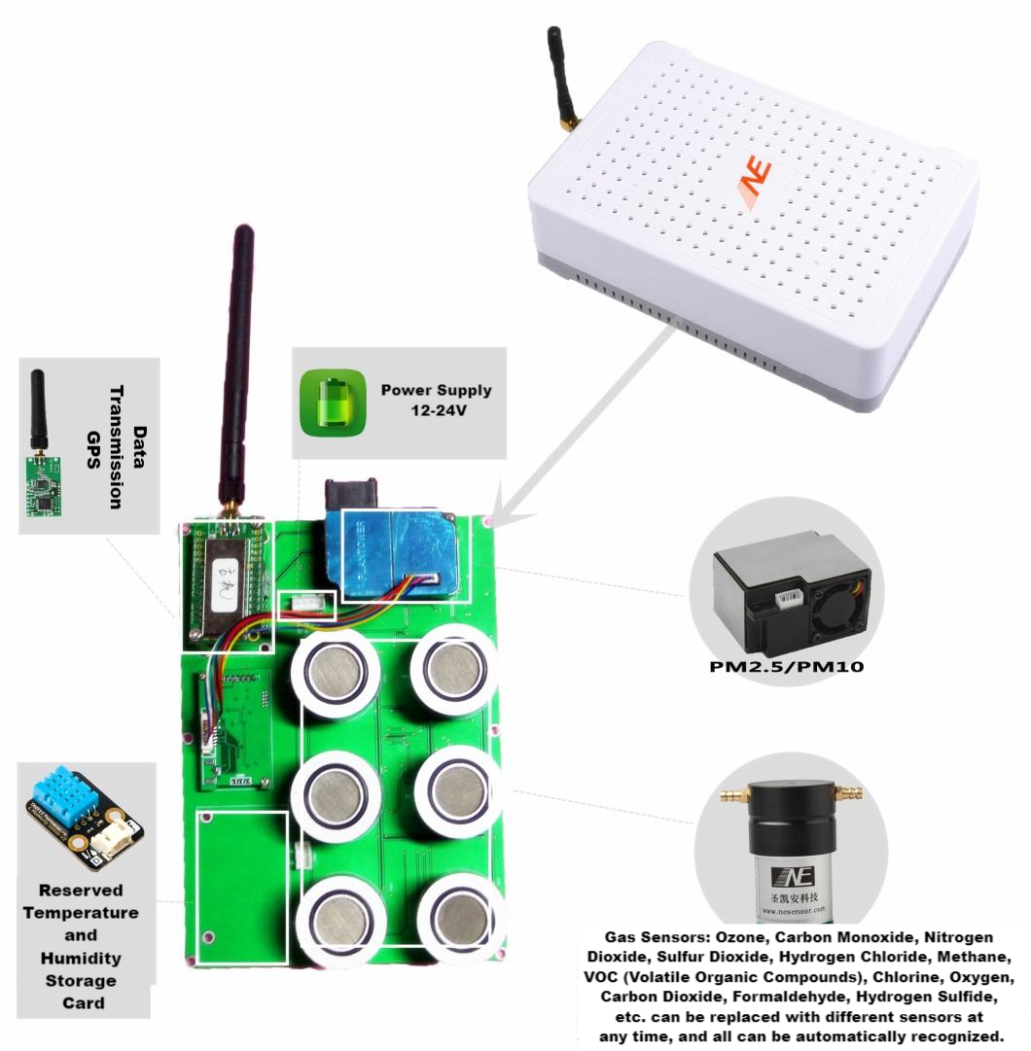
●Detection gas: PM2.5, PM10, NO2, SO2, CO, O3, VOC, etc.
●Electrochemistry, laser
●Weight: 1000g (7 parameters)
●Dimensions: 220×145×60mm
●Power supply: 12-24V
●Data transmission method: GPRS/digital transmission
●Working environment temperature: (-30~+60)℃
●Working environment humidity: (15 ~ 95)% RH no condensation
●Equipment life: Gas device life is 2 years
- Gas software interface and data analysis
Real-time data display
The platform can display various monitoring data in real time. Integrate air quality gas sensor data and toxic gas emergency monitoring data into a unified platform for unified management and comprehensive display. Gas sensor data is represented by different colors representing different pollution levels.
Historical Data Query
Conducting simple statistical analysis on the historical monitoring data at each point, such as daily change analysis, time series analysis, etc., can help the purchaser save the time and cost of manual analysis, and can also help the purchaser understand the basic pollution status.
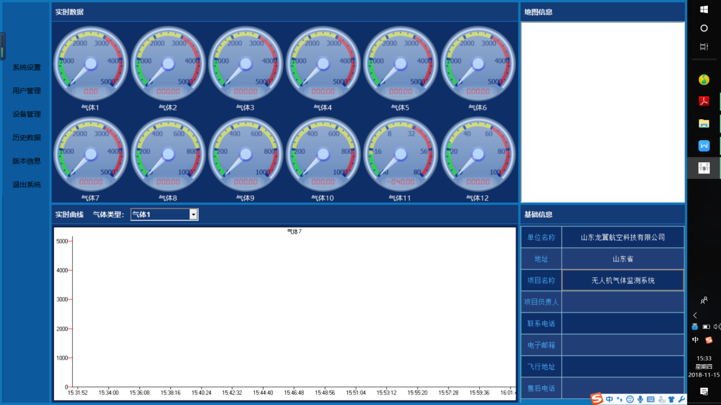
- YF-SG10X Zoom Dual-Light Gimbal
YF-SG10X high-precision gimbal can achieve stabilization in three directions: horizontal, roll and pitch. It adopts an integrated design of shock absorption and gimbal, which can greatly reduce mechanical vibration. It can be widely used in film and television aerial photography, aerial reconnaissance, anti-terrorism, and evidence collection. , geological survey, remote sensing mapping, communication relay, environmental protection, meteorological detection, disaster monitoring, aerial survey and public security firefighting and other industries and fields.
The 10F camera has 2 million effective pixels, supports 10x optical autofocus function, and high-definition 1080P video recording. There are two internal video streams, one is 1080P30FPS local H.264 compression and stored in the device, and the other outputs an HDMI signal in 1080P30FPS format for wireless image transmission. It is designed based on the characteristics of aerial photography applications. It has fast focusing, integrated functions, small size, and supports PWM and serial port control.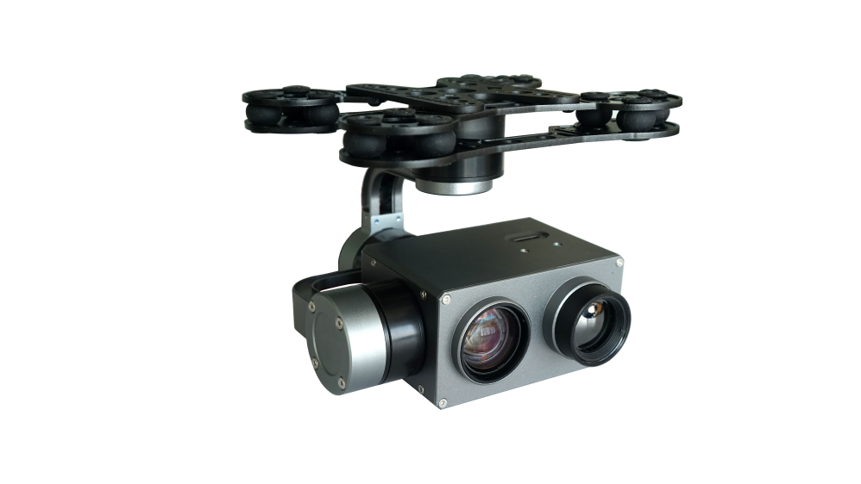
- Features and advantages of dual light pan/tilt:
Zoom range: Zoom focal length F=4.7~47mm, up to 10x optical zoom, allowing image details to be perfectly reflected.
Focus speed: specially designed for drone aerial photography. According to the characteristics of aerial photography, a fast focusing algorithm is adopted, and the focusing time is <1S.
Wide dynamic range: Using a wide dynamic range of 105dB, it can still be clear at the same time in the presence of backlight or strong light.
Clearly captures scenes that are too bright and too dark.
Ultra-low illumination: Ultra-low illumination, image features can still be clearly displayed under backlight conditions.
Output interface: The movement adopts CVBS analog and 1080P HDMI output, local high-definition 1080P H.264 compressed storage.
Multiple control methods: supports PWM control, S.BUS, and serial port command control.
Lens field of view FOV: H:WIDE 61.11°±5% TELE 7.65°±5%
V:WIDE 35.2°±5% TELE 4.12°±5%
- PTZ parameters
10x zoom dual light pan/tilt parameter index
1. Pod operating current: static current: 240mA (@12V) dynamic current: 320mA (@12V).
2. Pod input voltage: 3V~6V.
3. The working environment temperature of the pod: -10℃~50℃.
4. Pod size: L 119mm xW 121mm xH 117 mm.
5. Pod weight: 723g (including camera).
6. Pitch angle action range: ±90° Roll angle action range: ±45° Yaw angle action range: ±150° infinite rotation.
7. Angle jitter: pitch and roll direction: ±0.02° horizontal direction: ±0.03°.
8. Excellent 1080P (1920 × 1080) high-definition image quality.
9.1/2.9" high-performance CMOS sensor, 2 million pixels, high picture quality and high sensitivity.
10. Powerful zoom capability: 10x optical zoom, 12X digital zoom, excellent autofocus performance, fixed aperture of F1.6, focal length range of 4.7~47mm.
11. Video output pixel HV: 1920 × 1080.
12. Video format 1080p/25 1080p/30 1080p/50 1080p/60 720p/25 720p/30 720p/50 720p/60.
13. Day and night function (on, off, automatic).
14. Multiple white balance modes.
15. Powerful low-noise effect and excellent noise reduction performance.
16. Support ultra-low illumination: 0.05Lux@F1.6 color, 0.01Lux@F1.6 (black and white), 0Lux (IR) signal-to-noise ratio ≥52dB.
17. Picture special effects (electronic flip, black and white, mirror, image GAMMA, electronic fog, digital wide dynamic range).
18. Electronic shutter: supported.
19. Support OSD function display.
- Ground display
The Y-flight aviation image transmission box adopts a portable box design, which is rainproof and impact-resistant. It is especially suitable for field operations and portability. The display screen can be switched between visible light and infrared cameras with one click through the remote control, allowing you to view different effects at any time. It also supports photography, video and other settings to meet the different work requirements of different users.
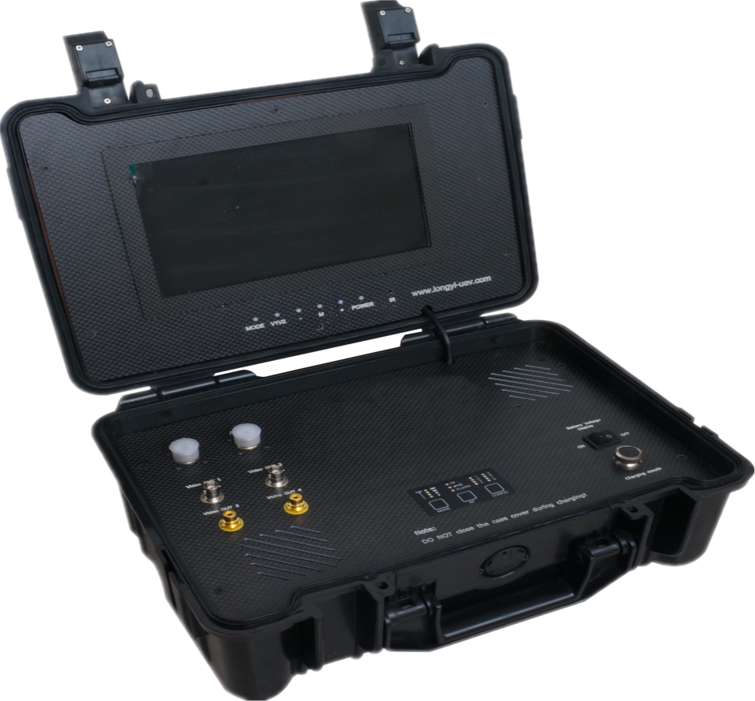

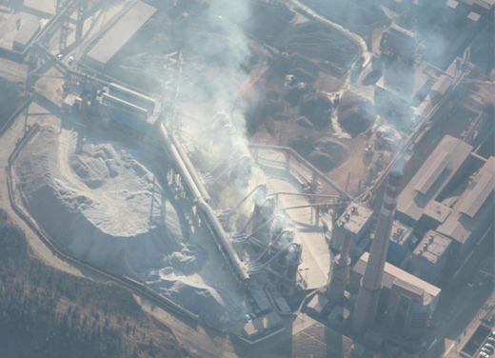
Take Forensic Photos

- YF-SZ1.0L water quality sampler
YF-SZ1.0L water quality sampler combined with drone system sampling completely replaces the traditional manual sampling method, making water quality sampling faster, more efficient and smarter. It makes up for the traditional shortcomings and improves the automation, accuracy and informatization level of water quality monitoring. It has good stability and controllability, accurate positioning, flexible take-off and landing, and high safety. It can be equipped with a water container and a water pumping device. According to the matching position information points, after flying to the center of the lake, it will fly to the sky above the lake. Take samples. This is conducive to cost savings, high work efficiency, and can quickly and timely detect lake water quality problems. It has the characteristics of small size, easy to move, convenient operation, environmental protection and energy saving. It is suitable for environmental monitoring stations, supervisory agencies, scientific research institutes, water affairs, municipal administration, and sewage treatment plants at all levels to automatically sample water samples from rivers, lakes, seas, etc.
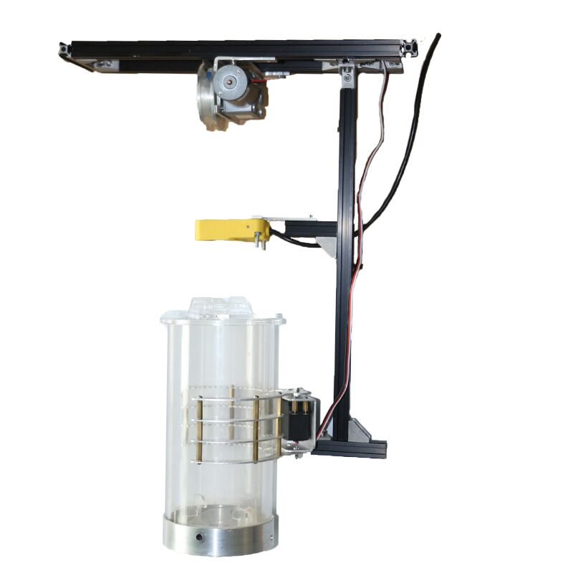
Product parameters
Weight: 1.5kg
Volume: 26cm*8cm*9cm
Water intake depth: 0.5m, 1m, 3m, 5m, 8m, 10m, etc.---Can be customized
Water intake capacity: 0.8L, 1.5L, 3L, 5L, etc. (This time 1.0L)
Material: composite material/stainless steel/aluminum alloy
Anti-shake level: Level 5
Power consumption: 4.8W
Installation method: embedded fixed
Power supply: 24V
Remote control transmission distance: 2KM
Depth error: ±1cm
2.6 Plan Implementation Process
2.6.1 Introduction To Monitoring Work
(1) Preparatory work for monitoring
First, the ground staff conducts a three-dimensional positioning of the longitude, latitude and height of the photovoltaic plant, and then performs the initial positioning of the lines. Input these parameters into the ground station for 3D image editing to set the flight route and hovering coordinates of the drone; at the same time, you can also determine the flight distance and take-off and landing location of the drone to provide battery life for the drone. Replace the battery and select the stopping point in advance to ensure flight safety.
(2) Introduction to work in monitoring
After all preparations are completed, take off with one click. During the inspection process, the drone performs operations according to the instructions of the ground staff on hovering, advancing and changing the course, as well as the rotation and adjustment of the gimbal to monitor the direction.
2.6.2 Flight Mission
The system can perform at least two tasks: surprise inspection (quickly and accurately find problem points), and routine inspection (replacing manual routine inspection, improving inspection efficiency, reducing inspection costs, and reducing the labor intensity of inspection personnel).
Three mission situations:
(1) UAV atmospheric monitoring flights
Solve the problem: Monitor and analyze the atmospheric environment
First of all: UAVs can respond quickly and are suitable for various emergency inspection needs and daily monitoring and inspection needs.
(2) UAV dual-light inspection flight
Solve problems: Carry out daily inspection tasks on a regular basis and search and collect evidence for problem points.
First: the drone conducts automatic flight inspections based on the GPS coordinate points programmed in advance for inspections.
Secondly: UAVs perform inspection and monitoring and synchronously transmit them to ground staff in real time.
Finally: After the drone completes the inspection mission, the ground staff will judge the inspection results based on the inspection content information, and formulate corresponding solutions according to the specific situation.
Advantages of conventional dual-light inspections: used for daily inspection tasks. Compared with traditional manual inspections on the ground, drone visible light inspections have the characteristics of high work efficiency, high accuracy, and large working range; compared with manned aircraft inspections, In short, drone inspections have obvious advantages such as high safety, low operating costs, and strong real-time performance.
(2) Remote water quality sampling by drone
Problem solving: regular daily water quality sampling and monitoring, emergency water quality sampling.
First: the drone flies automatically based on the GPS coordinate points programmed in advance for inspection.
Secondly: when the drone reaches the preset height, ground staff can carry out water fetching operations.
Finally: after the drone completes the task of fetching water, ground staff can return to the take-off point with one click, making it convenient for staff to conduct sampling, analysis and testing.

