Report No:

Foshan Yufei Technology Co., Ltd.

*** Photovoltaic Power Station

Drone Intelligent Inspection And Diagnosis
Report (Demonstration)

Table Of Contents

- Project Overview .............................................................................................................. 3

- Project Planning ............................................................................................................... 4

- UAV inspection implementation plan ........................................ ....................................... 8

Drone Intelligent Inspection Diagnosis Report ........................................ .........................1#~2#

Square Matrix (Example) ........................................................................................... ........... 14

15#~16# Square Matrix (Example) .................................................................................. ..... 54

1. Project Overview
1.1 Background Of The Project

At present, there are huge efficiency bottlenecks in the inspection work of photovoltaic power stations. Photovoltaic power stations cover a vast area, complex terrain, and changeable environments, resulting in complex power station operation and maintenance environments, heavy daily tasks, cracks, hot spots, and snails. Problems such as cracks and the operating status of the electrical system require professional and experienced technicians to use professional equipment to inspect them one by one to find them, and errors are prone to occur. The equipment and systems of the power station are installed in a relatively harsh environment. Photovoltaic modules, combiner boxes, etc. are exposed to sand, rain, snow, and high and low temperature outdoor environments all year round. They are prone to malfunctions and dust obstruction, resulting in poor power generation or failure of the equipment.
Traditional manual methods are time-consuming and labor-intensive, which greatly hinders the efficient operation and rapid development of power stations. Through the research results of many domestic photovoltaic power stations and the analysis of photovoltaic power station operation needs, we believe that photovoltaic power stations should establish an efficient and convenient inspection system as soon as possible to maximize inspection efficiency and improve macro-control capabilities.

1.2 Basic Information
Power plant name : ***110MWp photovoltaic power plant
Power station location :
administrative address
Longitude latitude altitude m
Owner *** Group
Contractor*** Electric Power Co., Ltd.
Installed capacity 110MWp
Component Brand1/Type/Nominal Power/Quantity***/***/*** ***W/***Block
Bracket type fixed/adjustable
Number of square arrays/capacity*** square arrays/***MW

Photovoltaic power station drone intelligent inspection and diagnosis report
A single string contains the number of components*** block components
Combiner box brand/quantity***/***sets
Inverter brand/quantity***/***set/***kW
Power generation date: ***month***, 2016

1.2 Basic Information

2. Project Planning
2.1 Implementation Schedule

Serial Number | Implementation Items | Content | Implementation Time | Remark
1 | Sign a Contract | Both Parties Sign Contract Agreement | -
2 | Design | Complete The Implementation Plan Setting And Submit It To Party A For Review | Within 3 Days Of Contract Signing
3 | Admission | After Party A Approves The Plan, Party B Arranges For 2 Engineers To Station At The Project Site | Within 7 Days After Signing The Contract
4 | Drone Inspection | When The Irradiance Is Greater Than 600W/㎡, Use Drones To Obtain Thermal Infrared And Visible Light Images Of Photovoltaic Modules, Totaling 50Mwp; | Within 12 Days After Signing The Contract | Due To Weather Conditions, The Construction Period Has Been Postponed
5 | Inspection Report | Detect Hot Spots With Component Temperature Abnormalities Exceeding 20°, Locate The Hot Spots, And Prepare The "110Mwp UAV Inspection Diagnosis Report" | Within 15 Days After Signing The Contract
6 | Report Submission | Submit The Final Version Of "110Mwp UAV Inspection Diagnosis Report" | Within 20 Days After Signing The Contract

2.2 Inspection Equipment

Intelligent Inspection And Reconnaissance Drone

Introduction: Innovatively integrating carbon fiber integrated casing, industrial-grade flight controller, high-performance power system, etc., it can adapt to different application characteristics such as large photovoltaic power station construction sites, high altitude, strong electromagnetic interference, complex terrain, etc., and realize photovoltaic power station without Human-machine fully autonomous flight inspection.
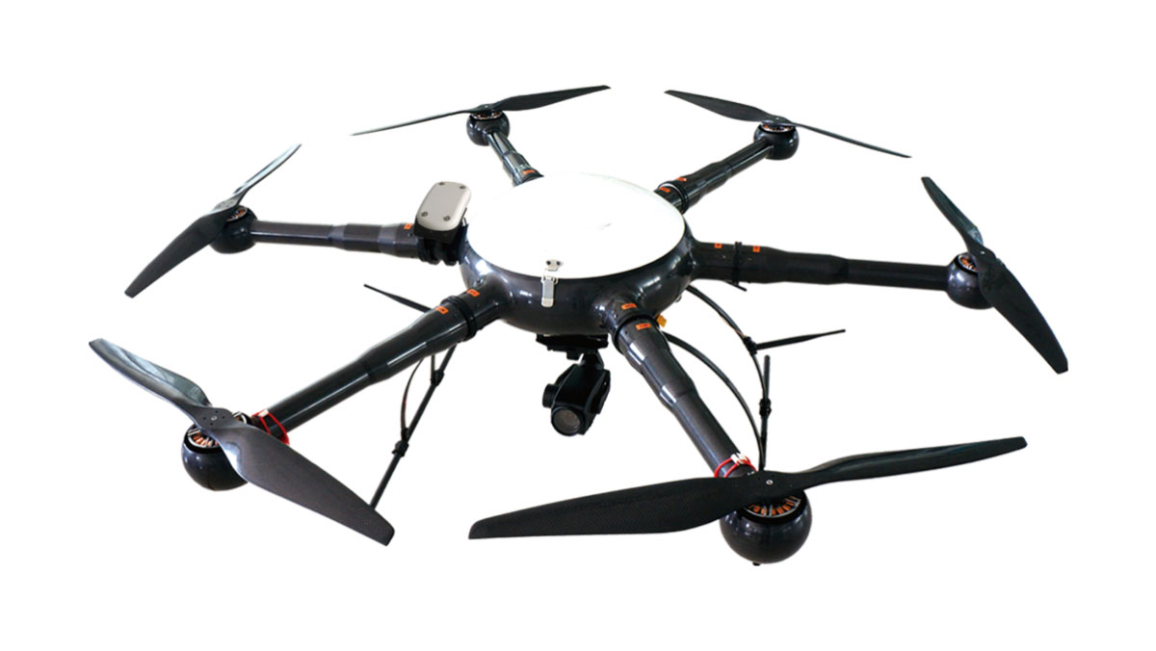
Figure 1.01 Industrial Drone
Main Performance Indicators:
- 1) Full carbon fiber body;
- 2) Protection level: ≧IP54;
- 3) Wind resistance: ≧ 8 m/s (28.8 km/h, level 4-5);
- 4) Maximum load (excluding battery): ≧3000g;
- 5) Maximum flight altitude altitude: 4000m;
- 6) Maximum relative flight altitude: ≧1000m;
- 7) Operation endurance time is greater than 45 minutes;
- 8) Flight mode: One-touch fully autonomous take-off and landing, automatic flight according to planned path.

Intelligent Task Device v3.0

Introduction: The integrated dual-light camera integrates a visible light camera and a thermal infrared camera, which can realize the simultaneous shooting of visible light images and thermal infrared images of photovoltaic power generation equipment.
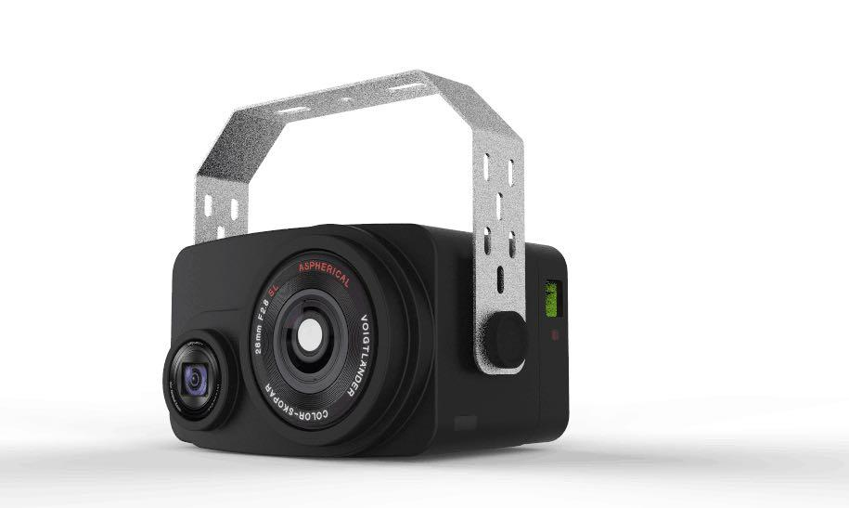
Figure 1.02 Integrated Bi-Optical Camera
Main Performance Indicators:
- 1) Integrated thermal infrared camera and visible light camera;
- 2) Thermal infrared camera resolution: 640(H)×480(V);
- 3) Visible light camera resolution: 5456(H)×3632(V);
- 4) Thermal infrared and visible light cameras trigger and take pictures simultaneously.

Solar Inspector Photovoltaic Intelligent Inspection And Diagnosis Software v1.0

Introduction: Mining, classification, calculation, analysis, and on-demand processing of data acquired by intelligent task equipment to achieve functions such as automatic identification, automatic location, and report generation of photovoltaic power generation component faults.
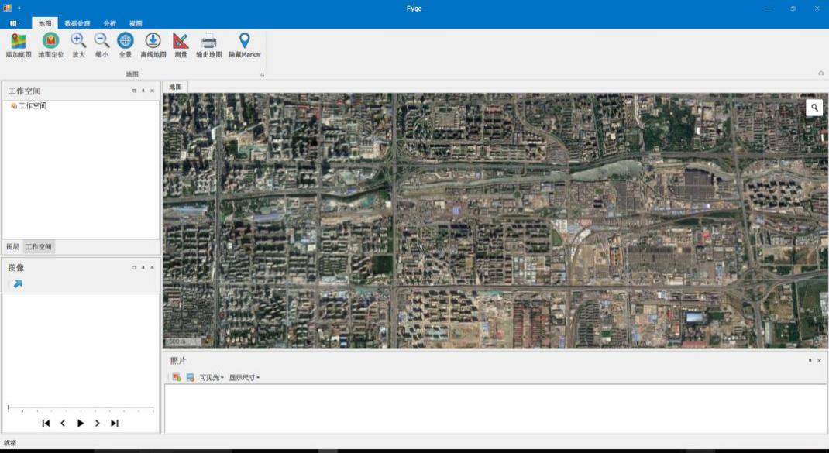
Figure 1.03 Screenshot Of Software Interface

Main Performance Indicators:
1) Management of base map data
The built-in GIS system of the UAV intelligent inspection and diagnosis system software can manage multiple formats (raster, adaptive
quantity) base map data. When the power station does not have measured base map data, the software can automatically collect online remote sensing images to provide a basis for locating fault points. At the same time, the software has an offline caching function and is suitable for on-site operations without network;
Google satellite images that can be automatically downloaded after connecting to the Internet;
High-precision surveying and mapping base maps can be imported.
2) Route and photo coverage display
By reading the display of photo coverage, you can clearly see the trajectory of the aircraft during a flight and the covered power station area to prevent missed shots.
3) Route playback
In addition to static coverage display, the drone intelligent inspection and diagnosis system software can also play back the flight process at any speed, clearly showing the location of the aircraft at each photo point and the range covered by this photo. As an example in Figure 1, the yellow rectangle in the figure is the dynamically displayed camera coverage, and the green dot is the position of the drone each time it takes a photo.
4) Thermal infrared photo viewing and color change
Thermal infrared cameras actually record grayscale images, and it is difficult to visually identify the fault point. For this reason, the drone intelligent inspection and diagnosis system software needs to provide a variety of color schemes that can be applied to different scenarios.
5) Real-time temperature display
The UAV intelligent inspection and diagnosis system software uses the measured thermal radiation information to display the highest temperature in the current photo in real time, as well as the temperature value corresponding to each pixel, providing accurate information for fault detection.
6) Manual marking of equipment faults
By browsing thermal infrared photos, the location and type of fault points in the photos can be manually marked. This information is automatically saved and used to calculate the actual geographical location of the fault point, which can handle various types of faults.
7) Automatic identification of equipment faults
The UAV intelligent inspection and diagnosis system software provides automatic hot spot detection function, which can detect abnormal points directly from the image and automatically mark and record the location information. Automatic labeling is faster than manual labeling.
8) Identification of equipment fault severity
The drone intelligent inspection and diagnosis system software can manually select and identify severe hot spots and mild hot spots based on the inspection irradiance conditions, and automatically mark and record location information.
9) Calculation of actual location of fault point
The UAV intelligent inspection and diagnosis system software can add marked fault point information and combine it with the GIS base map to calculate the actual geographical location of each fault point and display it on the base map to facilitate operation and maintenance personnel to inspect photovoltaic modules based on the fault location. maintain.
10) Report export
Based on the input information and test results, the drone intelligent inspection and diagnosis system software can export a report in PDF format and record the test time and other information to facilitate the standardized management of the test process.

2.3 Total Inspection Amount

***110Mwp Photovoltaic Power Plant Drone Inspection Workload
Serial Number | Category | Project | Quantity
1 | Intelligent Inspection | Component Infrared Thermal Imaging Test (Component Thermal Anomalies Are Found, And The Causes Of Failure Include Cracks, Debris, Dirt, Occlusion, Backplane Scratches, Diode Damage, Etc.) | 110Mwp
2 | String Electrical Loss Analysis | Comprehensive System Historical Data Analysis (String Current Mismatch, Power Loss, Fault Causes, Defect Elimination Guidance) | 110Mw

3. UAV Inspection Implementation Plan
3.1 Drone Inspection
3.1.1 According To The Standard

"Interim Provisions on the Management of Pilots of Civilian Unmanned Aircraft Systems"
"General Aviation Business License Management Regulations"
"Interim Regulations on the Operation of Light and Small Unmanned Aircrafts"
"Regulations on the Administration of Civilian Drone Pilots"
"Civil Unmanned Aircraft Systems Air Traffic Management Measures"
"Regulations on the Real-name Registration and Management of Civilian Unmanned Aircrafts"

3.1.2 Inspection Process
1. Power Station Map Download
1) Determine the area of the photovoltaic power station and download the satellite map of the corresponding area as a base map.

Use
2. Select The Drone Takeoff And Landing Location
1) The site is open and unobstructed, suitable for drone takeoff and landing;

3. Select Inspection Area
1) Select the area to be inspected on the base map of the power station, and the drone intelligent inspection and diagnosis system will automatically generate an inspection path;

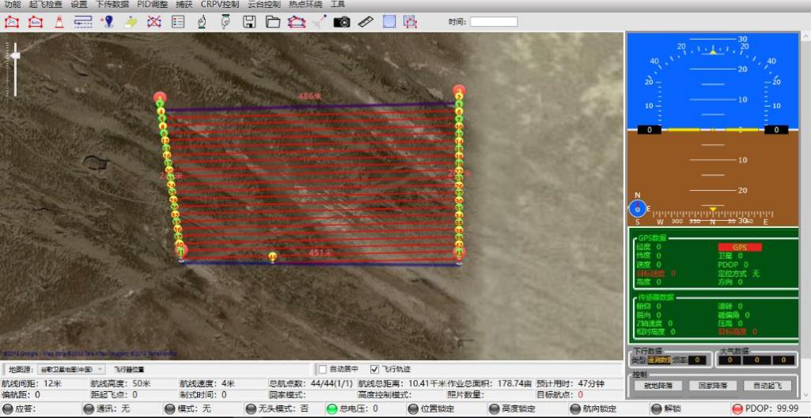
2) Plan inspection areas and automatically generate inspection routes (the waypoints shown are data collection points);

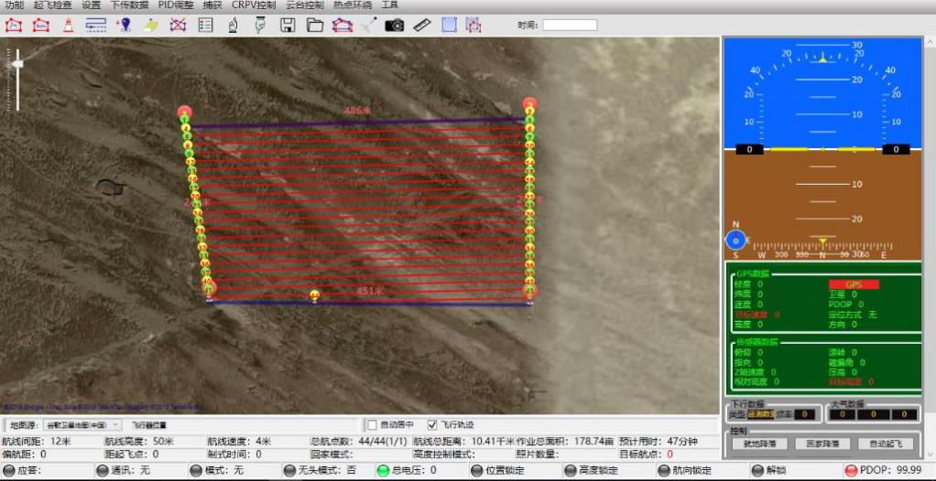
4. UAV Automatic Inspection Simultaneously Collects Visible Light Images And Thermal Infrared Images

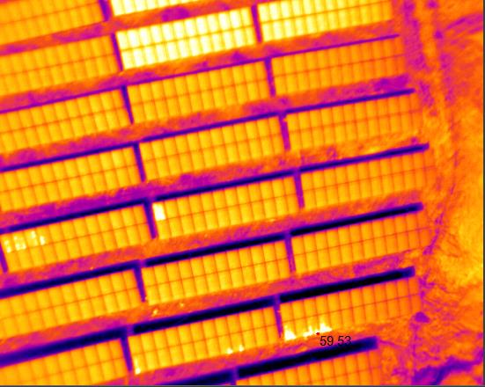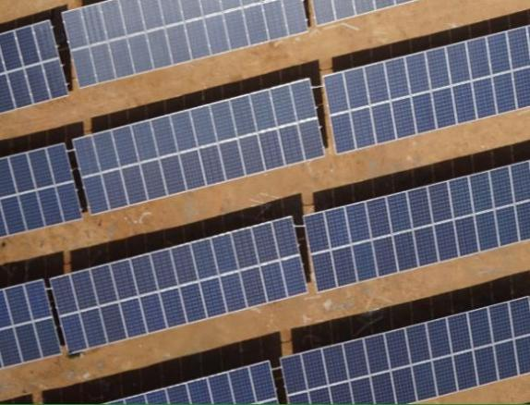
5. UAV Inspection Data Processing Software Automatically Processes Inspection Data

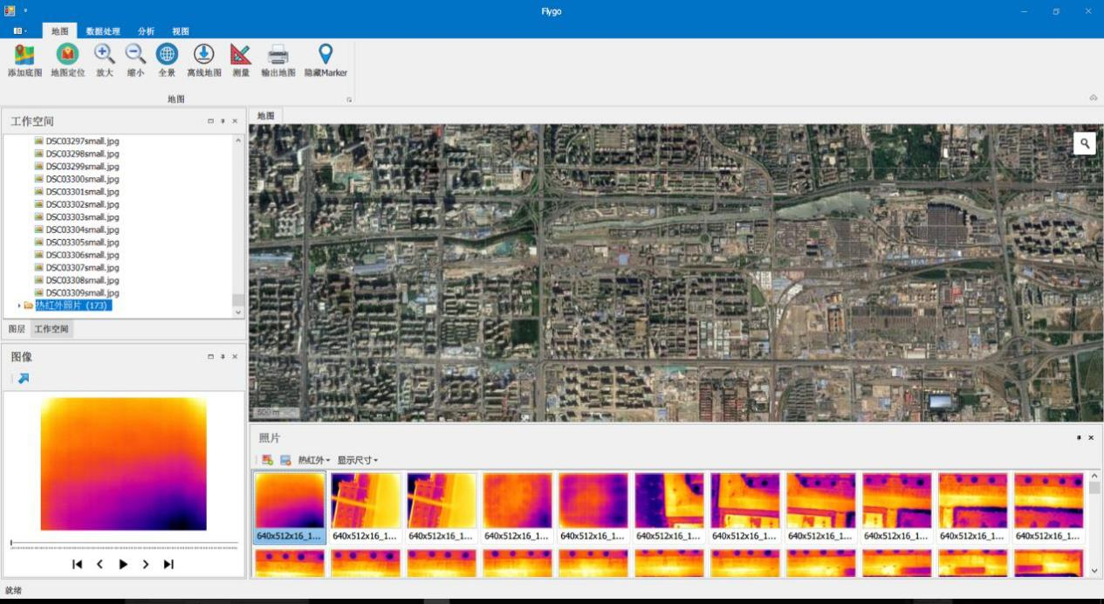
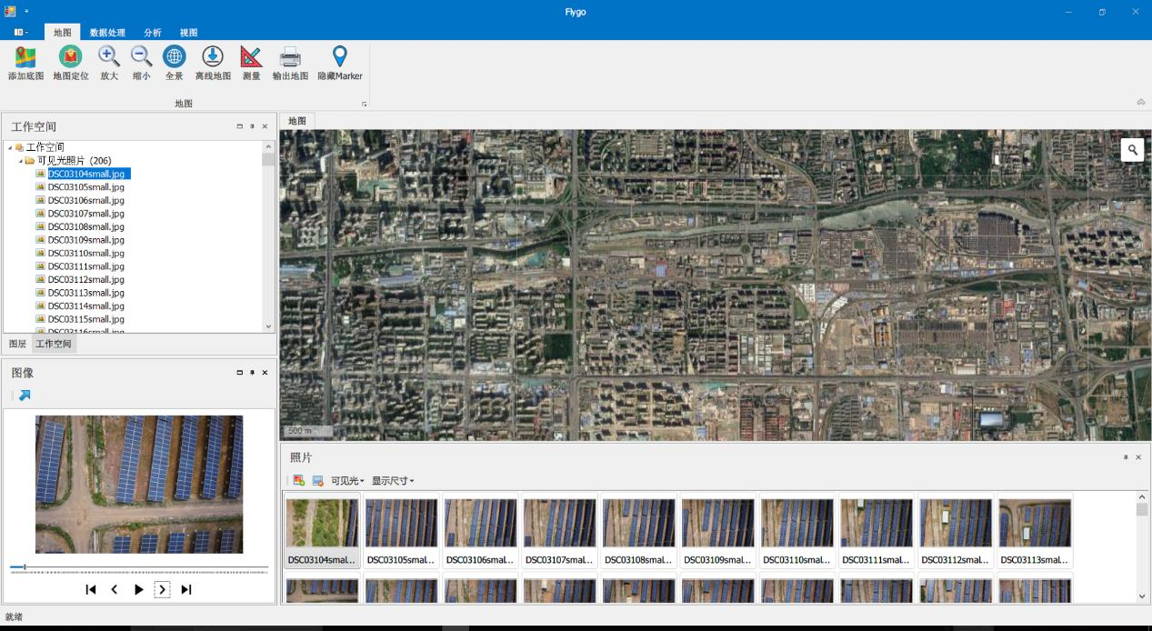
6. Combined With Background Data To Detect Equipment Performance And Quantify Equipment Faults

3.2 Component Infrared Thermography Testing
3.2.1 According To The Standard

"CNCA/CTS 0004-2010 Basic requirements for acceptance of grid-connected photovoltaic power generation system projects"

3.2.2 Example Of Results

The Statistical Results Are As Follows:
Component Model | SNQ275P | String | 22 Components/String
Detection Component Quantity | 60,000 Yuan | Detection Component Quantity | 3,000
Number Of Component Hot Spots | 3650 | Number Of String Faults | 236
The Proportion | 6% | The Proportion | 7.8%

Hot spot effect: The electrical characteristics of the solar cells used in each module must be basically the same, otherwise the so-called hot spot effect will occur on cells with poor electrical performance or that are blocked (problem cells).
Hazards of the hot spot effect: It may cause damage to the entire battery component and cause losses.

The Main Reasons For The Hot Spot Effect:
Shadow Occlusion
Battery Performance Is Inconsistent
Welding, Hidden Cracks, Short Circuit Due To Foreign Matter In Components

According to the testing requirements, infrared testing was conducted on 60,000 components of a certain *** photovoltaic power station, and it was found that 365 components on site had serious hot spots (the temperature difference was more than 20°C), and the proportion of faulty components in the sampled components was 6%. Components are distributed among 236 strings, and faulty strings account for 7.8%. Through analysis, it is found that the cause of hot spots is mainly caused by long-term adhesion of dust and soil on the surface of components. It is recommended to clean it up in time before further inspection.

4. Drone Intelligent Inspection And Diagnosis Report

Drone Intelligent Inspection Diagnostic Report
Tuesday, January 2, 2018
*************************************************** *******************************
Inspection Log Information
Power station name: ***110MW mountain photovoltaic power station
Testing start time: 11:10 on January 2, 2018 Testing end time: 12:00 on January 2, 2018
Weather conditions: Sunny, light wind, irradiance 650w/㎡ Temperature: 3℃
Operator:
Remark:
Equipment manufacturer:
*************************************************** *******************************
Testing Overview
Component Model | ***250W | String | 22 Components/String
Detection Component Quantity | 80,000 Yuan | Detect The Number Of Strings | 2,909 Strings
Hot Spot Effect Quantity | 1,166 Yuan | Number Of Current Mismatched Strings | 146 Strings
The Proportion | 1.47% | The Proportion | 5.02%

The dangers of hot spot effect:
1) It is the main cause of string current mismatch.
2) It may cause damage to the entire battery assembly and cause losses.

Fault Types Include: Component Damage, Diode Damage, Dirt Obstruction, Etc.

*************************************************** *******************************
Hot Spot Distribution

26
990
19
20
twenty four
8
13
33
13
20
0
200
400
600
800
1000
1200
1#~2# square matrix
3#~6# Square Array
9#~12# Square Array
15#~16# square array
17#~18# square array
46# Square Array
48# Square Array
20#~21# square array
26# Square Array
28# Square Array
Component Failure Component Failure Quantity Distribution Chart Distribution Chart
*************************************************** *******************************
Hot Spot Effect Overview
Fault Type | Quantity (Blocks) | Fault Type | Quantity (Blocks)
Component Missing | 3 | Damaged Components | 12
Diode Damaged | 3 | Surface Dirt | 55
Weed Cover | 4 | Components Block Each Other | 7
Other Occlusion | 2 | Unknown Fault | 1080

*************************************************** *******************************
Hot Spot Effect Details
1#~2# Square Matrix (Example)
Component Model | ***250P | String | 22 Components/String
Detection Component Quantity | 8074 Blocks | Detect The Number Of Strings | 367

Hot Spot Effect Quantity | 26 | Number Of Current Mismatched Strings | 26
The Proportion | 0.32% | The Proportion | 7.08%

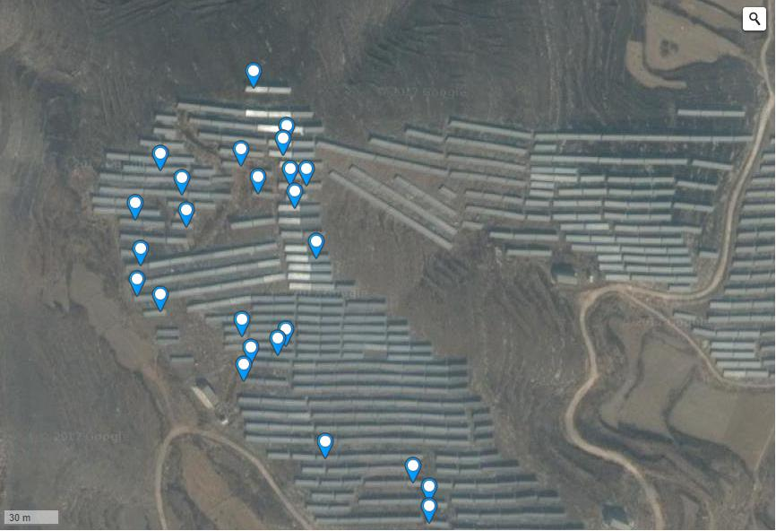
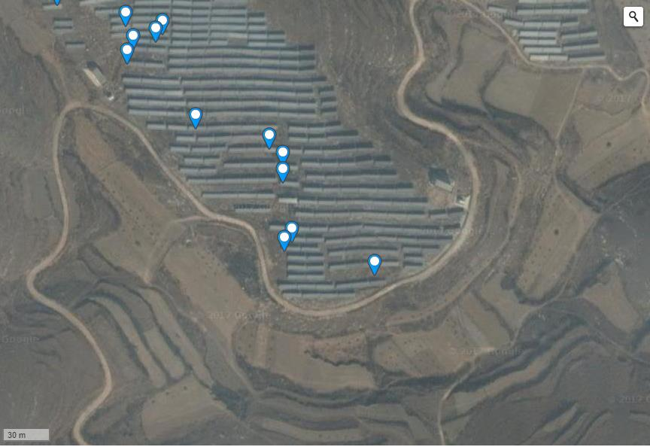
Full Picture Of Component Failure Location
Failure Point 1: Severe Hot Spot (Diode Damage);

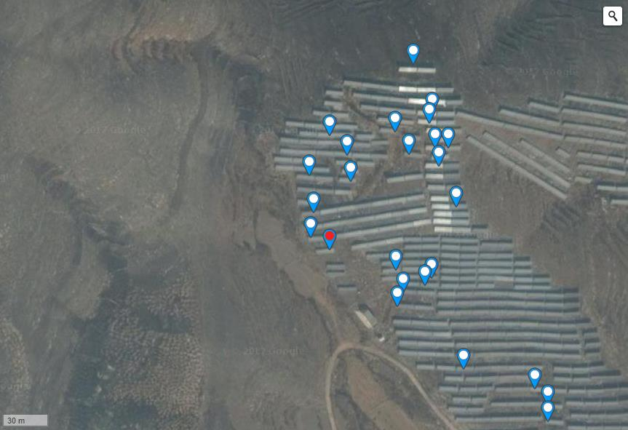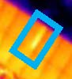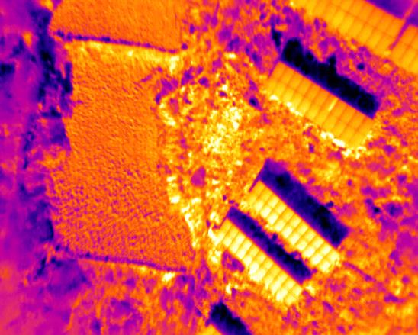
Hot Spot Temperature: 17.09℃;
Latitude And Longitude: N 38.7093835; E 114.6388826;
Note: Judging From The Shape Of The Hot Spot, The Component Hot Plate Effect Is Caused By Diode Damage;
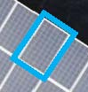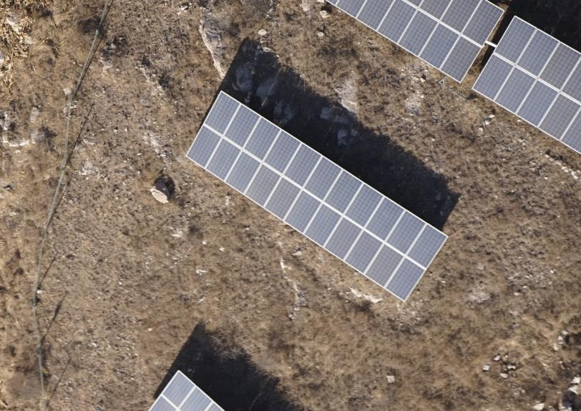

Fault Point 2: General Hot Spot (Temperature Difference At The Fault Point Is Less Than 20°C);

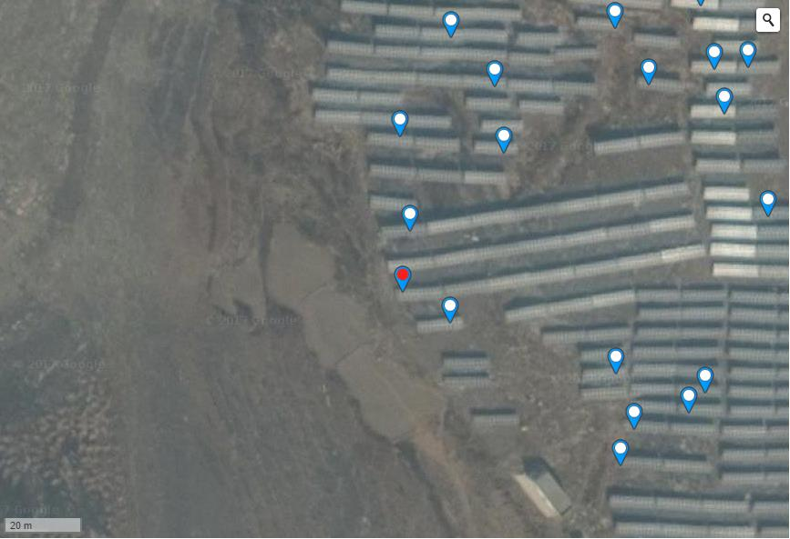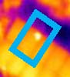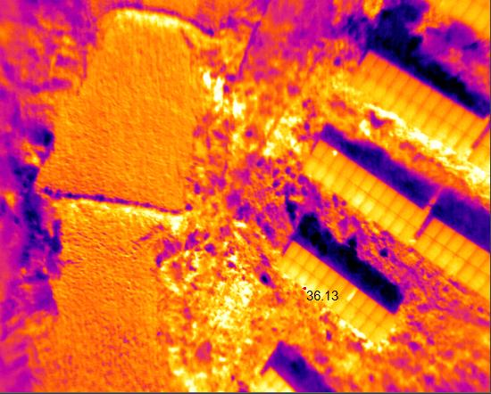
Hot Spot Temperature: 17.09℃;
Latitude And Longitude: N 38.7093835 ; E 114.6388826;
Remarks: None;
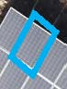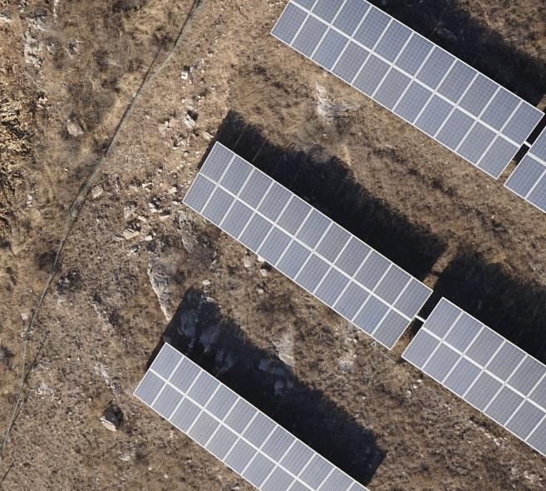

Fault Point 3: General Hot Spot (Temperature Difference At The Fault Point Is Less Than 20°C);

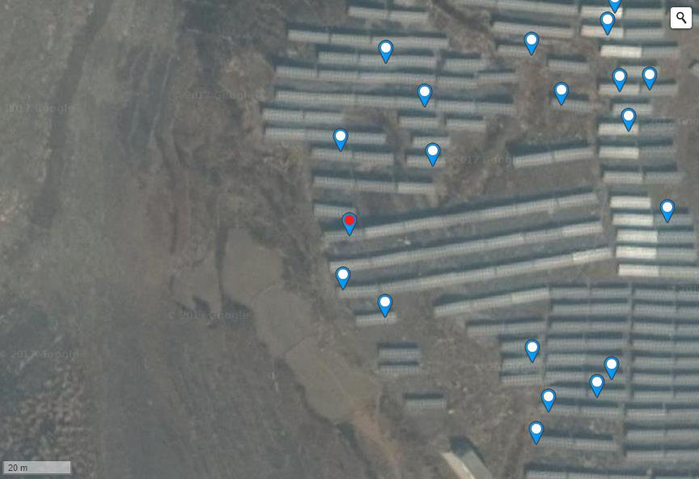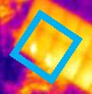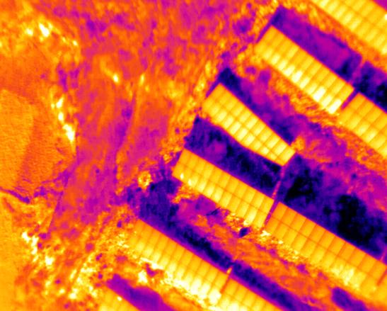
Hot Spot Temperature: 18.77℃;
Latitude And Longitude: N 38.7096661 ; E 114.6387695;
Remarks: None;
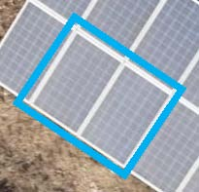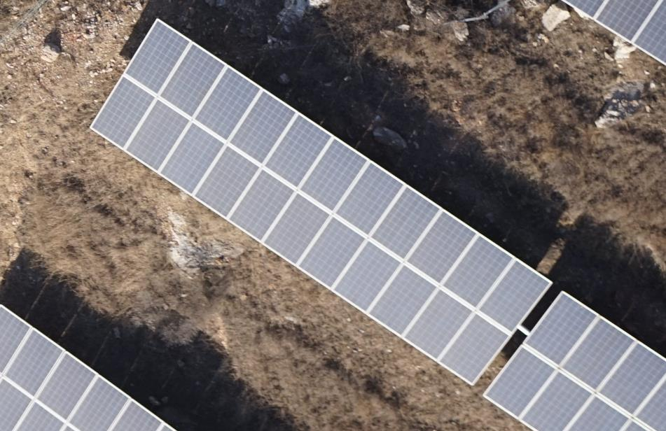

Fault Point 4: General Hot Spot (Temperature Difference At The Fault Point Is Less Than 20°C);

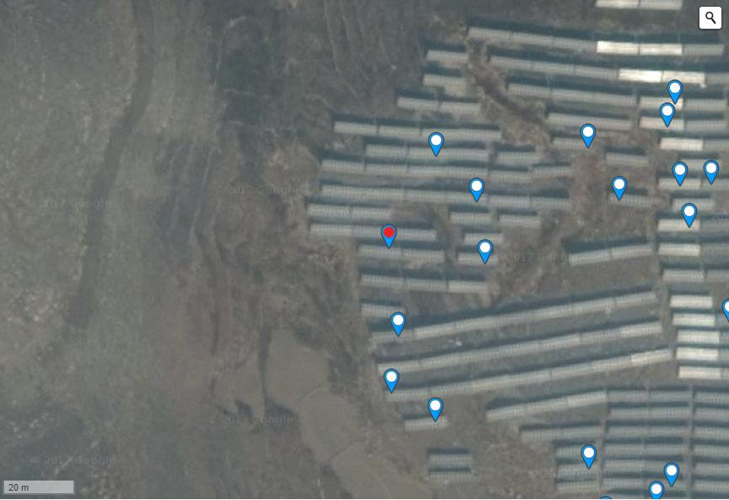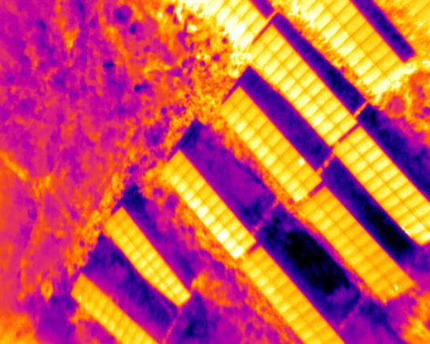
Hot Spot Temperature: 28.29℃;
Latitude And Longitude: N 38.7098601 ; E 114.6387498;
Remarks: None;
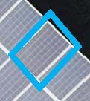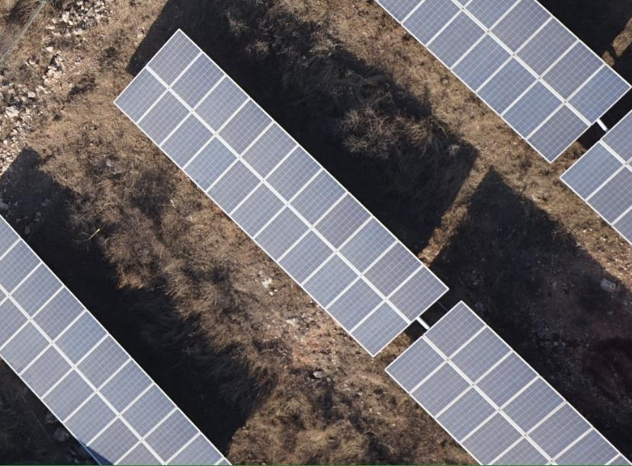

Fault Point 5: General Hot Spot (Temperature Difference At The Fault Point Is Less Than 20°C);

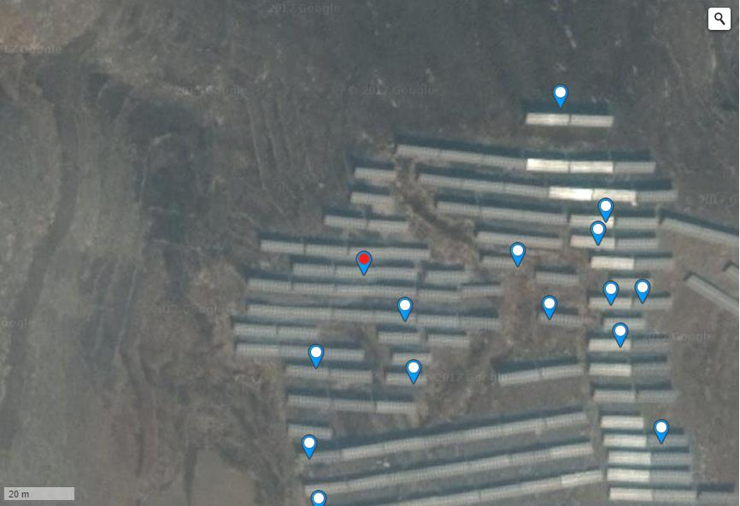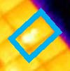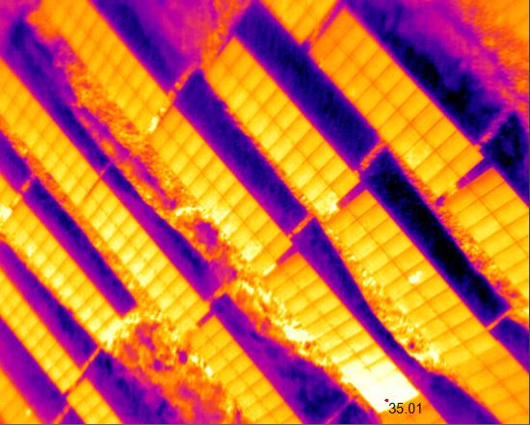
Hot Spot Temperature: 23.09℃;
Latitude: 38.71012954649925 Longitude: 114.63894098997118;
Note: Through Multi-Angle Comparison Of Different Images, The 35.1°C Point In The Infrared Image Of Fault Point 5 Is The Reflection Of Sunlight.
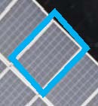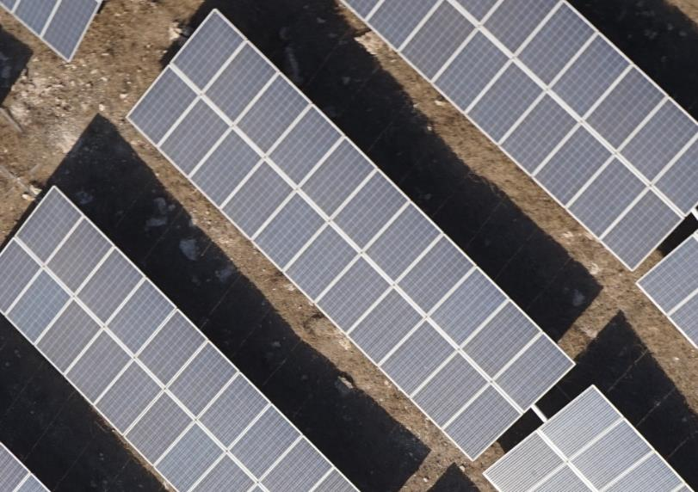

Fault Point 6: Severe Hot Spot (Temperature Difference At The Fault Point Is Greater Than 20°C);

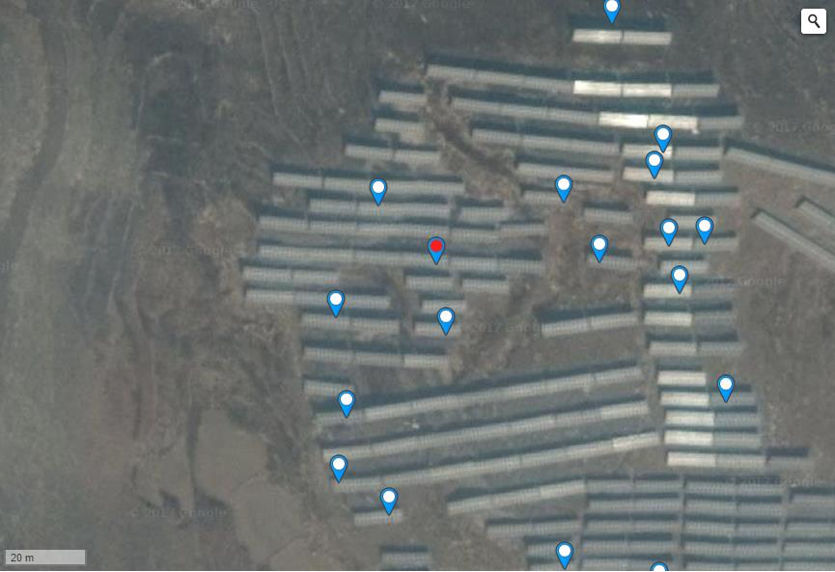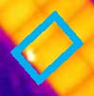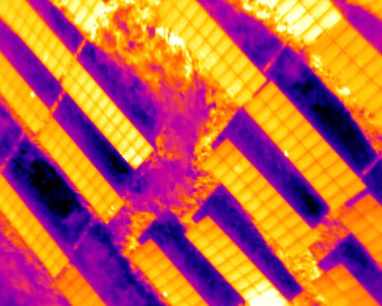
Hot Spot Temperature: 39.21℃;
Latitude: 38.71012954649925 Longitude: 114.63894098997118;
Note: There Is Sunlight Reflection;
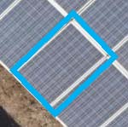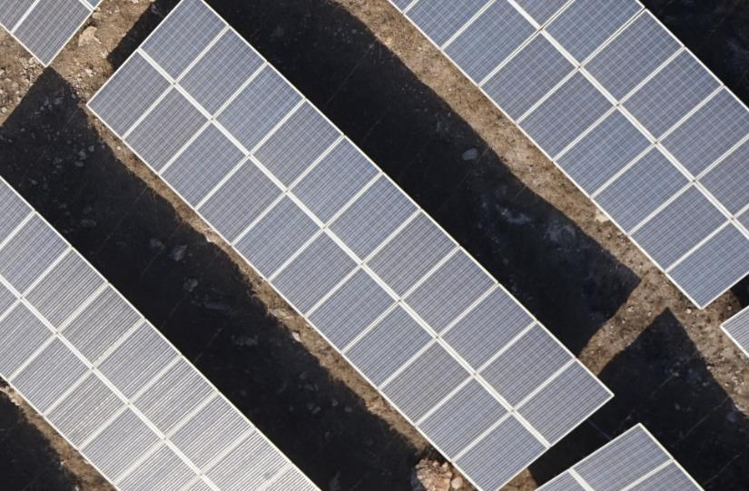

Fault Point 7: General Hot Spot (Temperature Difference At The Fault Point Is Greater Than 20°C);

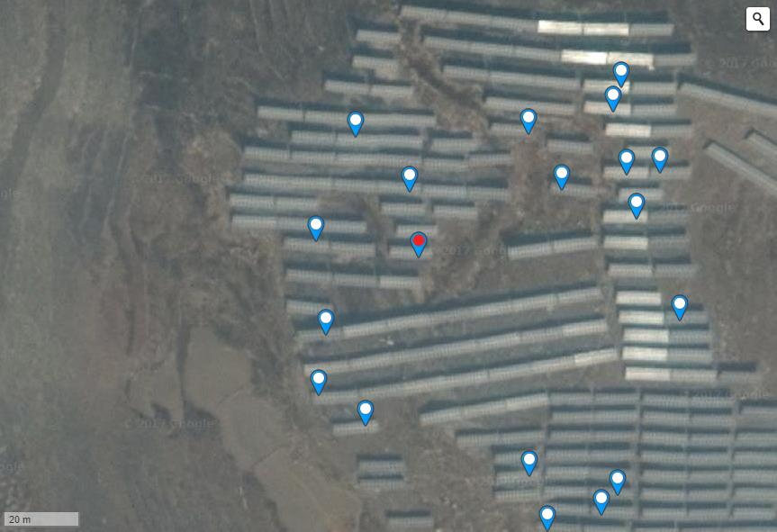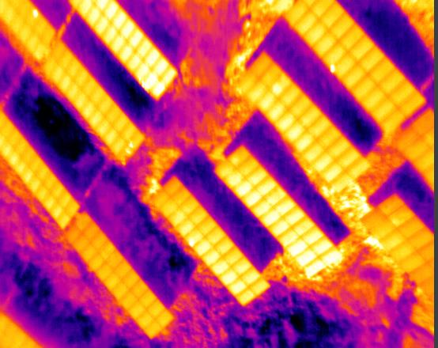
Hot Spot Temperature: 24.73℃;
Latitude: 38.70971722806262 Longitude: 114.63917165994646;
Note: There Is Sunlight Reflection;
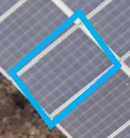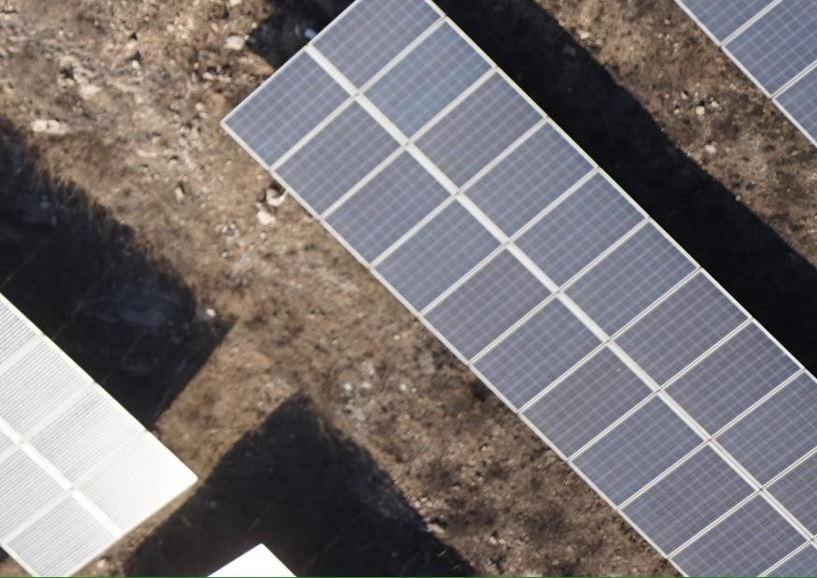

Fault Point 8: General Hot Spot (Temperature Difference At The Fault Point Is Greater Than 20°C);

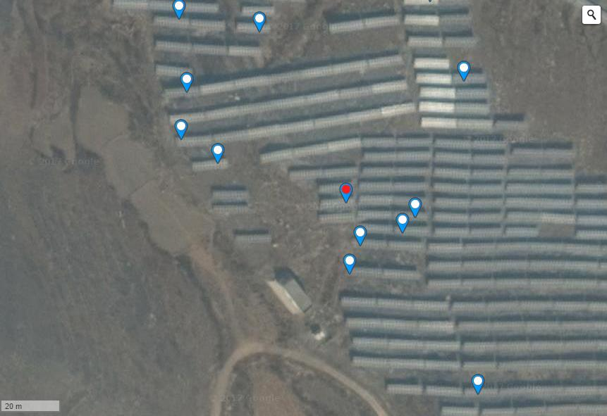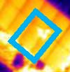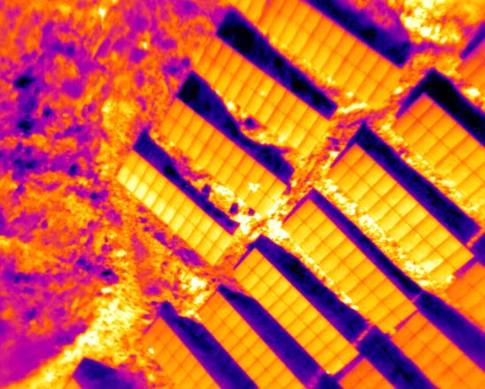
Hot Spot Temperature: 38.45℃;
Latitude: 38.70932897680256 Longitude: 114.63944390416147;
Remarks: None;
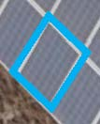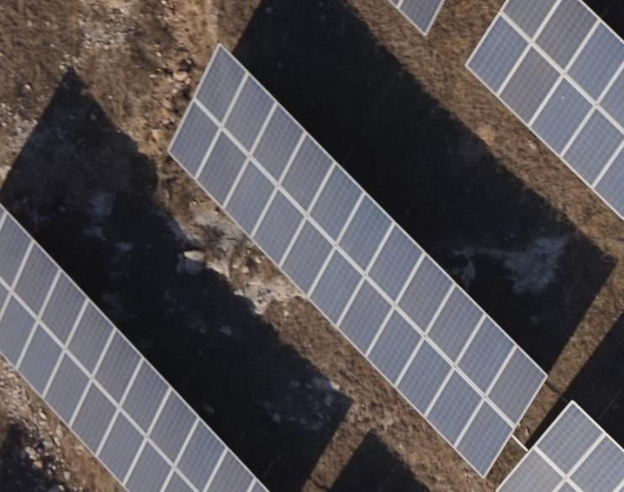

Fault Points 9~12: General Hot Spots (The Temperature Difference At The Fault Point Is Greater Than 20°C);

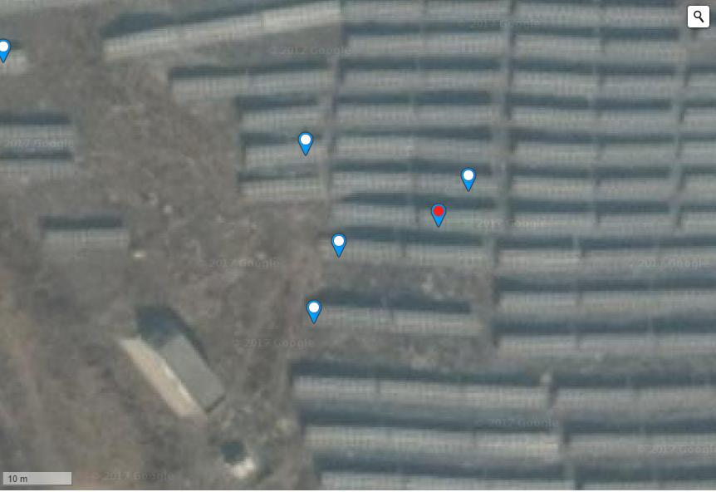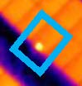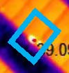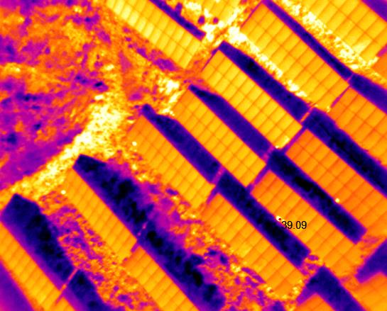
Hot Spot Temperature: 39.09℃;
Latitude: 38.709244210074516 Longitude: 114.63965848088266;
Latitude: 38.70920758244488 Longitude: 114.63949888944629;
Latitude: 38.70912490858331 Longitude: 114.63945597410205;
Latitude: 38.70929130271362 Longitude: 114.6397040784359;
Remarks: None;
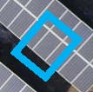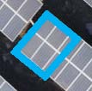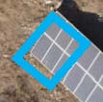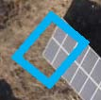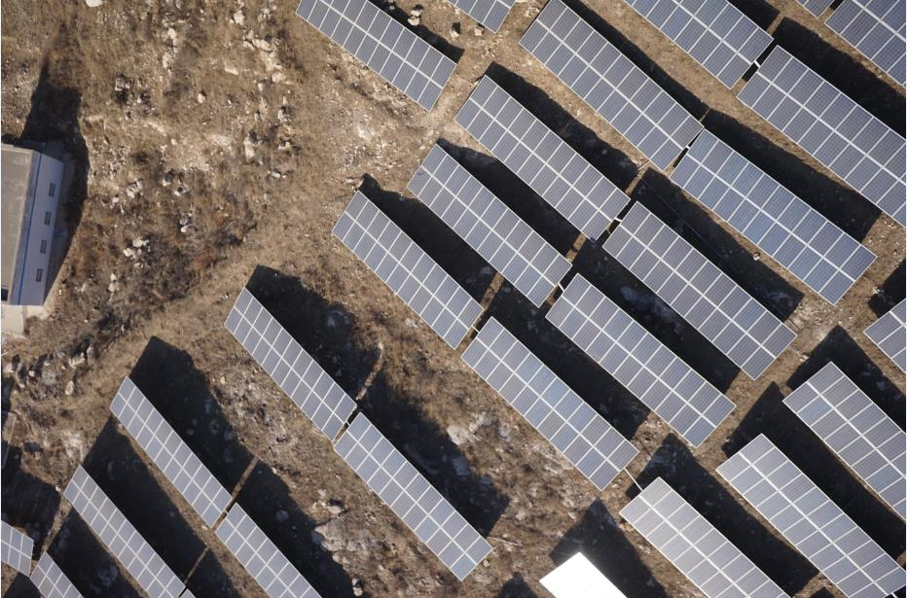

Fault Point 13: General Hot Spot (Temperature Difference At The Fault Point Is Greater Than 20°C);

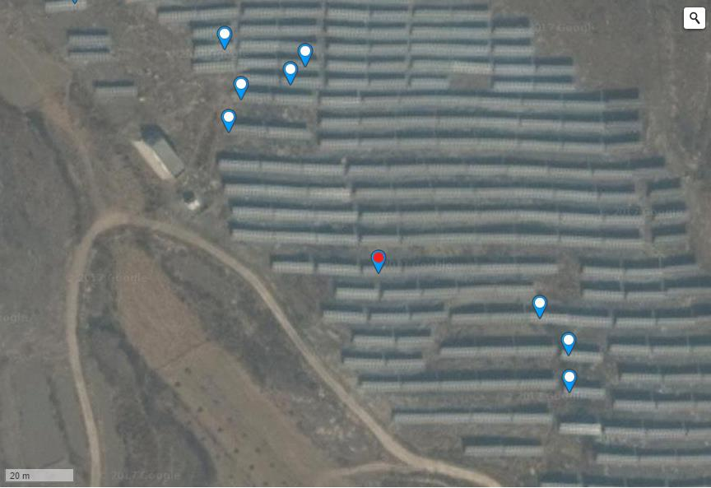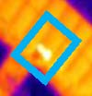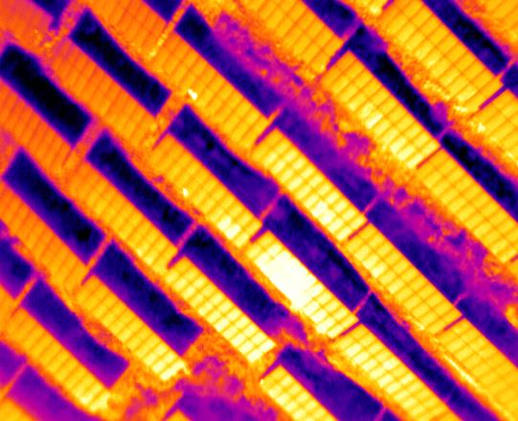
Hot Spot Temperature: 36.81℃;
Latitude: 38.708796305201 Longitude: 114.63993072509767;
Note: By Observing Visible Light Images, It Was Found That The Hot Plate Effect Is Caused By Surface Dirt;
There Is Sunlight Reflection Phenomenon;
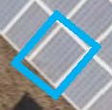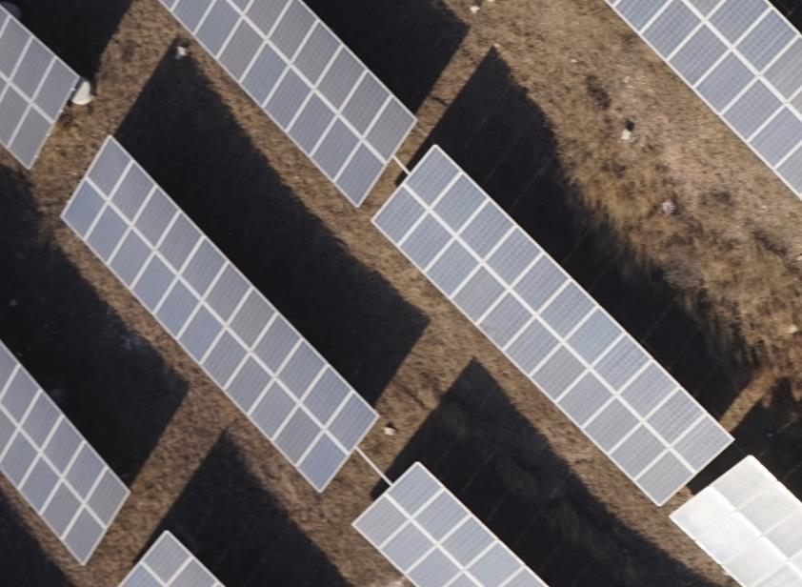

Fault Points 14~15: General Hot Spots (The Temperature Difference At The Fault Point Is Greater Than 20°C);

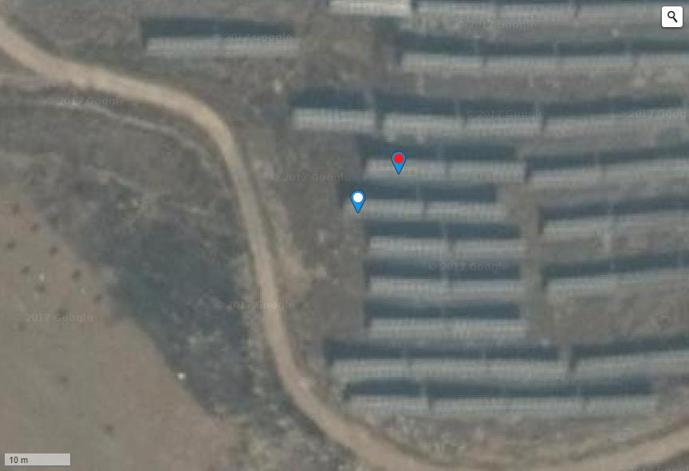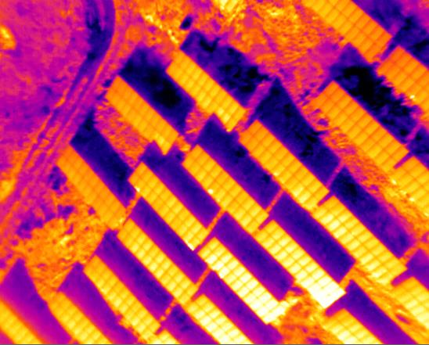
Hot Spot Temperature: 17.81℃;
Latitude: 38.70815269865902 Longitude: 114.64064821600917;
Latitude: 38.708095140068124 Longitude: 114.64058250188829;
Note: There Is Sunlight Reflection;
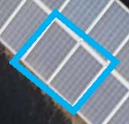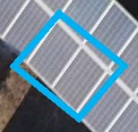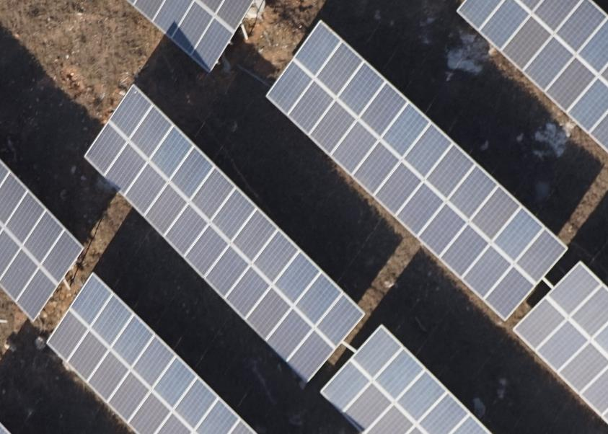

Fault Point 16: General Hot Spot (Temperature Difference At The Fault Point Is Greater Than 20°C);

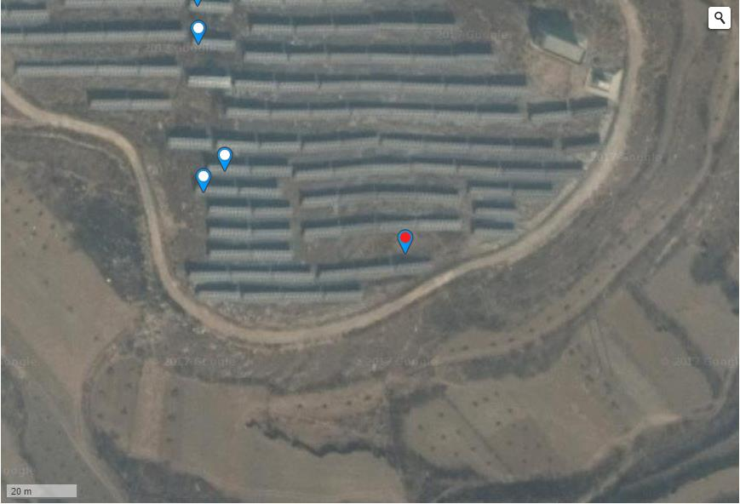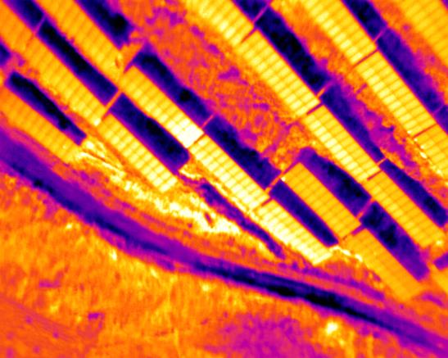
Hot Spot Temperature: 35.53℃;
Latitude: 38.70798002274739 Longitude: 114.64122623205188;
Note: There Is Sunlight Reflection;
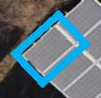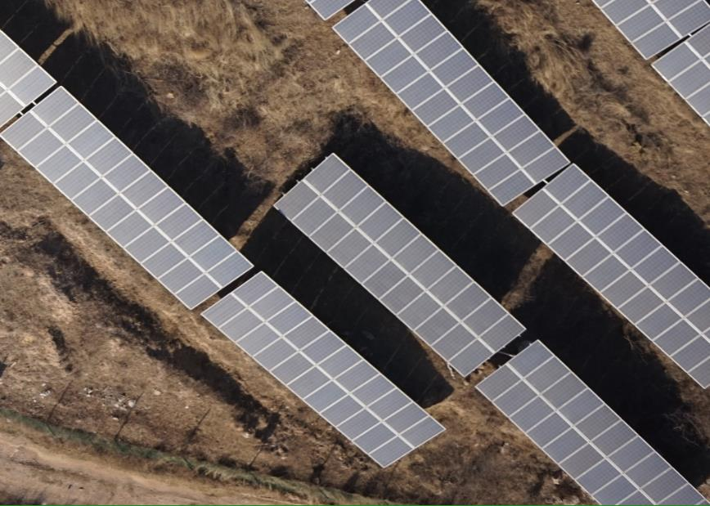

Fault Points 17~19: General Hot Spots (The Temperature Difference At The Fault Point Is Greater Than 20°C);

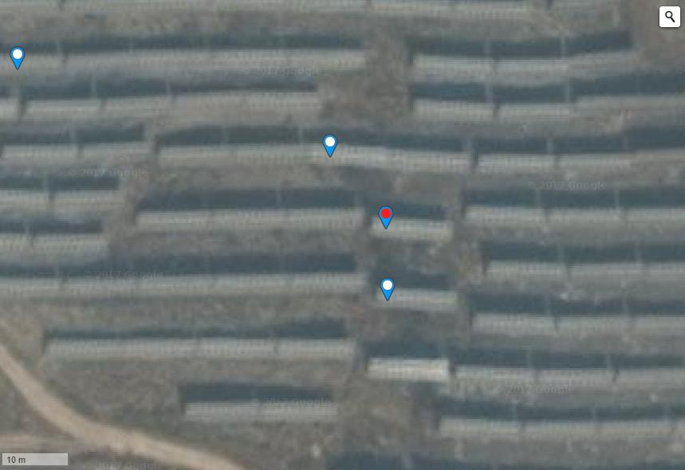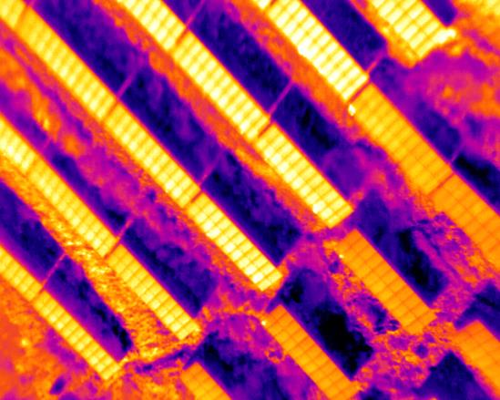
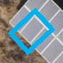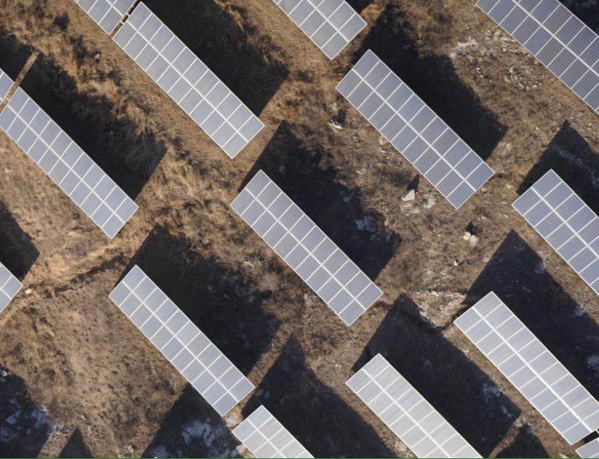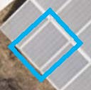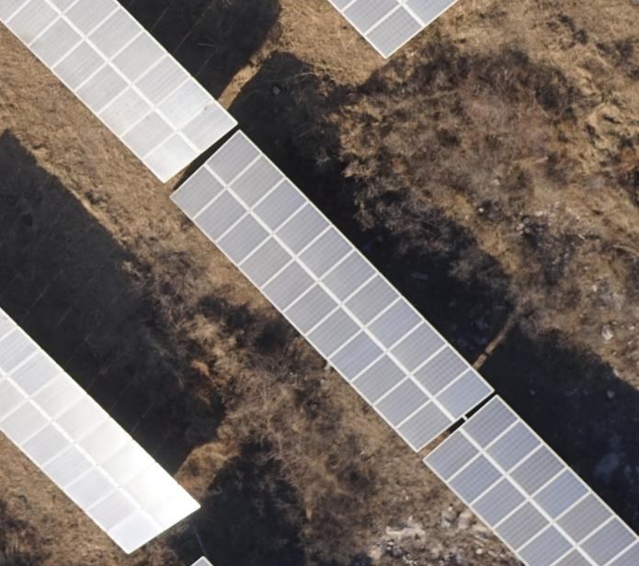
Hot Spot Temperature: 20.37℃;
Latitude: 38.70855770052468 Longitude: 114.64055970311166;
Latitude: 38.70846351424901 Longitude: 114.64057311415675;
Latitude: 38.70864665411552 Longitude: 114.64046716690065;
Note: There Is Sunlight Reflection;

Fault Point 20: General Hot Spot (Temperature Difference At The Fault Point Is Greater Than 20°C);
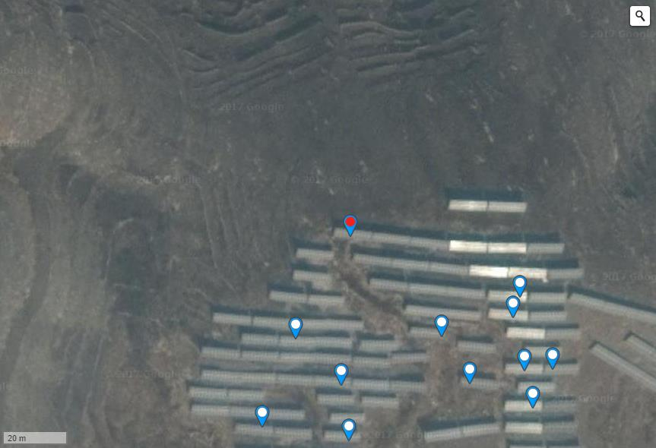
Hot Spot Temperature: 27.25℃;
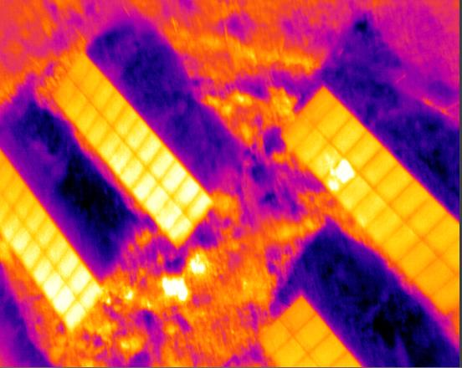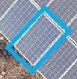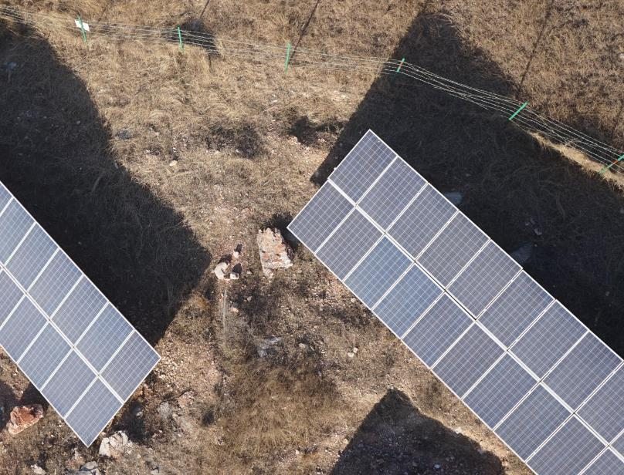
Latitude: 38.710420470259685 Longitude: 114.6391260623932;
Note: There Is Sunlight Reflection;

Fault Point 21: Severe Hot Spot (Temperature Difference At The Fault Point Is Greater Than 20°C);
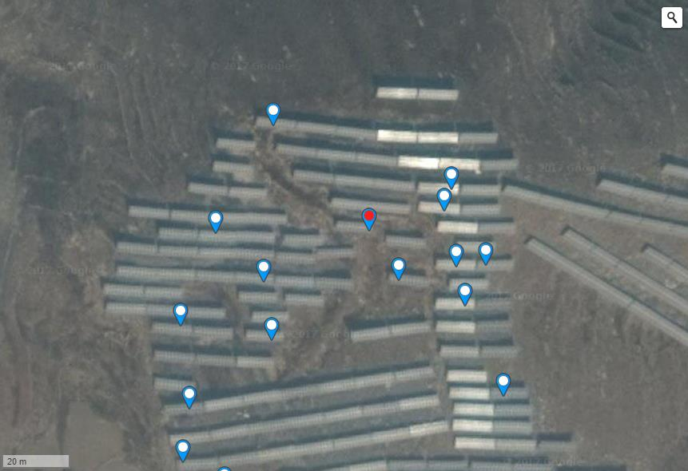
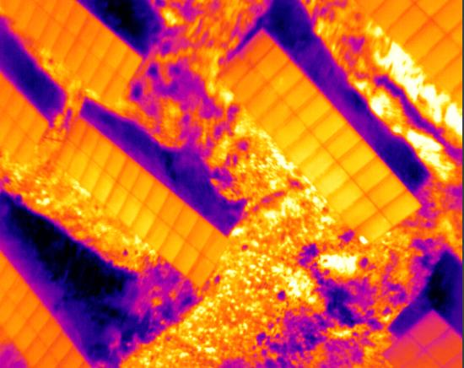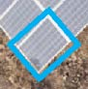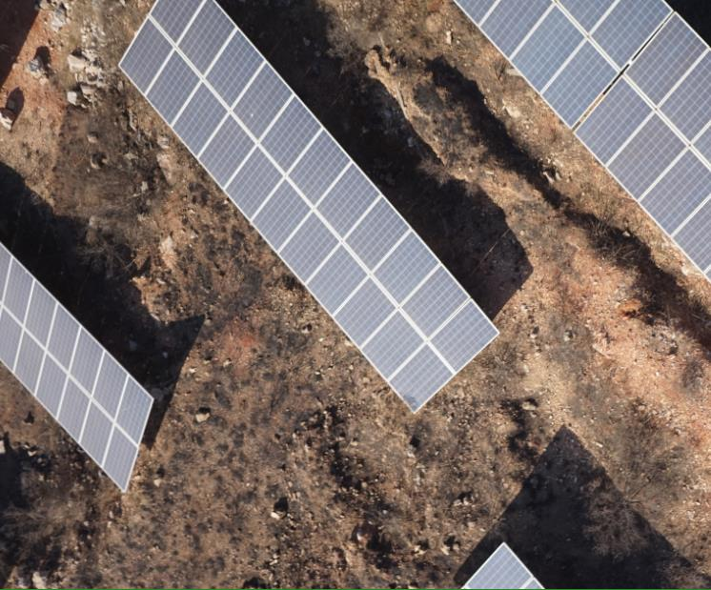
Hot Spot Temperature: 41.97℃;
Latitude: 38.71015466226625 Longitude: 114.63943451642993;
Note: Through The Observation Of Visible Light Images, It Was Found That The Hot Spot Effect Of The Component Is Caused By Surface Dirt Blocking;

Fault Point 22: General Hot Spot (Temperature Difference At The Fault Point Is Less Than 20°C);
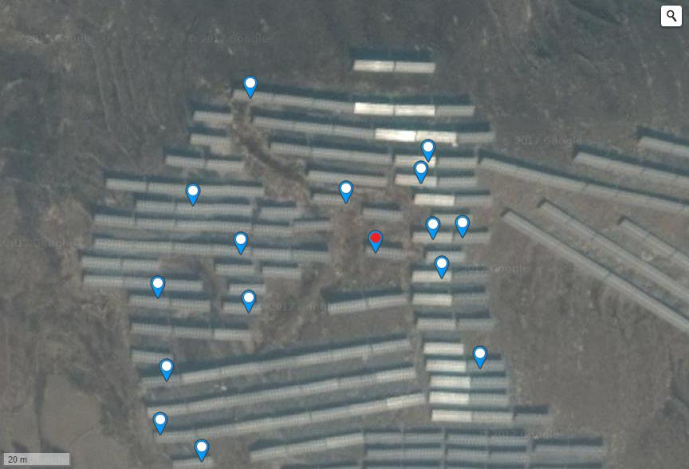
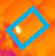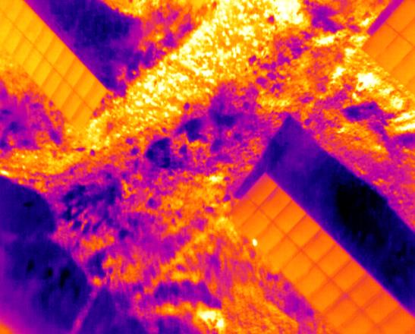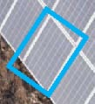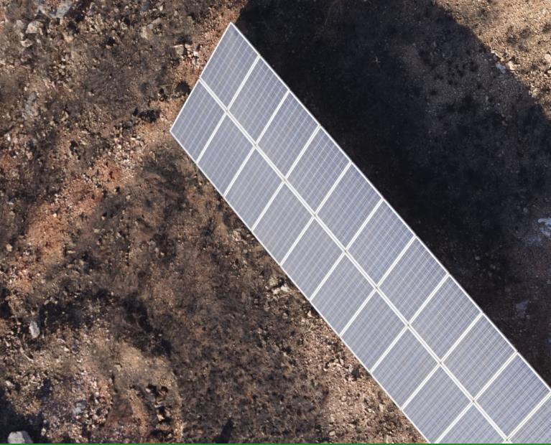
Hot Spot Temperature: 37.13℃;
Latitude: 38.710029083342945 Longitude: 114.63954448699953;
Remarks: None;

Fault Point 23: General Hot Spot (Temperature Difference At The Fault Point Is Less Than 20°C);
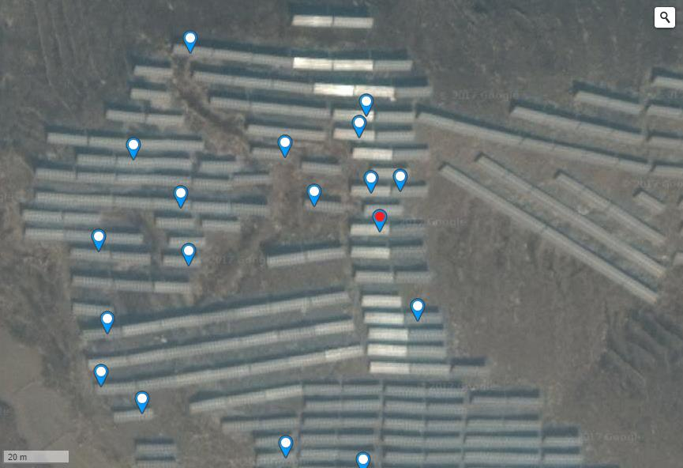
Hot Spot Temperature: 39.25℃;
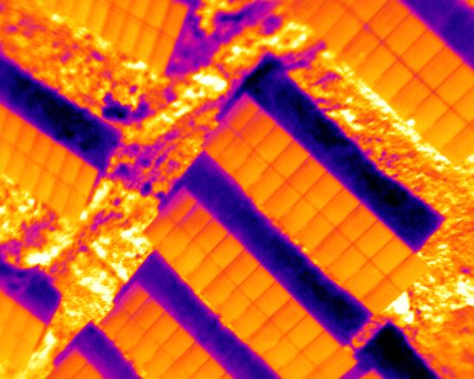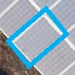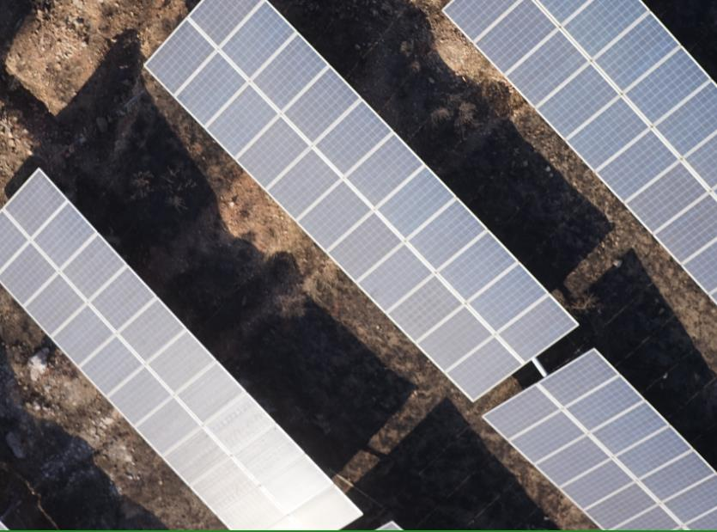
Latitude: 38.70995373588308 Longitude: 114.63976711034778;
Note: Through The Observation Of Visible Light Images, It Was Found That The Hot Spot Effect Of Components Is Caused By Weeds;

Fault Point 24: Severe Hot Spot (Temperature Difference At The Fault Point Is Greater Than 20°C);
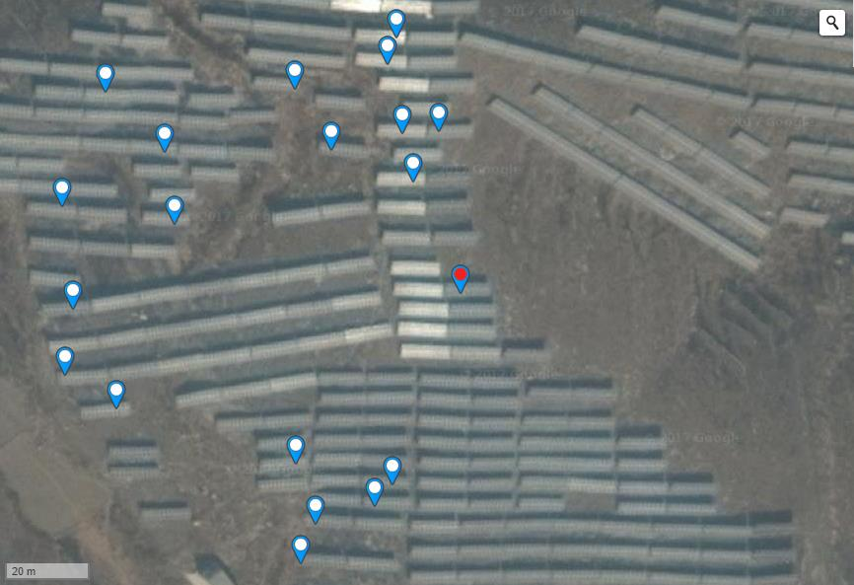
Hot Spot Temperature: 41.20℃;
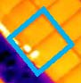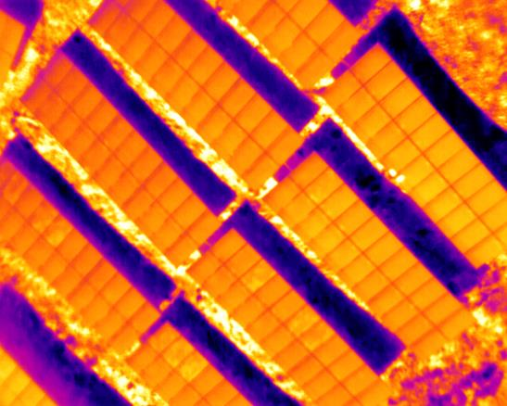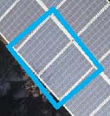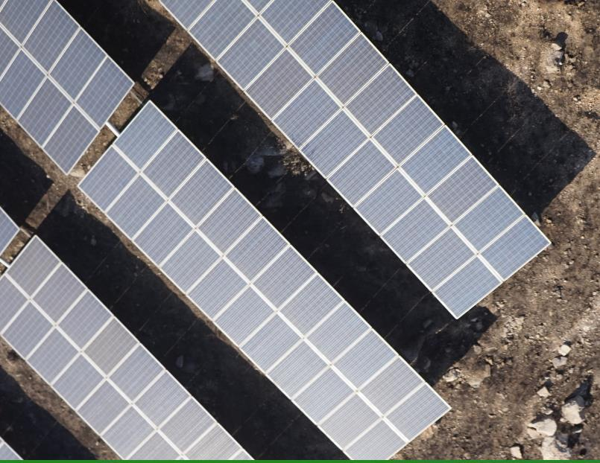
Latitude: 38.709725600034254 Longitude: 114.63989049196245;
Note: Through The Observation Of Visible Light Images, It Was Found That The Hot Spot Effect Of Components Is Caused By Weeds;

Fault Points 25~26: General Hot Spots (The Temperature Difference At The Fault Point Is Greater Than 20°C);
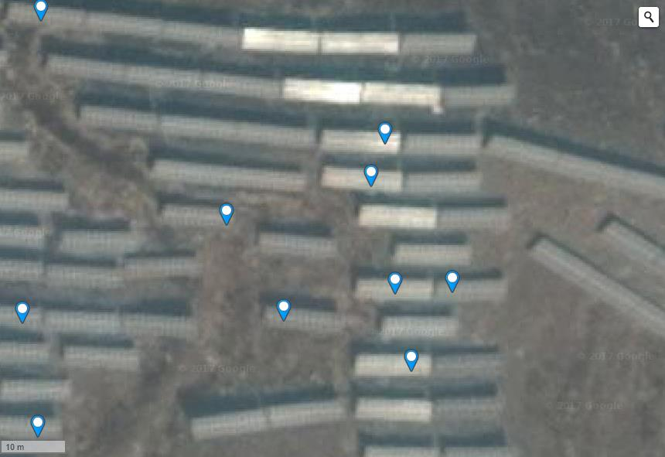
Hot Spot Temperature: 45.85℃;
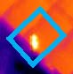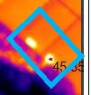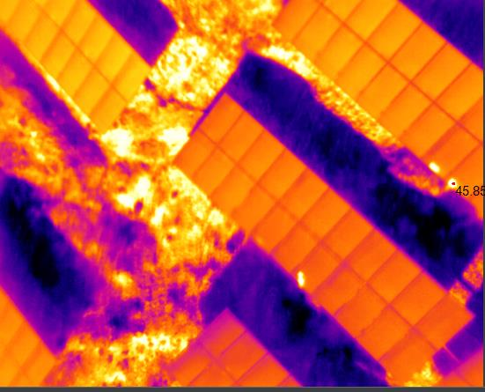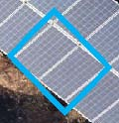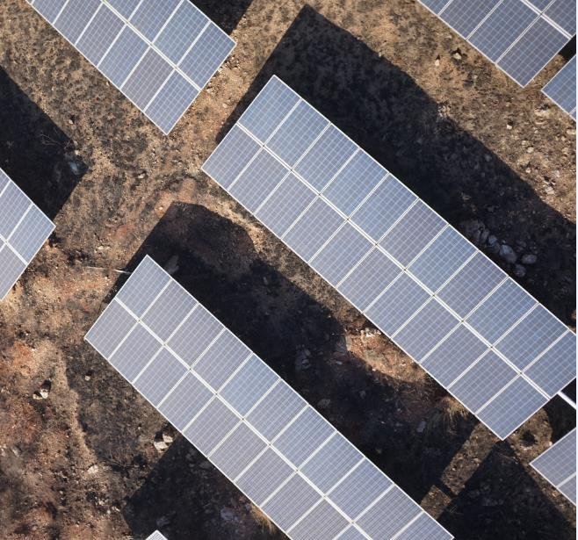
Latitude: 38.71026768310864 Longitude: 114.6397188305855;
Latitude: 38.71020489377383 Longitude: 114.63969200849535;
Remarks: None;

15#~16# Square Matrix (Example)
Component Model | ***250P | String | 22 Components/String
Detection Component Quantity | 8074 Blocks | Detection Component Quantity | 367
Hot Spot Effect Quantity | 20 | Number Of Current Mismatched Strings | 14
The Proportion | 0.25% | The Proportion | 3.81%

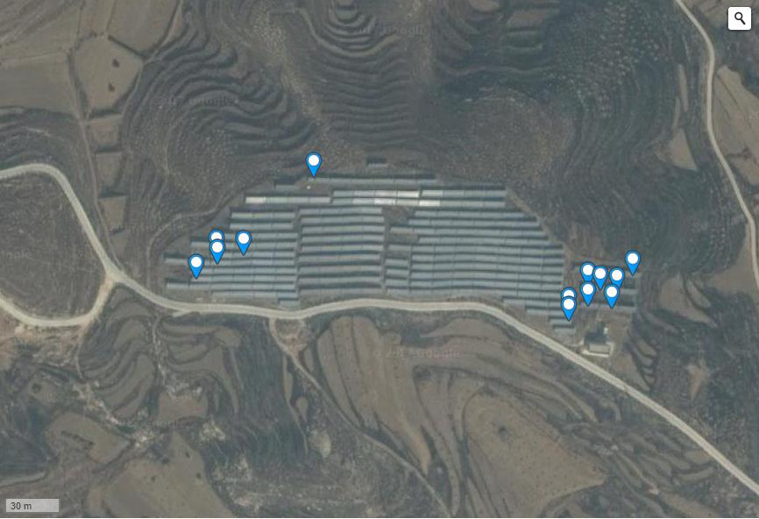
Full Picture Of Component Failure Location
Fault Points 1~8: General Hot Spots (The Temperature Difference At The Fault Point Is Less Than 20°C);

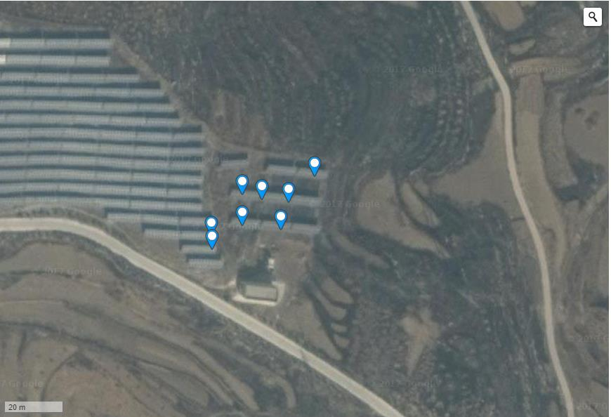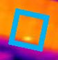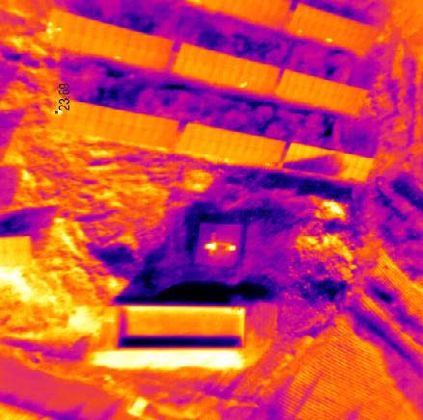
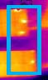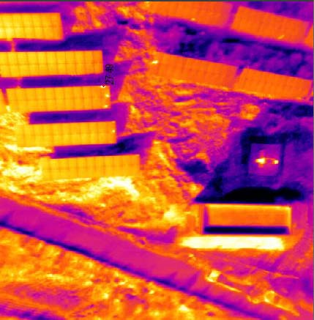
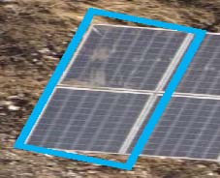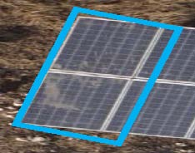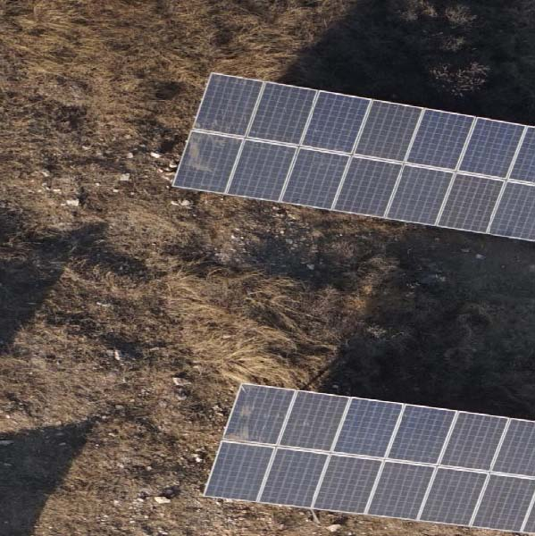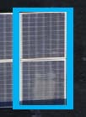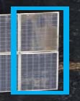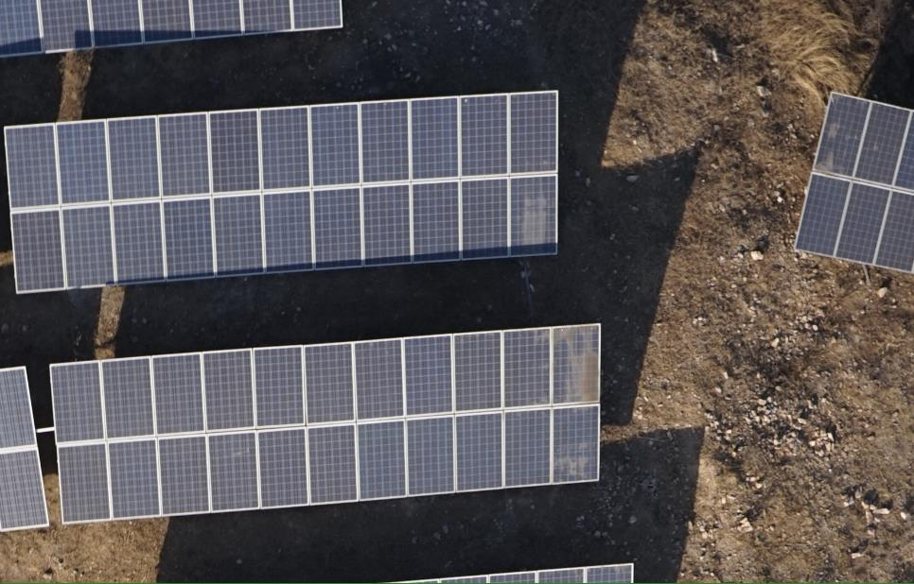
Hot Spot Temperature: 27.49℃;
Latitude: 38.69236839748515 Longitude: 114.64972883462909;
Note: By Observing Visible Light Images, It Was Found That The Component Hot Plate Effect Is Caused By Dirt On The Component Surface;

Fault Points 9~16: Components Are Damaged;
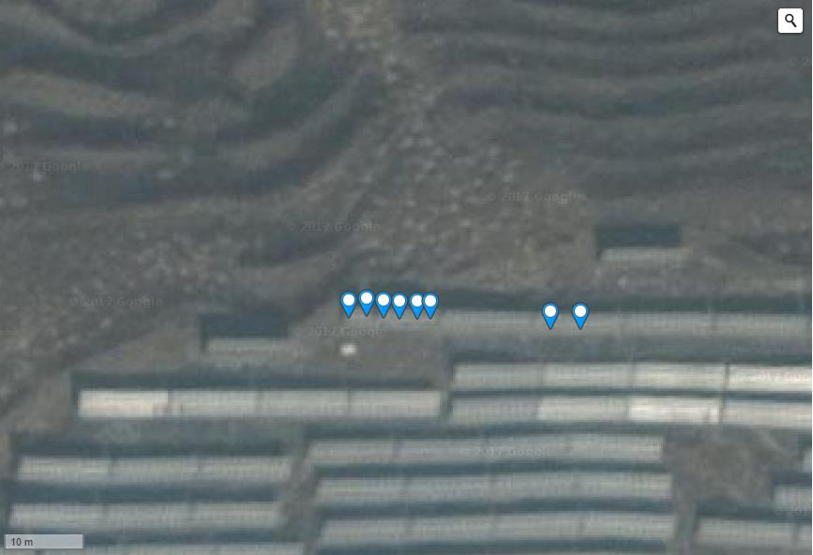
Hot Spot Temperature: 20.73℃;
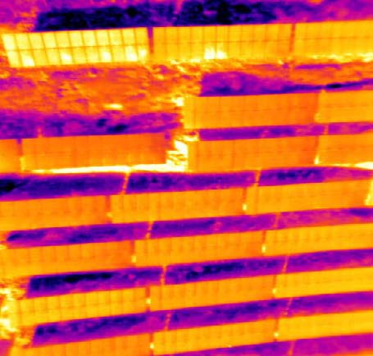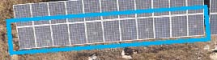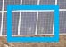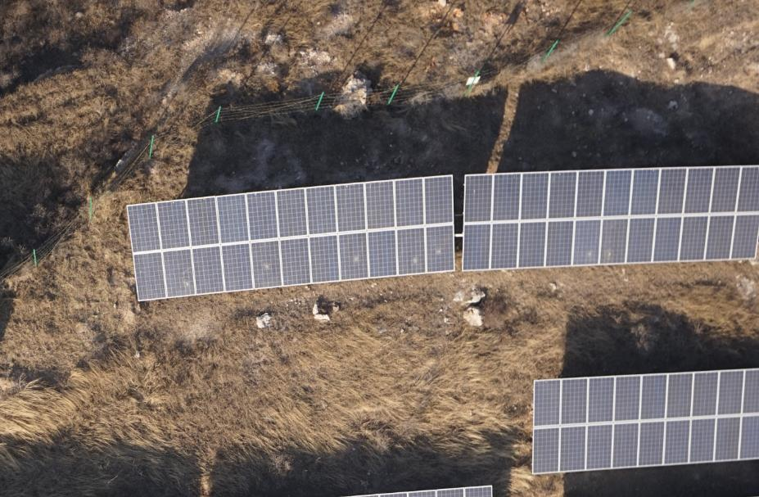
Latitude: 38.69295876228326 Longitude: 114.64822679758073;

Fault Points 17~20: General Hot Spots (The Temperature Difference At The Fault Point Is Less Than 20°C);
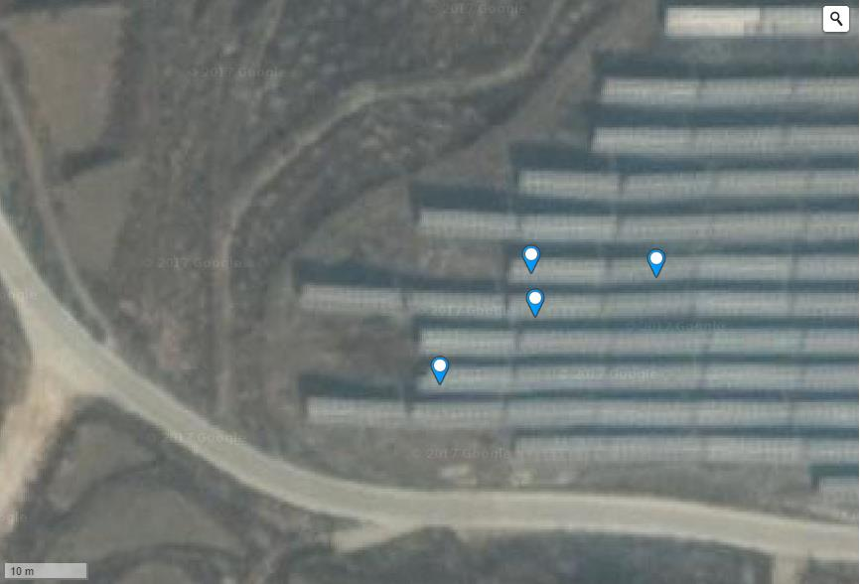
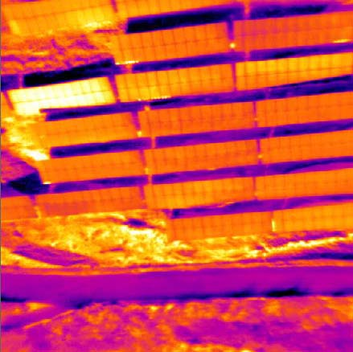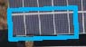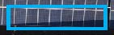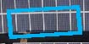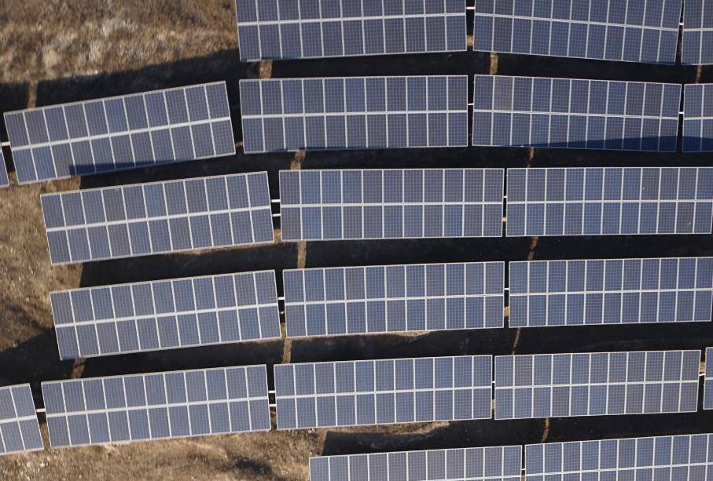
Hot Spot Temperature: 28.45℃;
Latitude: 38.69255681231175 Longitude: 114.64746236801147;
Latitude: 38.692476212696675 Longitude: 114.64733228087425;
Latitude: 38.692593448470404 Longitude: 114.64745163917542;
Latitude: 38.692589261481814 Longitude: 114.64761525392535;
Note: By Observing Visible Light Images, It Was Found That The Component Hot Plate Effect Is Caused By Component Occlusion;

*************************************************** *******************************
Fault Point Location Navigation Information
Serial Number | Fault Type | Longitude | Latitude | Line Number
1 | Local Hot Spot | 114.257346 | 38.410693 | #2
2 | Dust Accumulation | 114.256620 | 38.410828 | #2
3 | Dust Accumulation | 114.2566 | 38.41069 | #2
4 | Local Hot Spot | 114.2567 | 38.41069 | #2
5 | Dust Accumulation | 114.2566 | 38.41069 | #2
6 | Local Hot Spot | 114.2566 | 38.41069 | #3
7 | Dust Accumulation | 114.2566 | 38.41069 | #3
8 | Dust Accumulation | 114.2566 | 38.41069 | #3
9 | Damaged Components | 114.2566 | 38.41069 | #3
10 | Damaged Components | 114.2566 | 38.41069 | #3
11 | Damaged Components | 114.2566 | 38.41069 | #3
12 | Damaged Components | 114.2566 | 38.41069 | #6
13 | Damaged Components | 114.2566 | 38.41069 | #6

14 | Damaged Components | 114.2567 | 38.41069 | #6
15 | Damaged Components | 114.2566 | 38.41069 | #7
16 | Damaged Components | 114.2566 | 38.41069 | #7
17 | Local Hot Spot | 114.2566 | 38.41069 | #7
18 | Dust Accumulation | 114.2566 | 38.41069 | #7
19 | Dust Accumulation | 114.2566 | 38.41069 | #8
20 | Dust Accumulation | 114.2566 | 38.41069 | #8

*************************************************** *******************************
Thermal Field Map Of Inspection Area
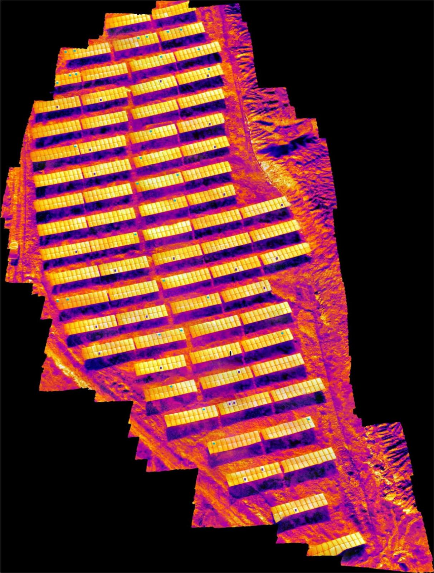
Thermal Field Map Of Inspection Area

