Foshan Yufei Technology Co., Ltd.
Electric Power Inspection Drone
Application Solution

1 Overview Of The Power Industry
1.1 Industry Background
At present, my country has formed six inter-provincial power grids including North China, Northeast China, East China, Central China, Northwest China and Southern Power Grid; the transmission lines above 110 KV have reached nearly 514,000 km. According to relevant data, the overall investment in my country's power industry is about 100 billion yuan every year, of which 73% is hardware facilities. This shows that transmission equipment plays an increasingly important role in the construction of the national power grid. As the power grid expands, the workload of line inspections increases. It is also increasing day by day, and 100km of line inspection work requires 20 line inspectors to work for one day to complete. Therefore, the traditional line inspection method can no longer meet the extensive needs of modern power systems.
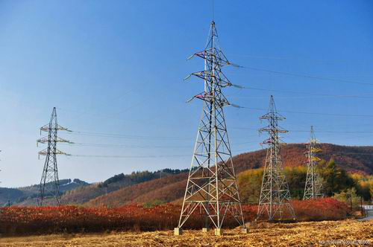
1.2 Industry Needs
The inability of line maintenance personnel to handle emergency power grid failures and abnormal weather conditions. With favorable transportation advantages, this method of using ordinary instruments to inspect facilities can no longer fully meet the needs of modern power grid construction and development. Ultra-high and ultra-high voltage power grids are in urgent need of advanced, scientific and efficient power line inspection methods. Especially for power lines that pass through primeval forest edge areas, high altitudes, and ice and snow-covered areas, there are frequent landslides, debris flows and other geological disasters along some lines. In most areas, the mountains are high and the slopes are steep. When transportation and communications are extremely underdeveloped, the daily life of power lines is reduced. Detection becomes a difficult task. Therefore, inspections are affected by many human factors, which endangers the lives of line inspection workers in dangerous areas. The amount of manual data entry is large and the data entry process is prone to errors. At the same time, the inspection of staff cannot be effectively managed, and inspections cannot be effectively managed. Quality cannot be guaranteed, and the safety of the lines cannot be guaranteed, leaving potential safety hazards.

2 Application Solutions
2.1 Y-flight UAV
Relying on the top domestic drone expert team and superb technical support, Y-flight UAV has launched a large-load fixed-wing electric inspection drone. This series of UAVs is an aerial platform with excellent performance. It adopts an intelligent system and has functions such as automatic takeoff, mission planning, route flight, fixed-point reconnaissance, regional reconnaissance, and automatic landing. The mid- and low-altitude monitoring system has technical characteristics such as fast maneuverability, low cost of use, and simple maintenance operations. It also has the ability to quickly and real-time patrol and monitor the ground. It is a new type of mid- and low-altitude real-time transmission and infrared imaging rapid acquisition system. It is very important for my country's power supply. Line corridors have unique advantages in terms of difficulty in detection due to the need to cross various complex geographical environments.
2.2 Scheme Design Specifications
Standards And Laws And Regulations For System Implementation
Serial Number | Standard | Name
1 | GB 4208 | Enclosure protection level (IP code)
2 | GB/T 15498-2003 | Enterprise standard system, management standard and work standard system
3 | GJB 2347 | General specifications for drones
4 | GJB 3060-1997 | General specifications for UAV electrical systems
5 | GJB 3065-1997 | General specification for carbon fiber unidirectional and fabric prepregs
6 | GJB 3728-1999 | UAV ground test requirements
7 | GJB 5434-2005 | General requirements for flight testing of unmanned aerial vehicle systems
8 | GJB 5435-2005 | UAV Strength and Stiffness Specifications
9 | GJB 5433 | General requirements for unmanned aerial vehicle systems
10 | GJB/Z105 | Electronic Products Anti-Static Discharge Control Manual
11 | HB 5662 | Aircraft equipment electromagnetic compatibility requirements and test methods
12 | HB 6434 | Basic requirements for interface design of airborne electronic equipment
13 | QJ 2245 | Anti-static requirements for electronic instruments and equipment

2.3 Plan Design Basis
1) People-oriented, humanized design, with customer service as the purpose, improve the efficiency of power inspection and reduce the difficulty of operation.
2) Fully consider the working environment of the power inspection drone and adopt an industrial-grade design. The electromagnetic compatibility design of the whole machine complies with the relevant regulations of RTCA/DO-160F and can be used normally when it is 5m away from AC and DC transmission lines of 500kv and above.
3) The ground station uses a high-brightness screen, which is suitable for field operations, and has multiple functions for easy use by operators.
4) It can quickly patrol the line, quickly obtain image data in a short time, transmit it back in real time, and make real-time decisions. The captured data can also be brought back for analysis, so that there are no blind spots during the inspection.
5) Can identify various transmission line defect problems. For example, it can identify key parts prone to accidents such as foundations, towers, brackets, wires, insulators, anti-vibration hammers, tension clamps, suspension clamps, etc. of overhead transmission lines. It can also identify man-made equipment, theft, tree discharges, lightning strikes, and pollution. , fog, etc. that affect transmission lines and cause line performance degradation.
6) The overall solution has low usage and maintenance costs, high efficiency, convenient transportation and easy to master. After one investment, the cost of each line inspection is extremely low.

2.4 Scheme Implementation Principle
The system application plan is based on the YF -866S unmanned aerial vehicle and is equipped with payloads (photoelectric pods) such as a gyro-stabilized visible light detector and an infrared thermal imager to inspect and record transmission lines.
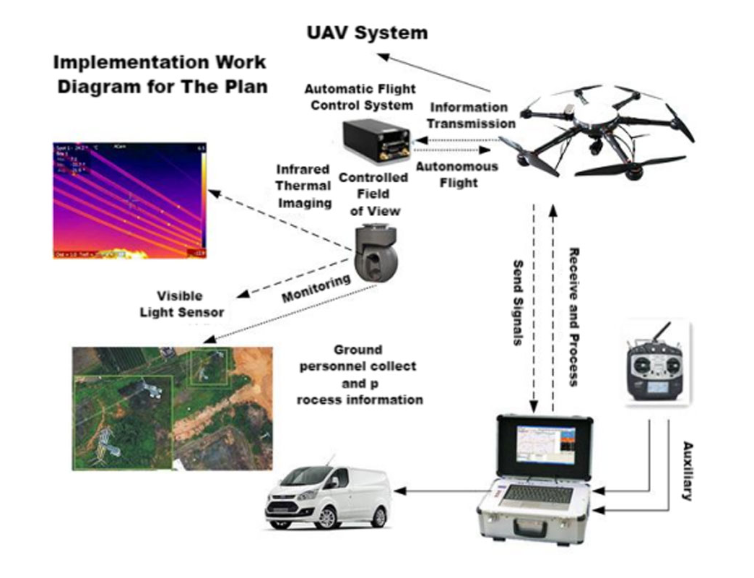
System inspection process: Y-flight UAV is equipped with mission equipment such as cameras, infrared thermal imagers or wire damage detectors; the ground control station with autonomous navigation and positioning function allows ground staff to set flight parameters and control the aircraft to take off autonomously along the line. It flies up and down; the digital image transmission station transmits video recordings during inspections in real time; ground inspectors judge the route conditions based on the real-time video and determine the location based on GPS positioning and record it. After completing a flight mission, the aircraft lands autonomously and is recovered.
Y-Flight Power Inspection Drone System Meets The Following Requirements:
(1) Support the required monitoring frequency.
(2) Have a certain battery life and support the required monitoring range;
(3) Able to adapt to the special meteorological and terrain environments in complex power pipeline network inspection operations;
(4) Real-time transmission capability of monitoring information;
(5) The equipment is modular and can be quickly switched to meet the inspection needs of different operations;
(6) Ease of training and operation, and adaptability to take-off and landing environments;
(7) It can meet the characteristics of distribution of power pipeline network and being far away from population centers.

2.5 Solution Equipment Composition
Y-flight power inspection UAV is composed of Y-flight UAV flight platform, automatic flight control system, measurement and control communication equipment, task load equipment and ground station control system. The UAV flight platform is responsible for completing the flight mission; the automatic flight control system is responsible for the autonomous flight control of the aircraft; the measurement and control communication equipment is responsible for two-way data communication between the aircraft and the ground and the transmission of aerial photography and mapping data; the mission load is mainly photoelectric pod equipment, supporting Visible light and infrared camera functions; the ground station is responsible for aircraft route planning, real-time adjustment of flight attitude and other tasks, and control of the rotation angle of the photoelectric pod.

2.5.1 UAV Flight Platform

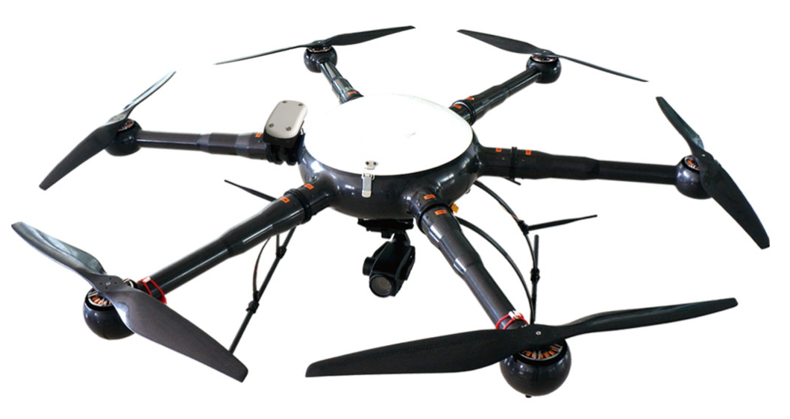
Y-flight Electric Power Inspection UAV flight platform adopts YF-866S six-rotor industrial UAV, which is made of carbon fiber composite materials. It has a modular structure and can be assembled in 5 minutes. Transportation and assembly are very convenient. YF-866S UAV is easy to operate and has strong industry applicability. It has the characteristics of longest flight time and stable flight at the same level, making the operation more convenient and reliable.
1) Structural Features
The new all-carbon fiber integrated machine technology has a stronger structure and lighter weight. The load capacity and flight time are guaranteed.
The entire machine adopts a modular design, and the arms, upper cover, fuselage, landing gear, load and other parts that need to be assembled can be quickly disassembled and assembled.
2) Working Environment
The working temperature ranges from minus 20 degrees to plus 60 degrees Celsius, ensuring normal operation in most places.
Wind resistance level: Level 6
It can work normally in places with high humidity and heat.
3) Technical Parameters
Drone physical indicators:
1. Body material: one-piece carbon fiber;
2. Motor: waterproof brushless motor;
3. Blade: 24-inch high-strength carbon fiber propeller;
4. Axis distance: 1250 mm;
5. Height: 500 mm;
6. Empty weight: <5kg
7. Maximum diameter: 1820 mm;
8. Battery pack: 6S1Px2x16000mAh
9. Storage box size: 800mmx800mmx430mm
UAV Performance Indicators:
1. Flight ceiling: 5000 m above sea level;
2. Whether there is RTK: Yes
3. Working height: ≤ 5000 m;
4. Maximum take-off weight: 18kg;
5. Battery life: Battery life >50min;
6. Power supply: military battery, total capacity 32000 mAh, voltage 22.2 V, equipped with 1 set of balancing charger;
7. Waterproof level: ≧IP45
8. Maximum lifting speed: 5 m/s;
9. Cruising speed: 10 m/s;
10. Hovering accuracy: ±0.2m in vertical direction, ±1m in horizontal direction;
11. Flight mode: autonomous flight, manual flight;
12. Minimum take-off and landing space: 4m*4m
13. Operating temperature: -20 ℃ ~ +60 ℃;
14. Environmental humidity: ≤95%;
15. Modular design: fully interchangeable;
16. Airborne POS: Airborne POS records fixed-point exposure posture information;
17. Double star positioning: Beidou and GPS dual system positioning;
2.5.2 Automatic Flight Control System
The automatic flight control system includes airborne flight control, ground station software, etc. It can stably control the Y-flight drone to fly unmanned in various environments. It is simple and convenient to use, has high control accuracy, and has strong GPS navigation automatic flight function. It can set the flight altitude, flight speed, etc., and has various task interfaces. Convenient for users to use various task equipment. It can complete autonomous takeoff and landing, route flight, etc. In addition, there are many safety protection solutions to ensure flight safety and failure protection to the greatest extent.
2.5.3 Ground Control Station System
The ground station system includes ground station notebook, ground digital transmission radio, serial port connection, and digital transmission antenna. The two-way data communication between the ground station software and the aircraft mainly has the following functions: setting flight control parameters, calibrating and setting sensor parameters, real-time adjustment of autonomous flight PID, monitoring and controlling flight status, graphically displaying flight data, controlling task loads, and playing back flight data.
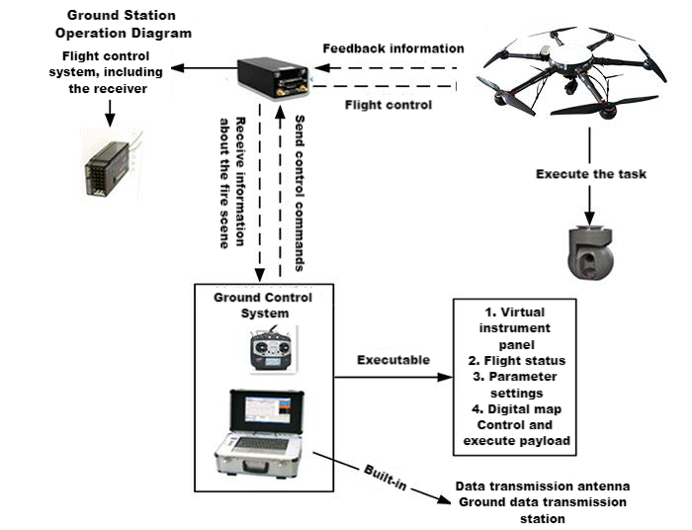
The Ground Station Can Mainly Achieve The Following Functions:
1) Communicate with the autopilot. The ground station control software communicates with the autopilot and data link through the serial port using the agreed communication protocol.
2) Flight control, send flight navigation instructions to the autopilot, switch flight modes, change routes in real time, customize tasks, etc.
3) Moving map, map loading, coordinate calibration, display, dragging, zooming; real-time flight track display, waypoint display and editing.
4) Route planning: edit waypoints on the electronic map, upload them to the aircraft after editing, and then download the waypoints in the autopilot to the ground station, and compare them with the edited waypoints to avoid missing waypoints.
5) Virtual instruments. Virtual instruments intuitively display various important data such as the aircraft's attitude, altitude, heading, throttle, and voltage.
6) Aircraft status and sensor value display, displaying various flight status and sensor values numerically or graphically.
7) Parameter configuration to ensure flight safety and ensure the smooth progress of the mission.

2.5.4 Task Load Equipment
The mission load mainly consists of optoelectronic pods. The pod is equipped with a dedicated high-definition 1080p visible light and infrared thermal imaging camera for inspection.
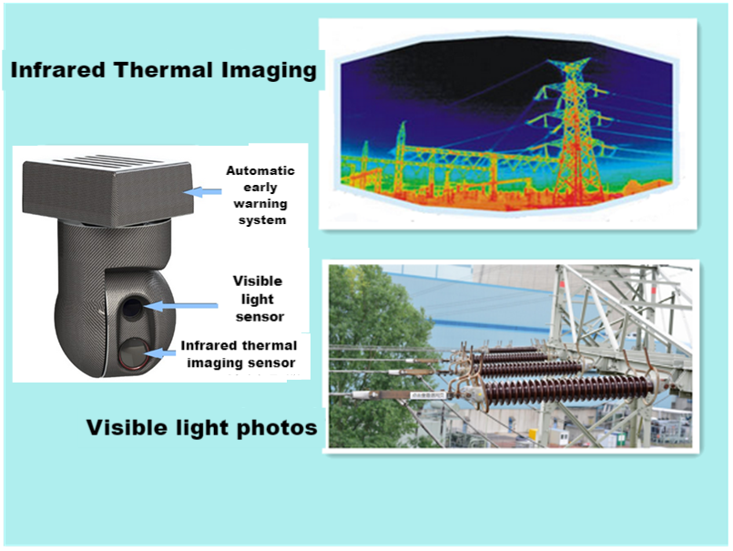
YF_SG14X is a 12-megapixel visible light movement with 14x zoom (3.5x optical*4x digital), and a 640*480 resolution, 50Hz, 25mm lens uncooled thermal imaging movement. Dual-light three-axis gimbal camera with target tracking function.
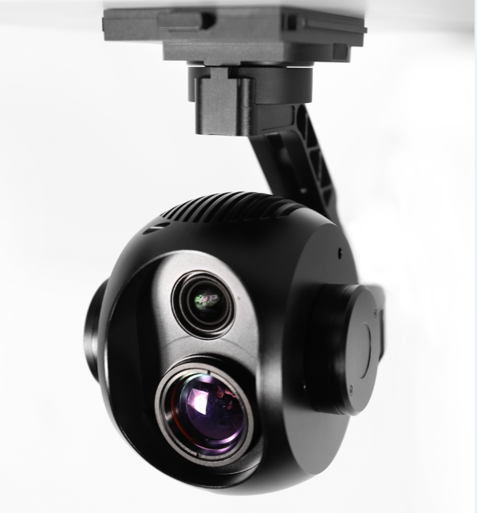
- Features
Easy to Operate
Point to zoom, return to center with one click, and operate the pod with the mouse or touch screen, making it easier to get started and operate more accurately.
GPS information record: (needs to be paired with customized flight control or open protocol, user-developed)
Video: subtitle file record. Photos: Picture overlay, POS point information. Special functions, more practical.
Quick Release
Patented design, convenient, reliable, tool-free quick disassembly, convenient for storage and replacement of other pod equipment.
High Precision
±0.008° control stabilization accuracy, industry leading. The image is still stable even at the maximum focal length and during rapid flight movements.
High Pixels
Visible light 12 million effective pixels, the picture is clearer.
Zoom
Visible light: 14x zoom (3.5x optical*4x digital) makes it easier to see details.
Smart Tracking
Intelligent target tracking makes tracking moving targets easier and more convenient.
Modular
The X30 series pods can be quickly switched without tools through the quick-release shock-absorbing structure. It is convenient to quickly replace other task equipment according to different usage scenarios. X30 pod (30x zoom, 5 million pixels), X30T pod (35x zoom, intelligent tracking),
Highly Expandable
, the pod series can be modularly replaced to adapt to different application scenarios. Standardized pod interface. There is also CAN bus expansion. Great room for expansion.
Open SDK
The ground station end is open, allowing users to integrate it into their own ground station software. Air unit: Data transmission and CAN bus interface are open for easy access to third-party flight control software. Share flight control data information, share data links, and remote control links.
- Technical Parameters
Overall Parameters
Product Name | D640 Dual Light Zoom Pod
Operating Voltage | 12V-25V
Power | 8.4W
Weight | 786g
Memory Card Type | Micro SD Card (Single Card)
Dimensions (Length, Width And Height) | 136*96*155mm
Interface Type | RJ45 (Network Port)
Control Display Mode | Windows System PC; Android Phone, Tablet (With Flight Control)
Real-Time Transmission Resolution | Thermal Imaging: 640*480 Visible Light: 720P, 1080P
Environmental Parameters
Operating Temperature | -10°~45°
Storage Temperature | -20°~70°
PTZ Parameters
Angle Jitter | ±0.008°
Installation Method | Removable
Controllable Rotation Range | Pitch: +70° To -90°; Heading: ±160°
Structural Design Scope | Pitch: +75° To -100° Heading: ±175°; Roll: +90° To -50°
Maximum Control Speed | Pitch: 120º/s; Heading 180º/s
Smart Target Tracking | Support
Camera Parameters
Visible Light
Sensor | CMOS:1/2.3″; Total Pixels 13 Million
Lens | 3.5x Optical Zoom Lens  F:3.85~13.4mm  Minimum Shooting Distance: 1m~3m (Near Focus~Far Focus)  Field Of View (Horizontal): 82~25°
Image Storage Format | Jpeg
Video Storage Format | Mp4
Operating Mode | Video; Take Pictures;
Through Fog | Electronic Fogging + Optical Fogging (Automatically Turned On)
Exposure Mode | Automatic Exposure
Resolution | 30fps;25fps(3840*2160)8 Million  Maximum Capture Resolution: (4024*3036) 12.22 Million
2D Noise Reduction | Support (Automatically Turned On)
3D Noise Reduction | Support (Automatically Turned On)
Electronic Shutter | 1/3~1/30000 Seconds
Exposure | Automatic Mode;
Information Video Overlay (Osd) | Support
Point To Zoom | Support
Pointing Zoom Range | 1~3.5x Optical 4x Digital
Zoom To Single Image With One Click | Support
Thermal Imaging
Detector Performance
Detector Type | Uncooled Infrared Microbolometer
Resolution | 640*480
Sensitivity | ≤60mk@300k
Frame Rate | 50Hz
Optical Properties
Lens | 25mm Fixed Focus Lens
F Number | 1.0

2.6 Plan Implementation Process
2.6.1 Introduction To Line Patrol Work
(1) Preparatory Work For Line Inspection
First, the ground staff conducts a three-dimensional positioning of the longitude, latitude and height of the tower, and then performs the initial positioning of the line. Input these parameters into the ground station for 3D image editing to set the flight route and hovering coordinates of the drone; at the same time, you can also determine the flight distance and take-off and landing location of the drone to provide battery life for the drone. Replace the battery and select the stopping point in advance to ensure flight safety.
(2) Introduction To Work During Line Patrol
After all preparations are completed, take off with one click. During the line patrol process, the drone performs operations according to the hovering, advancing and changing course instructions of the ground staff as well as the rotation adjustment and monitoring direction of the gimbal.
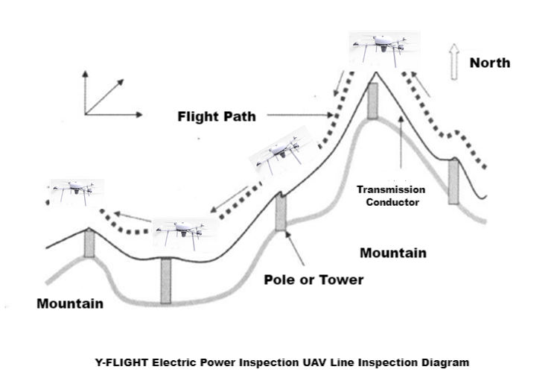
2.6.2 Cruise Mission
The system can perform at least three tasks: fault line patrol (quickly and accurately find fault points of the power grid and its equipment), regular line patrol (replacing manual regular line patrol, improving line patrol efficiency, reducing line patrol costs, and reducing line patrol costs). personnel labor intensity), annual patrol (replacing manned aircraft to implement the annual planned aviation patrol).
Three Mission Situations:
(1) UAVs for Emergency And Routine Flights
Solving the problem: Transmission equipment faces severe natural disasters
First of all: UAVs can quickly respond to emergencies and are suitable for natural disaster warning patrol flights and accident emergency flights;
Secondly: through large-scale flight inspections quickly, we can grasp the hidden danger points of accidents at the first time.
Finally: the degree of damage on the ground is understood through aerial photography and mapping. The ground workstation immediately notifies the transmission management office and the emergency repair team to carry out emergency repair and maintenance based on the real-time aerial monitoring data.
Advantages of emergency repair: It improves the efficiency of the emergency repair team in handling emergency incidents, quickly and accurately conducts damage assessment for disaster-stricken areas, and wins valuable and sufficient time for emergency repair of power towers and wires.
(2) UAV Visible Light Inspection Flight
Solve the problem: Carry out daily line inspection tasks regularly.
First of all: the drone conducts an automatic flight inspection based on the GPS coordinates of the power tower programmed in advance. The inspection content includes the following: diversion lines (with or without broken strands), pole towers (with or without bird nests, damage) , deformation, loose fastening hardware and theft of hardware), insulators (whether there are signs of falling, damage, dirt, foreign objects hanging), anti-vibration hammers (whether there are deformations, the presence of foreign objects), wire clamps (whether they are loose), wires (Whether there are broken strands or hanging foreign objects), ground environment (whether there are houses built within the specified range and plants growing outside the range), etc.;
Secondly: UAVs perform inspection and monitoring and synchronously transmit them to ground staff in real time.
Finally: After the drone completes the inspection mission, the ground staff will judge the inspection results based on the inspection content information, and formulate corresponding solutions according to the specific situation.
Advantages of conventional visible light line patrol: It is used for daily line patrol tasks. Compared with traditional ground manual patrols, UAV visible light line patrol has the characteristics of high work efficiency, high accuracy, and large working range; compared with manned aircraft line patrol, , UAV line inspection has obvious advantages such as high safety, low operating cost, and strong real-time performance.
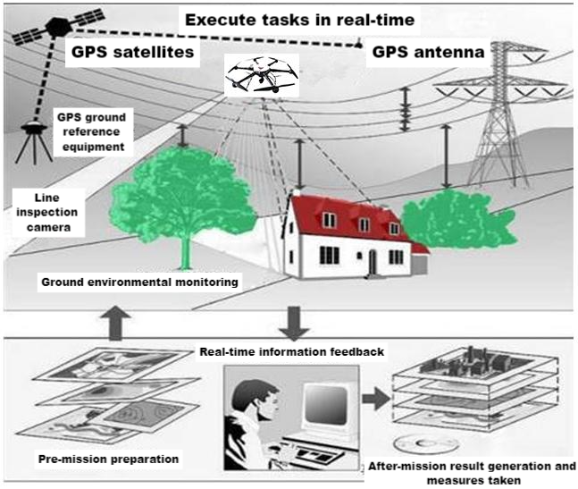
UAV Line Patrol Icon
(3) Inspection flights of drones equipped with infrared thermal imaging equipment
Problem solved: Transmission equipment failed during the night. The picture below shows the effect of infrared photography at night.
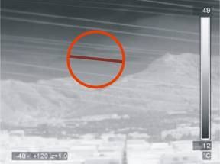
Illustration Of Infrared Camera Effects At Night
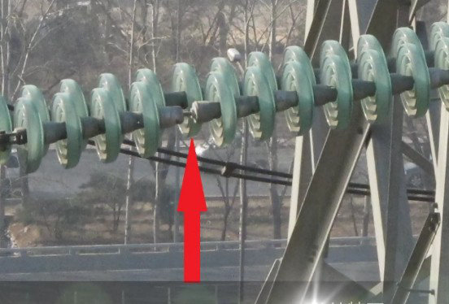
An Insulator Was Found To Have Fallen Off During Work
UAVs are equipped with infrared thermal imaging equipment to inspect inspection lines. By comparing abnormal temperature changes, they can find hidden fault points. Combined with traditional visible light patrols, thermal imaging patrols will greatly improve the accuracy of fault point detection. accuracy. Drones equipped with infrared thermal imaging equipment inspect power transmission equipment at night based on the following judgment criteria: wires (with or without red hot spots), clamps (with or without contact point heating), drainage wires (with or without hot spots), insulators (with or without breakdown) heating), pole tower (with or without breakdown heating), tensile tube (with or without heating).
Advantages of emergency repair: It improves the efficiency of the night repair team in handling emergencies. The drone is equipped with infrared thermal imaging equipment to quickly and accurately conduct infrared inspections of fault points, gaining valuable and sufficient time to find fault points and repair wires. As shown in the picture above, an insulator was found to have fallen off during operation.

3 Y-Flight Power Inspection Drone Line Inspection
Traditional line patrol icon
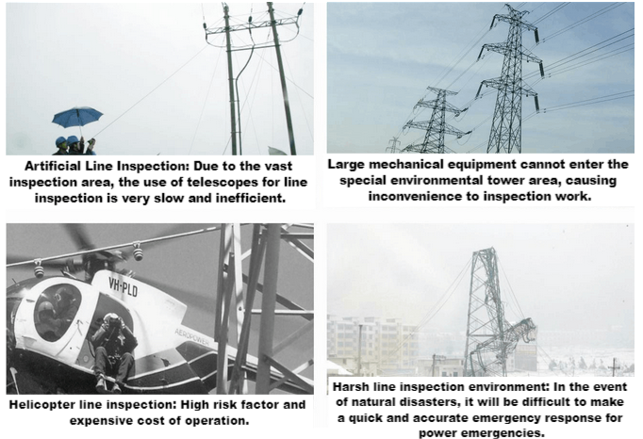
Advantage Comparison
Problems With Traditional Line Patrol
First: the line patrol distance is long, the workload is heavy, and the walking line patrol efficiency is very slow, which cannot improve the line patrol efficiency;
Second: In the event of natural disasters such as ice, snow, floods, earthquakes, and landslides, line inspection work will not be carried out;
Third: Line patrols in mountainous areas are highly risky and threaten the lives of line patrol personnel at all times. A large number of potential hazards endanger human life.
Advantages Of Drone Patrol
Y-flight UAV: a fully independently developed autopilot, the body is easy to carry, simple to operate, can hover for a long time, has a wide range of mission uses, has low environmental requirements for takeoff and landing, and can achieve fully autonomous flight.
Drone Advantages:
First: UAV line inspection improves the speed and efficiency of power maintenance and repair, allowing many tasks to be completed quickly in a completely electrified environment, ensuring the safety of electricity use. According to relevant information, drone line patrols are 40 times more efficient than manual line patrols.
Second: The use of drones for regular transmission line inspections can reduce labor intensity and improve the safety of line patrol workers compared with manned helicopter patrols, and the cost of drones is only 5-15 times that of manned aircraft. %, and the flight cost is only 1-5%.
Third: UAVs have the characteristics of fast line inspection and rapid emergency response, and can detect defects in time and provide timely information, avoiding line accidents and power outages, and recovering high losses in power outage costs.

4 Actual Photos Of The Tower Inspection
