Foshan Yufei Technology Co., Ltd.
Photovoltaic Industry Drones
Application Solution

1 Overview Of Photovoltaic Industry
1.1 Industry Background
Energy and environmental issues are two outstanding issues that restrict the sustainable development of the world economy and society. Since the Industrial Revolution, the consumption of fossil energy such as oil, natural gas and coal has increased dramatically, and the pressure on ecological and environmental protection has increased day by day, forcing countries around the world to seriously consider and take effective countermeasures. Energy conservation and emission reduction, green development, and the development and utilization of various renewable energies have become the development strategies of countries around the world.
Solar energy is a type of renewable energy. It has the characteristics of large reserves, permanent, clean and non-polluting, renewable, and locally available. Therefore, it has become the best energy choice currently known to mankind. With the implementation of the global sustainable development strategy, photovoltaic cell technology has received strong support from the governments of many countries and is widely used around the world. Especially in the 21st century, the photovoltaic industry is developing at an astonishing speed. From 2000 to 2016, the global cumulative installed capacity increased from 1,250MW to 304,300MW, with a compound annual growth rate of 40.98%.
At present, my country's large-scale ground power stations account for more than 80% of the total installed photovoltaic capacity. However, in recent years, my country's policies, while encouraging the construction of photovoltaic power stations, have actively promoted the continuous penetration of photovoltaic applications into other industries, and the application models of photovoltaic power generation have therefore begun to diversify. At this stage, my country's photovoltaic power station development is showing a diversified development trend that is integrated with agriculture, breeding, mining, and ecological governance, and has opened up various new models for combined application with the photovoltaic industry. Photovoltaic application product types such as photovoltaic water pumps, photovoltaic street lights, photovoltaic trees and photovoltaic consumer products are gradually diversified. On December 16, 2016, the National Energy Administration released the "13th Five-Year Plan for Solar Energy Development". During the "13th Five-Year Plan", my country will follow the overall plan of "innovation-driven, industrial upgrading, cost reduction, market expansion, and system improvement." ideas and vigorously promote the diversified application of photovoltaic power generation.
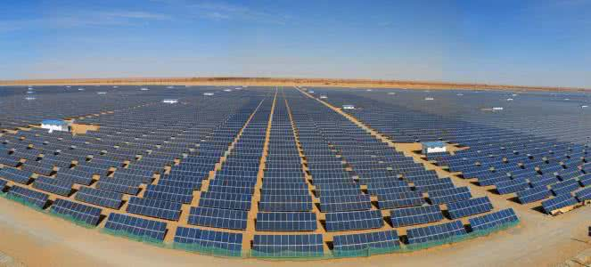
1.2 Industry Needs
Solar photovoltaic power generation systems are mainly divided into centralized and distributed. Centralized power stations generally cover a large area and are mostly built in northwest my country and some remote areas with harsh natural environments. Distributed power stations are generally built on rooftops, greenhouses and large pools. superior. However, after these photovoltaic power stations are connected to the grid, they bring a lot of operation and maintenance pressure, such as routine equipment testing, photovoltaic panel inspections, etc. The traditional operation and maintenance method uses manual inspection, which is inefficient, and most equipment faults are determined based on the experience of operation and maintenance personnel, which is prone to deviations. At the same time, in the harsh natural environment of remote areas, photovoltaic power station inspection work is very difficult and dangerous. For photovoltaic areas such as agricultural photovoltaic complementation, fishery photovoltaic complementation, and rooftop power stations, traditional manual inspections can no longer meet the needs and cannot achieve safe and efficient photovoltaic inspection purposes.
2 Application Solutions
2.1 Y-Flight Drone
Y-flight UAV relies on the country's top UAV expert team and superb technical support to launch a multi-rotor photovoltaic application UAV. This series of UAVs is an aerial platform with excellent performance. It adopts an intelligent system and has functions such as automatic takeoff, mission planning, route flight, fixed-point reconnaissance, regional reconnaissance, and automatic landing. The mid- and low-altitude monitoring system has technical characteristics such as rapid maneuverability, low cost of use, and simple maintenance operations. It also has the ability to quickly and real-time patrol and monitor the ground. It is a new type of mid- and low-altitude real-time transmission and infrared imaging rapid acquisition system. It is very important for my country's photovoltaic industry. The distribution needs to cross various complex geographical environments, which brings difficulties in detection, etc. It has its unique advantages.
2.2 Scheme Design Specifications
Standards And Laws And Regulations For System Implementation
Serial Number | Standard | Name
1 | GB 4208 | Enclosure protection level (IP code)
2 | GB/T 15498-2003 | Enterprise standard system, management standard and work standard system
3 | GJB 2347 | General specifications for drones
4 | GJB 3060-1997 | General specifications for UAV electrical systems
5 | GJB 3065-1997 | General specification for carbon fiber unidirectional and fabric prepregs
6 | GJB 3728-1999 | UAV ground test requirements
7 | GJB 5434-2005 | General requirements for flight testing of unmanned aerial vehicle systems
8 | GJB 5435-2005 | UAV Strength and Stiffness Specifications
9 | GJB 5433 | General requirements for unmanned aerial vehicle systems
10 | GJB/Z105 | Electronic Products Anti-Static Discharge Control Manual
11 | HB 5662 | Aircraft equipment electromagnetic compatibility requirements and test methods
12 | HB 6434 | Basic requirements for interface design of airborne electronic equipment
13 | QJ 2245 | Anti-static requirements for electronic instruments and equipment

2.3 Plan Design Basis
1) People-oriented, humanized design, with customer service as the purpose, improve work efficiency and reduce operating difficulty.
2) Fully consider the working environment of the photovoltaic industry and adopt industrial-grade design. The electromagnetic compatibility design of the whole machine complies with the relevant regulations of RTCA/DO-160F and can be used normally when 5m away from AC and DC transmission lines of 500kv and above.
3) The ground station uses a high-brightness screen, which is suitable for field operations, and has multiple functions for easy use by operators.
4) It can quickly perform tasks, quickly obtain image data in a short time, transmit it back in real time, and make real-time decisions. The captured data can also be brought back for analysis, so that there are no blind spots during the inspection.
5) Various defect problems can be identified. For example, it can identify whether there are any damages and stains on the surface of photovoltaic panels, and intuitively observe the working status of photovoltaic panels through infrared heat information. It can also identify performance degradation problems caused by human equipment, theft, lightning strikes, pollution, fog, etc.
6) The overall solution has low usage and maintenance costs, high efficiency, convenient transportation and easy to master. After one investment, the cost of each inspection is extremely low.
2.4 Scheme Implementation Principle
The system application plan is based on the YF -866S unmanned aerial vehicle and is equipped with a gyro-stabilized visible light detector and an infrared thermal imager and other payloads (photoelectric pod) to inspect and videotape the photovoltaic power station and conduct post-operation, maintenance and monitoring.

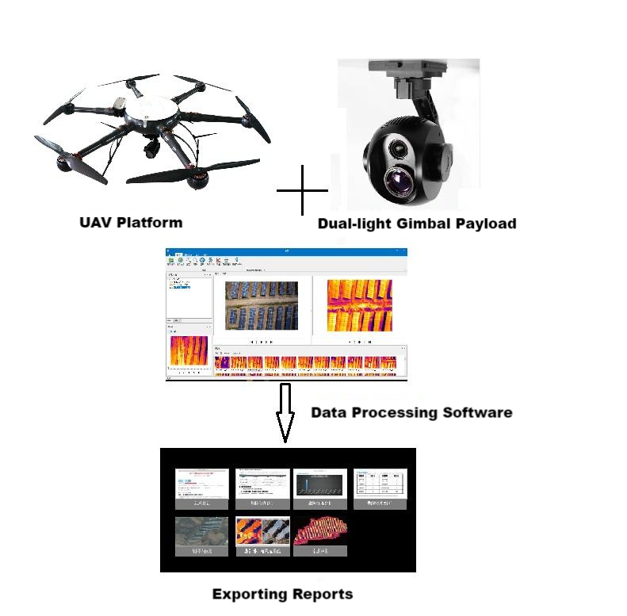
System working process: Y-flight UAV is equipped with mission equipment such as dual-light pod or damage detector; the ground control station with autonomous navigation and positioning function allows ground staff to set flight parameters and control the aircraft to take off autonomously and fly up and down along the line. ; The digital image transmission station transmits video recordings during inspections in real time; ground inspectors judge the line conditions based on the real-time video, and determine and record the location based on GPS positioning. After completing a flight mission, the aircraft lands autonomously and is recovered.
Y-flight electric photovoltaic drone system meets the following requirements:
(1) Support the required monitoring frequency.
(2) Have a certain battery life and support the required monitoring range;
(3) Able to adapt to the special meteorological and terrain environments in complex power pipeline network inspection operations;
(4) Real-time transmission capability of monitoring information;
(5) The equipment is modular and can be quickly switched to meet the inspection needs of different operations;
(6) Ease of training and operation, and adaptability to take-off and landing environments;
(7) It can meet the characteristics of photovoltaic network distribution and distance from population centers.

2.5 Solution Equipment Composition
Y-flight power inspection drone is composed of the Y-flight drone flight platform, automatic flight control system, measurement and control communication equipment, mission load equipment and ground station control system. The UAV flight platform is responsible for completing the flight mission; the automatic flight control system is responsible for the autonomous flight control of the aircraft; the measurement and control communication equipment is responsible for two-way data communication between the aircraft and the ground and the transmission of aerial photography and mapping data; the mission load is mainly photoelectric pod equipment, supporting Visible light and infrared camera functions; the ground station is responsible for aircraft route planning, real-time adjustment of flight attitude and other tasks, and control of the rotation angle of the photoelectric pod.

2.5.1 UAV Flying Platform
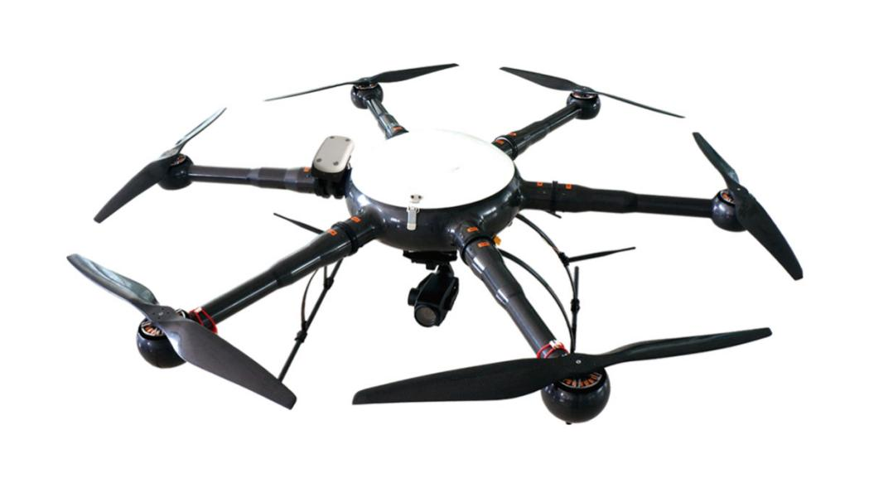
The Y-flight power inspection drone flying platform uses the YF -866S six-rotor industrial drone, which is made of carbon fiber composite materials. It has a modular structure and can be assembled in 5 minutes. Transportation and assembly are very convenient. YF -866S UAV is easy to operate and has strong industry applicability. It has the characteristics of longest flight time and stable flight at the same level, making the operation more convenient and reliable.
1) Structural Features
The new all-carbon fiber integrated machine technology has a stronger structure and lighter weight. The load capacity and flight time are guaranteed.
The entire machine adopts a modular design, and the arms, upper cover, fuselage, landing gear, load and other parts that need to be assembled can be quickly disassembled and assembled.
2) Working Environment
The working temperature ranges from minus 20 degrees to plus 60 degrees Celsius, ensuring normal operation in most places.
Wind resistance level: Level 6
It can work normally in places with high humidity and heat.
3) Technical Parameters
Drone Physical Indicators:
1. Body material: one-piece carbon fiber;
2. Motor: waterproof brushless motor;
3. Blade: 24-inch high-strength carbon fiber propeller;
4. Axis distance: 1250 mm;
5. Height: 500 mm;
6. Empty weight: <5kg
7. Maximum diameter: 1820 mm;
8. Battery pack: 6S1Px2x16000mAh
9. Storage box size: 800mmx800mmx430mm
UAV Performance Indicators:
1. Flight ceiling: 5000 m above sea level;
2. Whether there is RTK: Yes
3. Working height: ≤ 5000 m;
4. Maximum take-off weight: 18kg;
5. Battery life: Battery life >50min;
6. Power supply: military battery, total capacity 32000 mAh, voltage 22.2 V, equipped with 1 set of balancing charger;
7. Waterproof level: ≧IP45
8. Maximum lifting speed: 5 m/s;
9. Cruising speed: 10 m/s;
10. Hovering accuracy: ±0.2m in vertical direction, ±1m in horizontal direction;
11. Flight mode: autonomous flight, manual flight;
12. Minimum take-off and landing space: 4m*4m
13. Operating temperature: -20 ℃ ~ +60 ℃;
14. Environmental humidity: ≤95%;
15. Modular design: fully interchangeable;
16. Airborne POS: Airborne POS records fixed-point exposure posture information;
17. Double star positioning: Beidou and GPS dual system positioning;
2.5.2 Automatic Flight Control System

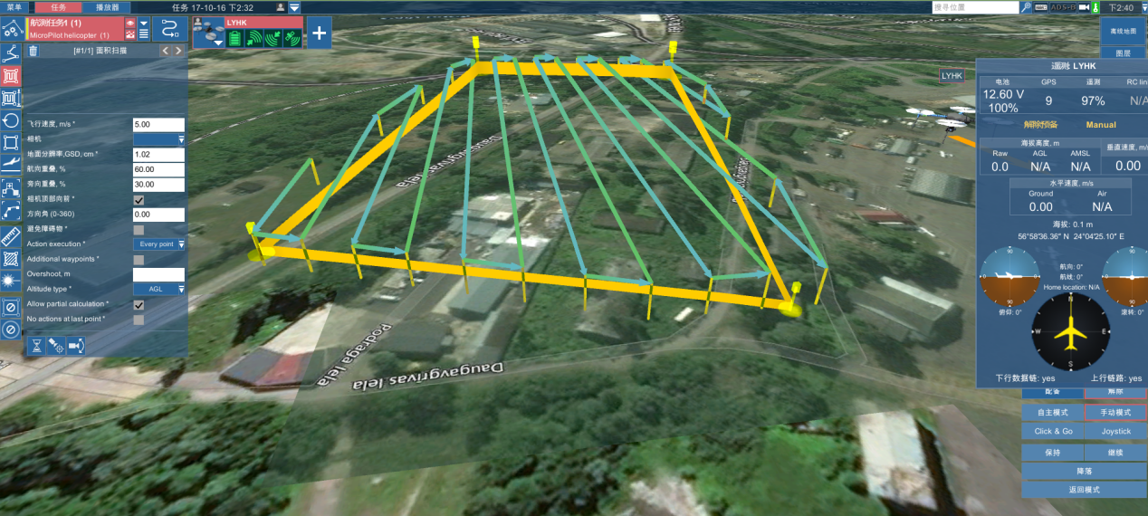
The automatic flight control system includes airborne flight control, ground station software, etc. It can stably control the Y-flight drone to fly unmanned in various environments. It is simple and convenient to use, has high control accuracy, and has strong GPS navigation automatic flight function. It can set the flight altitude, flight speed, etc., and has various task interfaces. , convenient for users to use various task equipment. It can complete autonomous takeoff and landing, route flight, etc. In addition, there are many safety protection solutions to ensure flight safety and failure protection to the greatest extent.
2.5.3 Ground Control Station System
The ground station system includes ground station notebook, ground digital transmission radio, serial port connection, and digital transmission antenna. The two-way data communication between the ground station software and the aircraft mainly has the following functions: setting flight control parameters, calibrating and setting sensor parameters, real-time adjustment of autonomous flight PID, monitoring and controlling flight status, graphically displaying flight data, controlling task loads, and playing back flight data. .
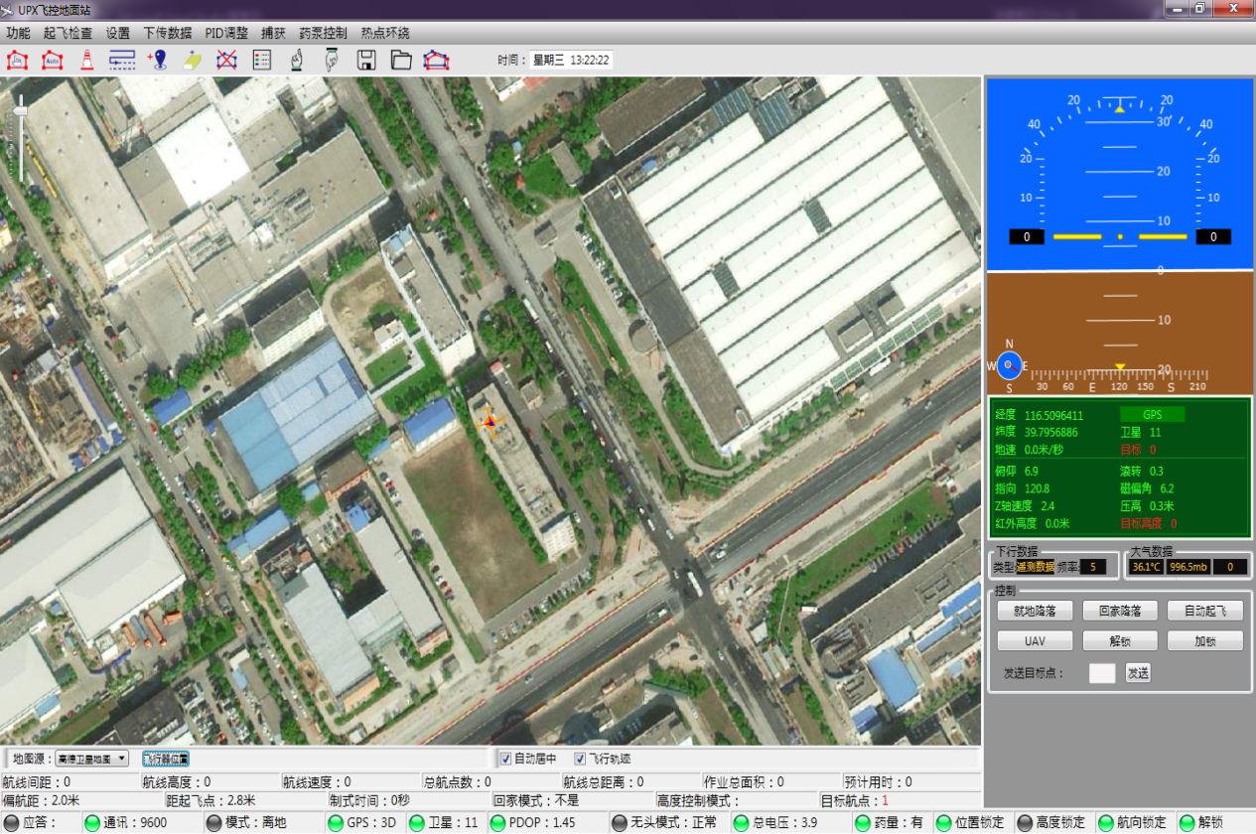
Control Bar
Navigation Data
Route Information Bar
Map Control Bar
Status Bar
Aircraft Position
Altitude
Ground Speed
Pitch Angle
Zoom In/Out on the Map
Toolbar
Roll Angle
Menu Bar

The Ground Station Can Mainly Achieve The Following Functions:
1) Communicate with the autopilot. The ground station control software communicates with the autopilot and data link through the serial port using the agreed communication protocol.
2) Flight control, send flight navigation instructions to the autopilot, switch flight modes, change routes in real time, customize tasks, etc.
3) Moving map, map loading, coordinate calibration, display, dragging, zooming; real-time flight track display, waypoint display and editing.
4) Route planning: edit waypoints on the electronic map, upload them to the aircraft after editing, and then download the waypoints in the autopilot to the ground station, and compare them with the edited waypoints to avoid missing waypoints.
5) Virtual instruments. Virtual instruments intuitively display various important data such as the aircraft's attitude, altitude, heading, throttle, and voltage.
6) Aircraft status and sensor value display, displaying various flight status and sensor values numerically or graphically.
7) Parameter configuration to ensure flight safety and ensure the smooth progress of the mission.
2.5.4 Task Load Equipment
The mission load mainly consists of dual optical optoelectronic pods. The pod is equipped with a dedicated high-definition 1080p visible light and infrared thermal imaging camera for inspection.
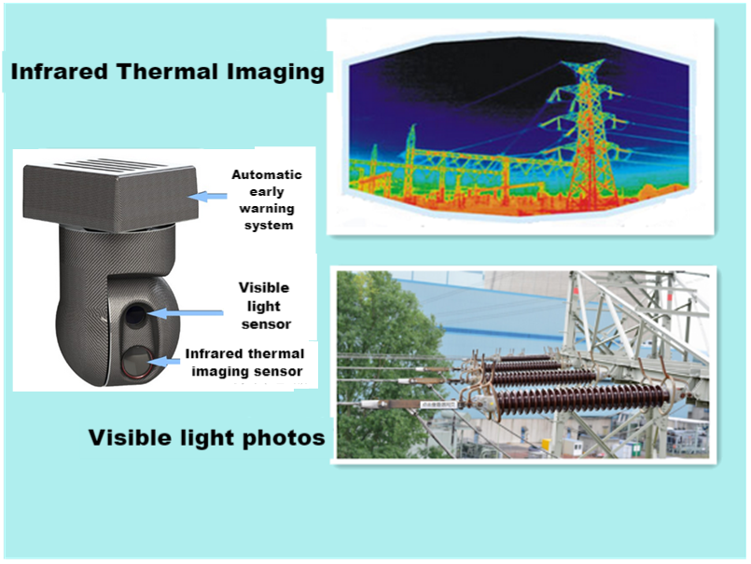
YF _SG14X is a 12-megapixel visible light movement with 14x zoom (3.5x optical*4x digital), and a 640*480 resolution, 50Hz, 25mm lens uncooled thermal imaging movement. Dual-light three-axis gimbal camera with target tracking function.
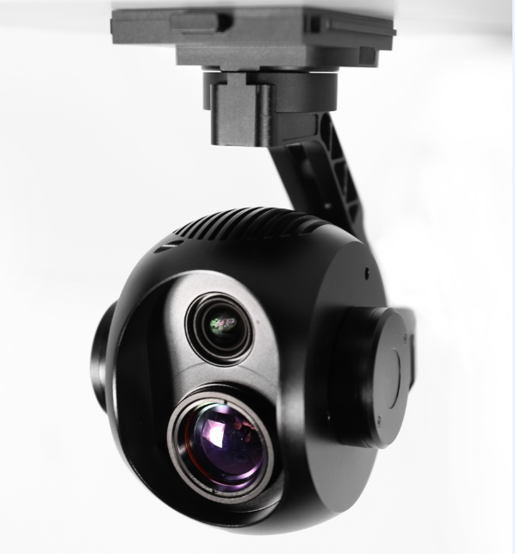
- Features
Easy To Operate
Point to zoom, return to center with one click, and operate the pod with the mouse or touch screen, making it easier to get started and operate more accurately.
GPS information record: (needs to be paired with customized flight control or open protocol, user-developed)
Video: subtitle file record. Photos: Picture overlay, POS point information. Special functions, more practical.
Quick Release
Patented design, convenient, reliable, tool-free quick disassembly, convenient for storage and replacement of other pod equipment.
High Precision
±0.008° control stabilization accuracy, industry leading. The image is still stable even at the maximum focal length and during rapid flight movements.
High Pixels
Visible light 12 million effective pixels, the picture is clearer.
Zoom
Visible light: 14x zoom (3.5x optical*4x digital) makes it easier to see details.
Smart Tracking
Intelligent target tracking makes tracking moving targets easier and more convenient.
Modular
The X30 series pods can be quickly switched without tools through the quick-release shock-absorbing structure. It is convenient to quickly replace other task equipment according to different usage scenarios. X30 pod (30x zoom, 5 million pixels), X30T pod (35x zoom, intelligent tracking),
Highly Expandable
The pod series can be modularly replaced to adapt to different application scenarios. Standardized pod interface. There is also CAN bus expansion. Great room for expansion.
Open SDK
The ground station end is open, allowing users to integrate it into their own ground station software. Air unit: Data transmission and CAN bus interface are open for easy access to third-party flight control software. Share flight control data information, share data links, and remote control links.
- Technical Parameters
Overall Parameters
Product Name | D640 dual light zoom pod
Operating Voltage | 12V-25V
Power | 8.4W
Weight | 786g
Memory Card Type | Micro SD card (single card)
Dimensions (Length, Width And Height) | 136*96*155mm
Interface Type | RJ45 (network port)
Control Display Mode | Windows system PC; Android phone, tablet (with flight control)
Real-Time Transmission Resolution | Thermal imaging: 640*480 Visible light: 720P, 1080P
Environmental Parameters
Operating Temperature | -10°~45°
Storage Temperature | -20°~70°
PTZ Parameters
Angle Jitter | ±0.008°
Installation Method | Removable
Controllable Rotation Range | Pitch: +70° To -90°; Heading: ±160°
Structural Design Scope | Pitch: +75° To -100° Heading: ±175°; Roll: +90° To -50°
Maximum Control Speed | Pitch: 120º/s; Heading 180º/s
Smart Target Tracking | Support
Camera Parameters
Visible Light
Sensor | CMOS:1/2.3″; total pixels 13 million
Lens | 3.5x optical zoom lens  F:3.85~13.4mm  Minimum shooting distance: 1m~3m (near focus~far focus)  Field of view (horizontal): 82~25°
Image Storage Format | JPEG
Video Storage Format | MP4
Operating Mode | video; take pictures;
Through Fog | Electronic fogging + optical fogging (automatically turned on)
Exposure Mode | automatic exposure
Resolution | 30fps;25fps(3840*2160)8 million  Maximum capture resolution: (4024*3036) 12.22 million
2D Noise Reduction | Support (automatically turned on)
3D Noise Reduction | Support (automatically turned on)
Electronic Shutter | 1/3~1/30000 seconds
Exposure | automatic mode;
Information Video Overlay (Osd) | support
Point To Zoom | support
Pointing Zoom Range | 1~3.5x optical 4x digital
Zoom To Single Image With One Click | support
Thermal Imaging
Detector Performance
Detector Type | Uncooled infrared microbolometer
Resolution | 640*480
Sensitivity | ≤60mk@300k
Frame Rate | 50Hz
Optical Properties
Lens | 25mm fixed focus lens
F Number | 1.0
2.5.5 Data Processing Software
FYFgo drone inspection data processing software can automatically identify and locate photovoltaic module hot spots by analyzing visible light and thermal infrared photos acquired by drones . In this way, the faulty equipment of the DC side power generation unit can be discovered in time, the time for equipment failure to be eliminated, the power lost due to equipment failure can be reduced, the quality and performance level of the photovoltaic power station equipment can be improved, thereby increasing the power generation of the photovoltaic power station. In addition, the automatic and fast diagnostic process can save a lot of time in manual inspections and is safer, more efficient and more accurate than traditional methods .
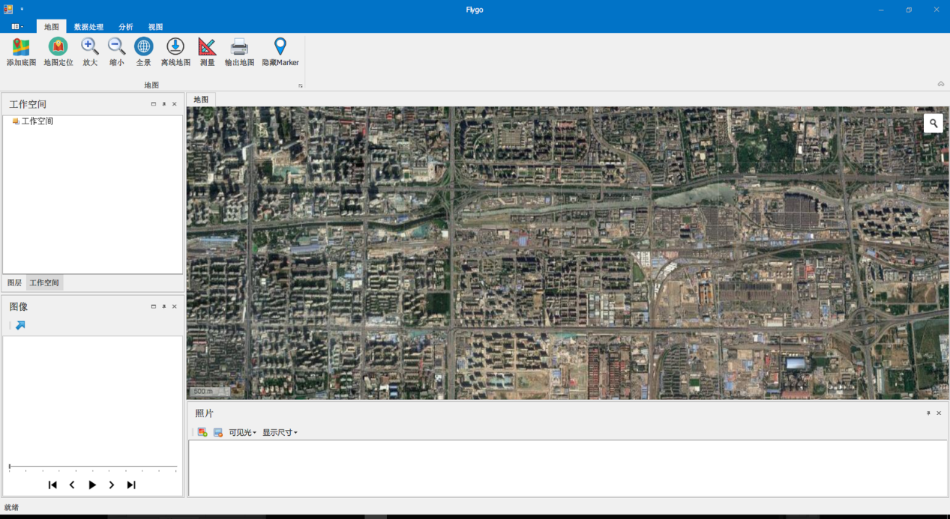
The Main Function
Basemap Data Management
The built-in GIS system of FYFgo UAV inspection data processing software V 3.0 can manage base map data in multiple formats ( raster , appropriate volume). When the power station does not have measured base map data, the system can automatically collect online remote sensing images to provide a basis for locating fault points. At the same time , the software has an offline caching function and is suitable for on-site operations without network.
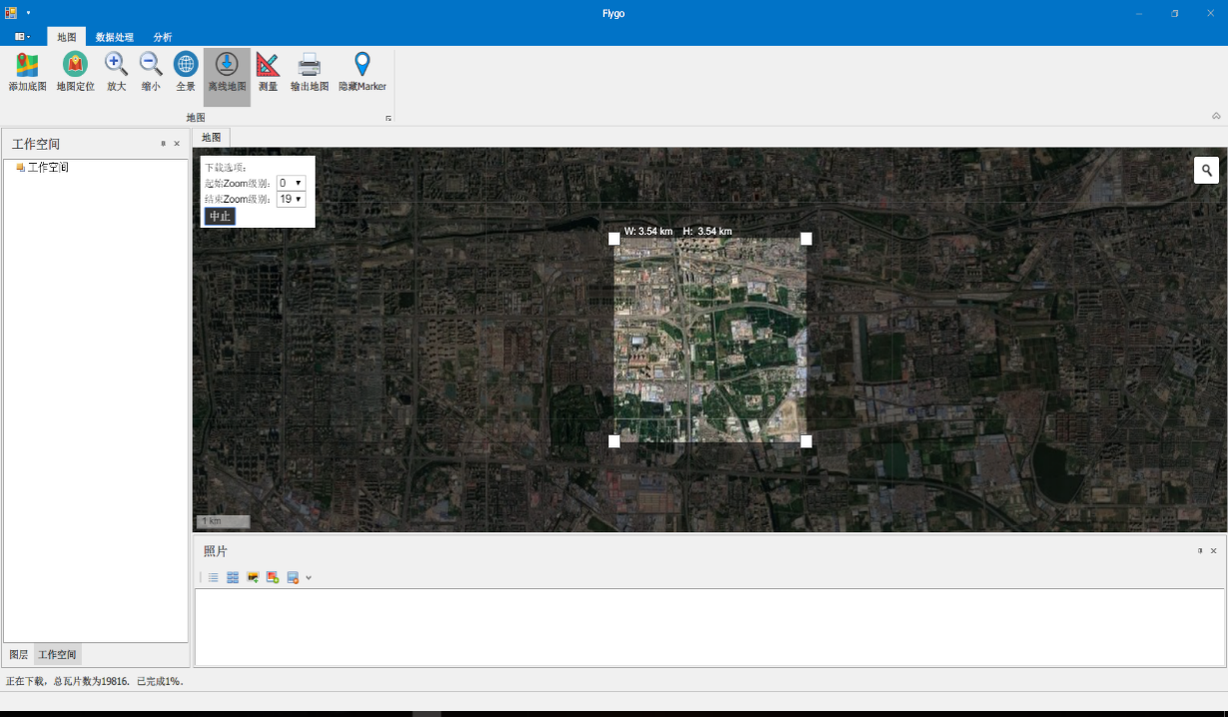
Data Batch Import
By reading the inspection data history database , inspection data can be automatically imported in batches according to inspection tasks , saving tedious data import time.
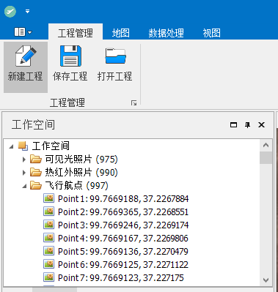
Map Data Management
FYFgo drone inspection data processing software V 3.0 manages satellite maps and drone high-definition maps, including base map addition (adding self-made maps, offline satellite maps, etc.), map positioning (automatic positioning by inputting location information) ), base map data enlargement and reduction, panoramic map display (panoramic puzzle, satellite panorama), offline map download (after selecting an area, automatically download the base map of multi-satellite data sources with preset resolution), measurement (area measurement, distance measurement), output map (supports output of pdf version of map, convenient for printing).
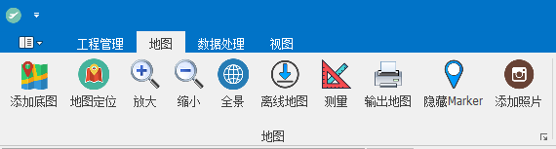
Multi-Type Inspection Data Processing
It can process multiple types of data such as optical images , thermal infrared images , aircraft flight data , and satellite remote sensing data for identification and processing, and can read data in bmp / jpg / png / tiff / raw / JPEG/BMP and other formats .
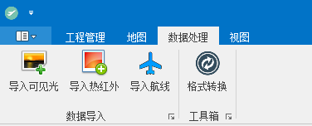
Image Synchronization Comparison
FYFgo UAV inspection data processing software V 3.0 can simultaneously compare optical images and thermal infrared images , and can also superimpose aircraft flight data , satellite remote sensing images, and panoramic mosaics to facilitate accurate identification of abnormal points.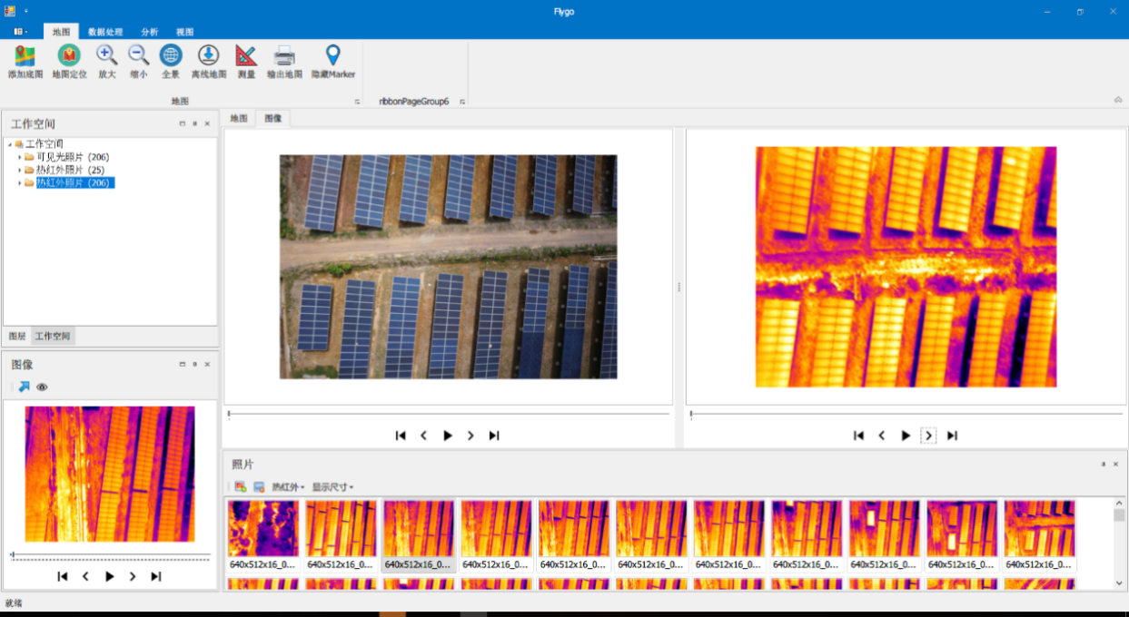
Batch Conversion And Color Change Of Thermal Infrared Photos
Thermal infrared cameras actually record grayscale images, but it is not easy to see the fault point visually. To this end, F YF go drone inspection data processing software V 3.0 provides a variety of color schemes , which can be applied to different scenarios.
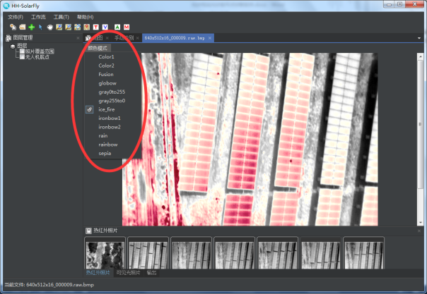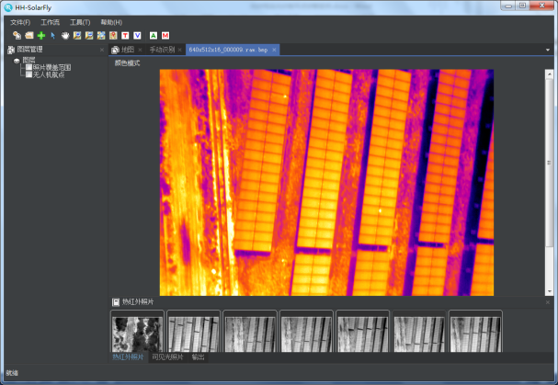
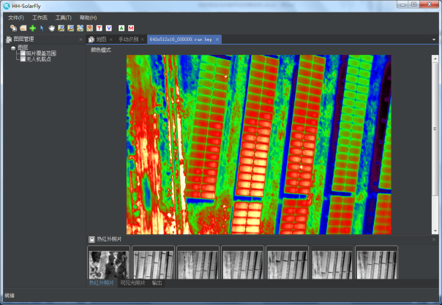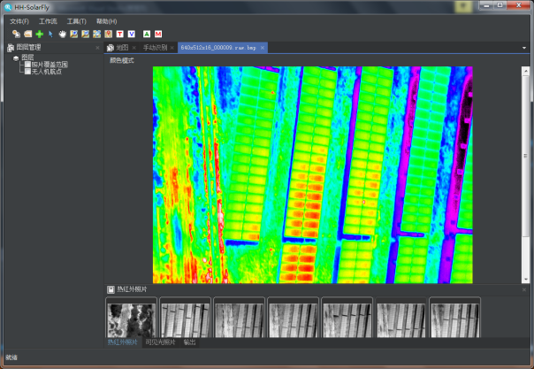
Layer Management
FYFgo drone inspection data processing software V 3.0 can import Google satellite map, Amap satellite map, Tiantu satellite map, Bing satellite map, Google Streets satellite map , Google Hybrid satellite map , Google Terrain satellite map , OpenStreetMap satellite maps , user-made maps, and maps with multi-source data, making it easier to use more alternative basemaps when there is no map data .
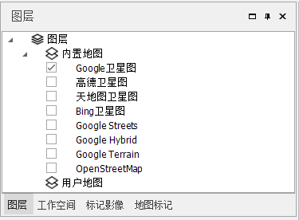
Marking Of Fault Points
Through manual judgment of the image , the location and type of the fault point in the photo can be manually marked by right -clicking the mouse. This information is automatically saved and used to calculate the actual geographical location of the fault point. The advantage of manual marking is high accuracy and the ability to handle various types of faults.
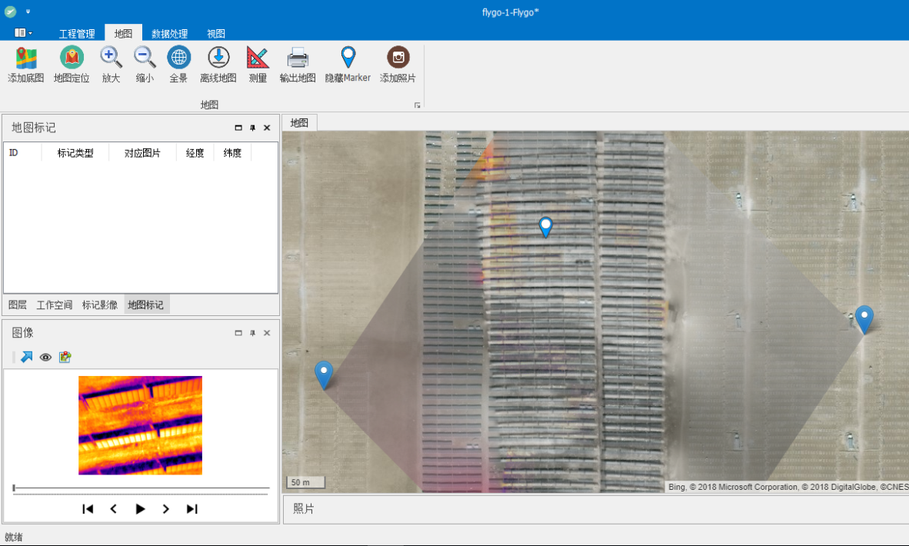
Automatic Marking Of Fault Points
FYFgo drone inspection data processing software V 3.0 provides automatic fault point detection function, which can detect abnormal points directly from images and automatically mark and record location information. Compared with manual labeling, automatic labeling is faster but is susceptible to background interference .
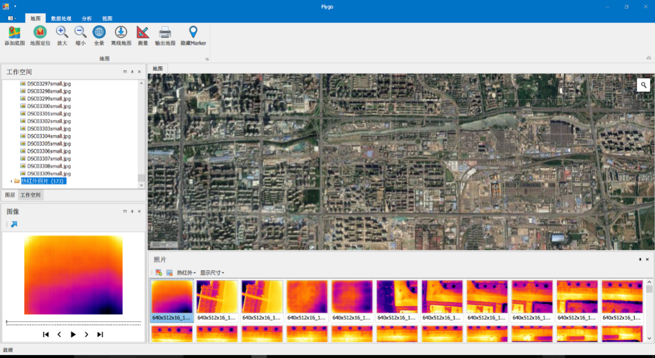
Calculation Of Actual Location Of Fault Point
FYFgo UAV inspection data processing software V 3.0 can add marked fault point information, combine it with the GIS base map , calculate the actual geographical location of each fault point, and display it on the base map to facilitate operation and maintenance personnel Perform photovoltaic panel maintenance based on fault location .
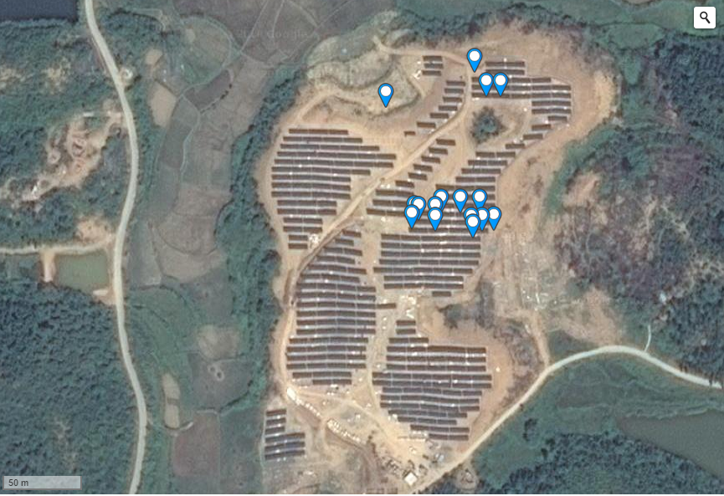
Accurate Locating
FYFgo UAV inspection data processing software V 3.0 can display UAV inspection images, such as optical images and thermal infrared images, on the base map, and can be manually dragged and registered with the base map. Achieve accurate positioning with zero error.
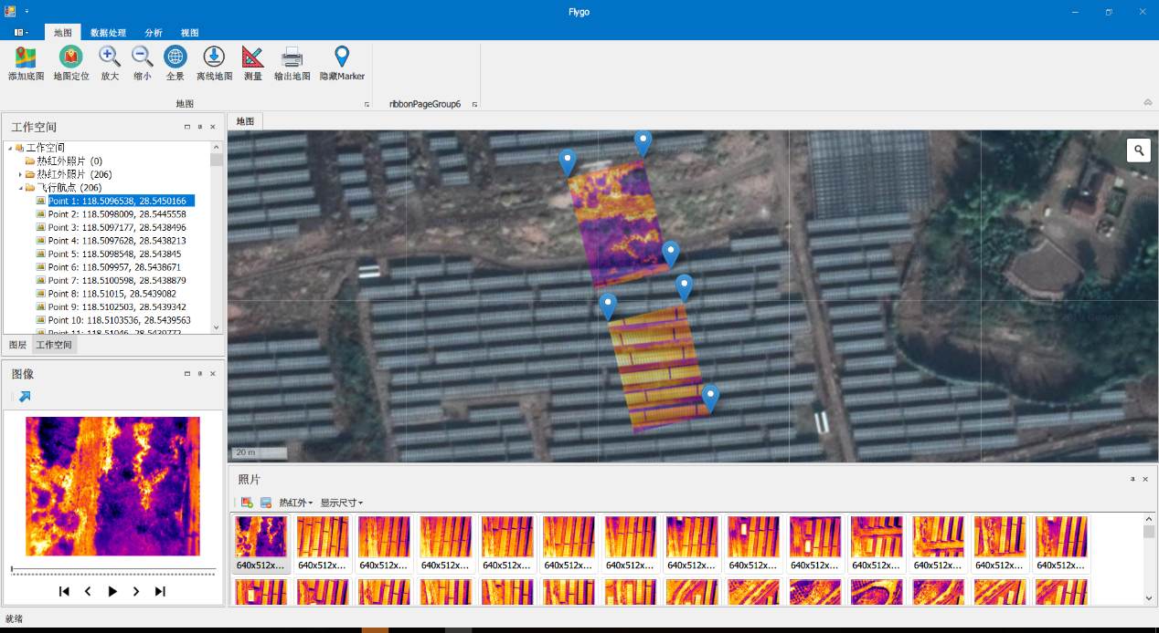
Report Export
Based on the input information and inspection results , F YF go UAV inspection data processing software V 3.0 can export PDF format reports, including inspection logs , inspection result summary , fault point analysis , fault point quantification , fault point location , etc. Information to facilitate the standardized management of the inspection process and a reliable basis for rectification and correction .
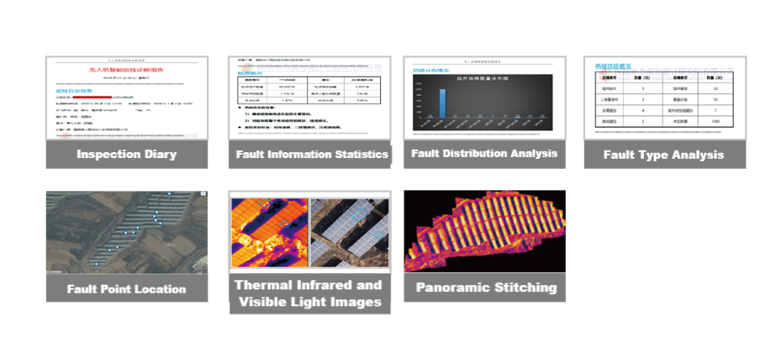
Panorama Generation _
The panorama can have a macroscopic image of the entire detection area . The detailed pictures it provides can provide operation and maintenance personnel with positioning information accurate to the inside of the photovoltaic panel , which can greatly improve work efficiency .
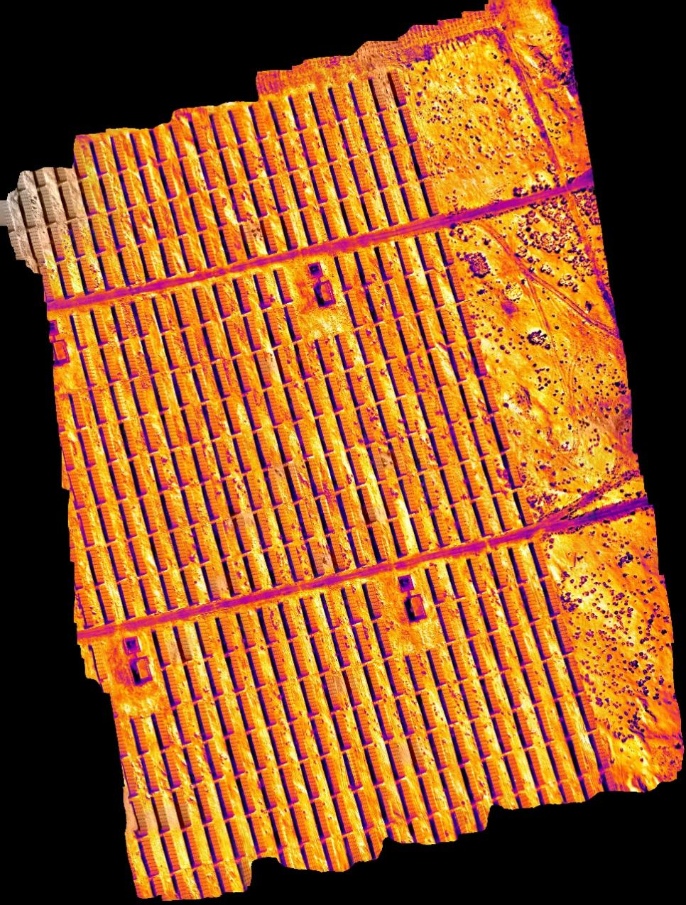
Expand Applications
Combined with the photovoltaic power station intelligent detection system - 'Photovoltaic Elf', it fully taps the value of power station production data, improves the efficiency of power station performance judgment, fault discovery, and elimination, and comprehensively constructs equipment based on a series of intelligent detection algorithms such as neural networks, fuzzy algorithms, and expert fault diagnosis. The performance detection model can conduct real-time monitoring and prediction of string performance, realize power station performance monitoring and quantitative analysis, generate scientific fault elimination tasks, and avoid unpurposeful large-area inspections by inspection personnel. By mining and analyzing the historical/real-time production data of photovoltaic power stations, intelligent detection of string performance, component performance, and system performance can be achieved, helping owners easily understand the health of the power station.
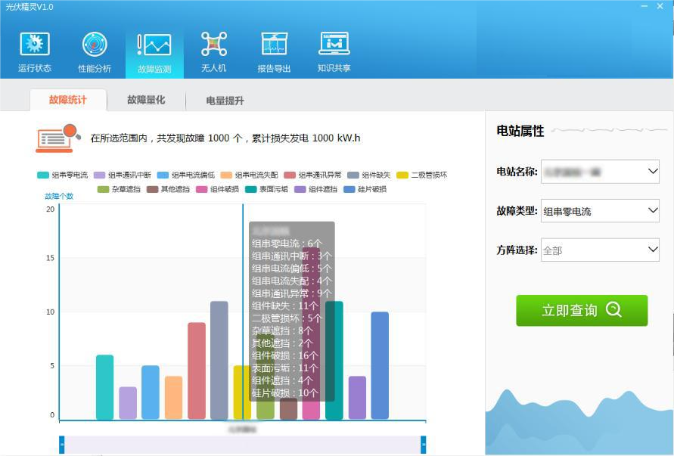
2.6 Plan Implementation Process
2.6.1 Introduction To Operation And Maintenance Work
(1) Preparatory work for inspection
First, the ground staff conducts a three-dimensional positioning of the longitude, latitude and height of the photovoltaic plant, and then performs the initial positioning of the lines. Input these parameters into the ground station for 3D image editing to set the flight route and hovering coordinates of the drone; at the same time, you can also determine the flight distance and take-off and landing location of the drone to provide battery life for the drone. Replace the battery and select the stopping point in advance to ensure flight safety.
(2) Introduction to work during inspection
After all preparations are completed, take off with one click. During the inspection process, the drone performs operations according to the instructions of the ground staff on hovering, advancing and changing the course, as well as the rotation and adjustment of the gimbal to monitor the direction.
2.6.2 Cruise Mission
The system can perform at least three tasks: fault inspection (quickly and accurately find fault points of the power grid and its equipment), routine inspection (replacing manual routine inspection, improving inspection efficiency, reducing inspection costs, and reducing inspection costs). personnel labor intensity), annual inspection (replacing manned aircraft to perform annual planned aviation inspections).
Three Mission Situations:
(1) UAVs for emergency and routine flights
Solving the problem: Photovoltaic equipment faces severe natural disasters
First of all: UAVs can quickly respond to emergencies and are suitable for natural disaster warning patrol flights and accident emergency flights;
Secondly: through large-scale flight inspections quickly, we can grasp the hidden danger points of accidents at the first time.
Finally: the degree of damage on the ground is understood through aerial photography and mapping. The ground workstation immediately notifies the transmission management office and the emergency repair team to carry out emergency repair and maintenance based on the real-time aerial monitoring data.
Advantages of emergency repair: It improves the efficiency of the emergency repair team in handling emergency incidents, quickly and accurately conducts damage assessments for disaster-stricken areas, and wins valuable and sufficient time for emergency repairs.
(2) UAV dual-light inspection flight
Solve the problem: Carry out daily inspection tasks regularly.
First of all: the drone conducts automatic flight inspections based on the GPS coordinate points programmed in advance. The inspection content includes: panel status monitoring including cracks, snail lines, damage, welding ribbon failures, etc., and power plant environment monitoring including whether there are Problems such as suspicious persons, animal intrusion, vegetation obstruction, etc.
Secondly: UAVs perform inspection and monitoring and synchronously transmit them to ground staff in real time.
Finally: After the drone completes the inspection mission, the ground staff will judge the inspection results based on the inspection content information, and formulate corresponding solutions according to the specific situation.
Advantages of conventional dual-light inspections: used for daily inspection tasks. Compared with traditional manual inspections on the ground, drone visible light inspections have the characteristics of high work efficiency, high accuracy, and large working range; compared with manned aircraft inspections, In short, drone inspections have obvious advantages such as high safety, low operating costs, and strong real-time performance.
2.6.3 Data Processing, Analysis Report
This process mainly uses the F YF go UAV inspection data processing software V3.0 to import and process the data obtained from the cruise mission. Through the software's preset function, fault point marking and precise location calculation are processed, and the final report is exported in PDF format . , including inspection logs , inspection result summary , fault point analysis , fault point quantification , fault point location and other information, to facilitate the standardized management of the inspection process and a reliable basis for elimination and rectification .
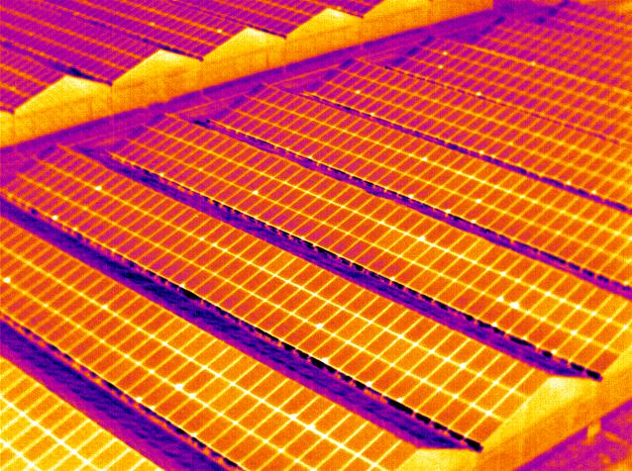
Infrared Camera Effect Illustration
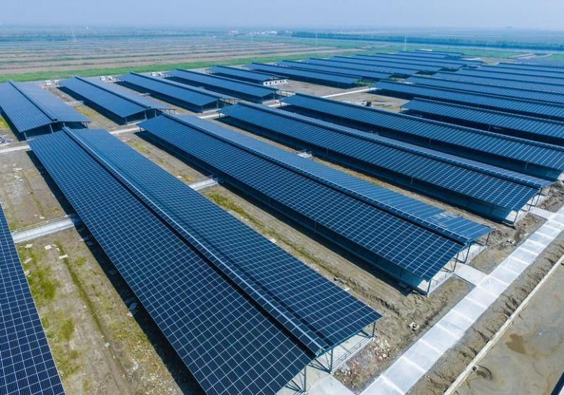
Visible Light Photography Effect Illustration

UAVs are equipped with infrared thermal imaging equipment to inspect inspection lines. By comparing abnormal temperature changes, they can find hidden fault points. Combined with traditional visible light inspections, thermal imaging inspections will greatly improve the accuracy of fault point detection. accuracy.
3 Advantages Of Y-Flight Photovoltaic Inspection Drone Inspection
Advantage Comparison
Problems With Traditional Inspections
First: the inspection distance is long, the workload is heavy, and the walking inspection efficiency is very slow, which cannot improve the inspection efficiency;
Second: In the event of natural disasters such as ice, snow, floods, earthquakes, landslides, etc., inspection work will not be carried out;
Third: Inspection in mountainous areas is high-risk and threatens the life safety of inspection personnel at all times. A large number of potential hazards endanger human life.
Advantages Of Drone Inspections
The Y-flight UAV: a fully independently developed autopilot, the body is easy to carry, simple to operate, can hover for a long time, has a wide range of mission uses, has low environmental requirements for takeoff and landing, and can achieve fully autonomous flight.
Drone Advantages:
First: Drone inspections improve the speed and efficiency of power maintenance and repairs, allowing many tasks to be completed quickly in a completely electrified environment, ensuring the safety of electricity use. According to relevant information, drone inspections are 40 times more efficient than manual inspections.
Second: Using drones to conduct regular transmission line inspections can reduce labor intensity. Compared with manned helicopter inspections, it can improve the safety of inspection workers, and the cost of drones is only 5-15 times that of manned aircraft. %, and the flight cost is only 1-5%.
Third: UAVs have the characteristics of fast inspection and emergency response, and can detect defects in time and provide information in a timely manner, avoiding line accidents and power outages, and recovering high losses in power outage costs.
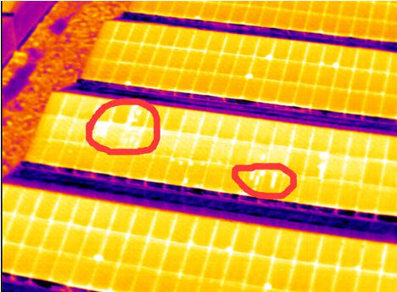
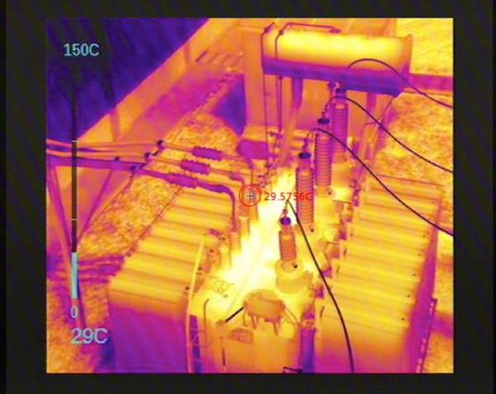
Fault Point Icon

